Table of Contents

1. Introduction | 2
1.1 General Background | 2
1.2 Reverse Engineering | 2
2. Research Objectives | 3
3. Methodology | 4
3.1 Getting Started | 4
3.2 Scanning Procedures | 4
3.3 Creating The Scan Window | 5
3.3.1 Flat Scanning | 5
3.3.2 Rotational Scanning | 5
4. DataSculpt Procedures | 6
4.1 Closing Surfaces | 6
4.2 Wrapping Rotational Scans | 6
5. Integration Into Pro/ENGINEER 2000 | 6
5.1 Conversion and Importation of Scanned Image | 6
5.2 Surface Creation | 7
6. Simple Geometries | 8
6.1 Rotational Scan of a Simple Object | 8
6.2 Flat Scan of a Simple Object | 9
7. Future Work With Huxley | 11
7.1 Recommendations | 11
7.2 Specific Project Proposal For the Spring of 2000 | 12
8. References | 14
9. Appendices | 15
9.1 APPENDIX A – Using The Laser Digitizer | 15
9.2 APPENDIX B - Using DataSculpt to Close the Scan Curves | 17
9.3 APPENDIX C - Wrapping Rotational Scans | 18
9.4 APPENDIX D - Converting the Scanned Files | 19
9.5 APPENDIX E - Using ProE/2000 Scantools To Create A Surface | 20
9.6 APPENDIX F – Customized Dell Computer

1. Introduction

1.1 General Background
Our project involves intensive work with the Laser Design Surveyor 3000 Point Digitizer, a $100,000 machine manufactured by Laser Design, Inc. For simplification, we will refer to the machine as Huxley. To scan, Huxley emits a small laser beam onto the surface of the object, and a sensor helps compute the position of the laser. Huxley then changes these positions into a series of coordinates that define the geometry of the object. The coordinates are saved as an output file, which is then transferred to another computer and converted into a usable file. This converted file can be imported into a Computer Aided Design program in order to create a solid model of the scanned object. The solid model can be modified, run through a finite element analysis, or even recreated through use of a stereo lithography machine.

Some research has already been completed on the Huxley and related applications. The National Zoological Park created The Biovisualization Laboratory User Manual, which is essentially an extremely detailed 30-page manual on scanning with Huxley and instructions for using the software package called DataSculpt. DataSculpt, also developed by Laser Design, Inc., provides an interactive graphic interface to modify and edit the scanned data provided by Huxley. Further research on the Huxley is included in a graduate student’s thesis report entitled System Design for Object Reconstruction Using Information-Based Manufacturing. Basically, this report explains background information on Huxley and DataSculpt, scanning techniques, and the scanning and editing processes associated with fossil fragments from a Homunuculus skull and with a distributor. These two sources provided some useful background information and gave our team a better idea of how to scan with Huxley.

An important aspect of using the Huxley is that it can be used for reverse engineering. The following section provides a detailed description of what reverse engineering is and why it is important.

1.2 Reverse Engineering
Reverse engineering is the term usually used for taking apart a commercial product to see how it works so that such information can be used to develop another product. Reverse engineering is common in the auto industry where automobile companies purchase a product made by a competitor and disassemble it to examine how the welds, seals and components of the vehicle are put together. Reverse engineering also provides systematic steps to help understand and document the design and the design process so that a non-expert can take over the project later, without relying on an expert.

Reverse engineering or re-engineering comes about for a variety of reasons, chief among them is the need to replace worn, broken or obsolete parts that are no longer available from the original manufacturer. Re-engineering a part or assembly can provide an improved or added performance to an old process. New and improved materials and techniques may be utilized improving operations, maintenance and support. Usually, all that is needed to re-engineer mechanical parts and assemblies is an original sample. In the case of a single part, the part is measured, a material analysis is performed if required, and drawings of it are made together with any required changes. In the case of an assembly, the assembly is taken apart and each part is treated as above. In this case, a tooth was recreated through the use of scanning and sculpting programs.

Another benefit of reverse engineering is that it is cost effective. Parts that are very expensive to buy can be reproduced cheaply using reverse engineering. Reverse engineering can also be used to create life-sized models for molding. Dinosaurs in the movie Jurassic Park II – The Lost World were created by sending the digitized data to a CNC – Sculpting machines. In the course of the sculpting process, the models were finished to such fine detail that they went almost directly to mold. Tons of clay was not required to build up an armature which would need babysitting or staking for fear of slumping overnight. This process also saved several months is production time.

Reverse engineering is also used in electrical or electronic parts, as well as in software. According to Elliot J. Chikofsky, “Driven by the economic importance of maintaining and improving the enormous base of existing software systems, the reverse engineering of software been of rapidly growing interest over the past decade. More and more commercial software tools support aspects of reverse engineering, and more and more researchers in academic and industrial organizations are addressing themselves to the fundamental problems of reverse engineering.” For electrical or electronic parts, the process is much the same as for mechanical parts. The reverse engineering is more difficult unless circuit diagrams are available. Sometimes old circuits may be combined into large-scale integrated circuit packages to save time and money.

2. Research Objectives

One objective of our project is to become familiar with the Huxley and the associated scanning methods. Huxley is a sophisticated machine, and the team members must practice scanning objects to learn how to operate the machine successfully. Scanning methods must also be mastered in order to efficiently use Huxley. These scanning methods include optimizing the scan density, scan height, and methodology for scan window creation. Another objective is to become familiar with converting the output files into Pro/ENGINEER 2000 format and with utilizing the converted file as a part in Pro/ENGINEER 2000.

Further team objectives involve creating simplified instruction manuals. As mentioned earlier, the main reference for Huxley operation is a 30-page detailed manual. The team has decided to create much simpler instructions that will provide an easy method for scanning so that anyone can follow. The file conversion process is also somewhat detailed, and the team will develop instructions that will convert Huxley’s output file to a file that is compatible with Pro/ENGINEER 2000. A final set of instructions to be created is for scanned object solid model creation and utilization with Pro/ENGINEER 2000. Currently, there are no simple instructions available that explains the integration of data from Huxley into the Scantools application in Pro/ENGINEER 2000. Instructions available to our team only explain detailed integration into the DataSculpt software package. Since Pro/ENGINEER 2000 is becoming one of the most popular CAD programs in industry, our group deemed it necessary to provide instructions for this program. During our research this semester, we also needed to use DataSculpt to wrap rotational scans, edit data, and to close surfaces. A final objective is to make simple instructions for the DataSculpt procedures that we used. All of these instruction manuals will be useful for any other groups that attempt future research with the Huxley system.

3. Methodology

3.1 Getting Started
Before we could scan any objects and convert it to Pro/ENGINEER 2000 format, we needed to set up a lab area to run the Huxley machine. The machine is composed of two parts; the digitizer and the PC control unit. Both components are located in the Manufacturing Building on campus.

Once the Huxley was set up, the next step was to take a look The Biovisualization Laboratory User Manual. This manual is long, detailed, and complex. After looking through it, we realized that we would need to create a simplified instruction manual in order to easily use and operate the Huxley. This simple manual can be used as a reference for our team and for a guide for future teams that work with Huxley.

After familiarizing ourselves with the scanning instructions, a graduate assistant gave our team a quick demonstration on how to scan an object with Huxley. He quickly took us through the scanning and conversion process step by step. After the demo and some experimentation, the team created a simple two-page instruction sheet that clearly explains each step involved with scanning an object and saving the data. This instruction sheet is included at the end of this report as Appendix A. Each group member attempted to scan an object using the new instructions. Problems were noted, and the instructions were revised. At this point, we decided to pick one object to repeatedly scan so more consistent comparisons can be made. We chose a small ceramic tooth to use for the rest of our scans.

3.2 Scanning Procedures
Scanning objects with the Huxely requires the input of several parameters into the laser digitizer software program. First, the laser needs to be homed and focused. These processes get a reference point for the laser to start from. Homing the laser is required at the start of every new scan. The next step is to focus the laser on the object to be scanned. By focusing the laser on the object, the height is determined. The height is then set as the start point for the laser to start searching during scanning. The search height must also be set in order to tell the laser the vertical distance to search, a distance determined by the scan object. The scan line density must also be set. The scan line density is set based on the resolution required for the scan. The smaller the grid the higher the resolution and the longer the scan will take. The final step in scanning an object is to create a scan window. The scan window tells the laser where to search for points on the object being scanned. Objects can be either flat-scanned or rotationally scanned. The scanning method depends on the scan object geometry. Different geometric shapes are better suited for the different types of scanning. The tooth geometry is best suited for rotational scanning because the top is wider than the bottom, and a flat scan would not capture all of the details of the tooth. A right angle bracket, on the other hand, is better suited for flat scanning. Appendix A at the end of the report gives simple instructions on how to scan with Huxley.

3.3 Creating the Scan Window
The scan window is the area defined on an object that the laser scanner will scan. There are three key points to successfully creating the window for a scan. First, focus the laser on the object you are scanning and not on the platform. Some shiny surfaces may reflect the laser and prevent it from focusing. Focusing on the object will also reduce the distance in the “z-direction” the laser has to search. Secondly, if you are scanning a tall object, keep the scan window on the object. If the laser goes off the object, it will spend a considerable amount of time searching. While digitizing, the scanner may be unable to focus on the object and, therefore, store a bad point. Bad points during scans, called spec points, are indicated by yellow on the computer screen scan window (good points are shown in red). These spec points can prevent the scanned file from being converted using the dspost command in the DataSculpt software. Finally, if the scan height is not set to the proper dimensions, spec points may be obtained because the object will either be too far away or too close for the laser to focus. It is recommended that the scan height be set to equal up and down search distances and set in increments of 4’s. If you get spec points even though everything is set up properly, changing the search height or the scan line density could eliminate the spec points.

3.3.1 Flat Scanning
When setting the parameters for a flat scan, it is recommended that the laser stays focused on the scan object. It is possible to focus on the platform if the scan object is short. The scan window should trace the outline of the object as close as possible. This may require that the linear increment be set to a small value like 0.1mm. There is no limit to the number of points chosen to define the scan window. When tracing the scan object the laser should be completely on the object. If the laser seems to be split on the object, the laser should be moved so it is entirely on the object. Ensuring that that the laser is entirely on the scan object will help to prevent spec points.

3.3.2 Rotational Scanning
There are several differences when doing rotational scans, although most of the rules for flat scanning still apply. First, with rotational scanning you need to keep the laser on the object that you are scanning because there is nothing directly under the scan object for the laser to focus on. If the scan height is set so that the laser is able to focus on the platform, the scan will not resemble the scan object. Setting the scan density requires the use of the DataSculpt run 150 file. This file calculates the required scan distance between point for 150 points per mm² scan density. To use the run 150 file, the laser focus height is needed. The resultant calculation is the value for the scan distance between lines. Unlike flat scanning, spec points in rotational digitizing do not have the same impact on the scan file. Scan files with a few spec points will usually be able to be read and wrapped using DataSculpt (Wrapping is discussed in a later section). This may be because the DataSculpt software might be more forgiving then dspost. When creating the scan window, the object should only be rotated 359 degrees. If you rotate a full 360 degrees, you will get spec points. The Huxley has limitations with rotational scanning. Make sure that the object you are scanning can be accurately scanned. An example of the limitations of the scanner is the tooth-cap in this report. Because of the tall sides most of the underside of the tooth was not scanned. The fixed laser head causes this problem. If the laser head was able to rotate the problem may be alleviated.

4. DataSculpt Procedures
4.1 Closing Surfaces
All scans provide data that show the basic texture of the surface of the scanned object. Many scans, especially flat scans, only collect coordinates from the top surface of the object. As a result, the scan curve lines are not connected. In order to convert the scanned data into a solid model, these scan curve lines must be connected to close the surface. We spent countless hours trying to close the surface using the Pro/ENGINEER 2000 interface to no avail. Although we desired to complete the entire process using Pro/ENGINEER 2000, we chose to use the DataSculpt software to close the surfaces of the scanned objects.

After using DataSculpt for only a short time, we determined an easy method to connect the scan curve lines. DataSculpt is only available on the Silicon Graphics machines, and any group desiring to use the program must obtain authorization from a network administrator in the Manufacturing Building. Once authorized, the filename.scn file generated by Huxley is loaded into the DataSculpt program. By using the Latch and Poly function, a single scan curve line is connected endpoint to endpoint. This endpoint connection process is repeated for each scan curve line in the generated data. The specific instructions for this entire process are given as Appendix B at the end of this report.

4.2 Wrapping Rotational Scans
When a rotational scan is completed, Huxley writes the rotational coordinates as angles. However, DataSculpt reads these values as normal y-coordinates. The result on the DataSculpt screen is a series of long parallel lines. To convert the coordinates to rotational angle values, the WRAP command is used. A customized run file called master1.run, which should be located in the /dsculpt/run folder, gets the filename.scn file, wraps it around the x-axis and then rotates the whole geometry 90 degrees around the x-axis. The resulting geometry is the same as the scanned object. The specific instructions for this process is given as Appendix C at the end of this report.

5. Integration into Pro/ENGINEER 2000

5.1 Conversion and Importation of Scanned Image
After the object is scanned, an output file is created. The output file from Huxley is in the form of ‘filename.scn.’ This output file is converted from a ‘filename.scn’ to a ‘filename.ibl’ file, which is compatible with Pro/ENGINEER 2000. This process is accomplished with the use of a Unix program (dspost) written particularly for this application. The entire conversion process is outlined in another brief set of instructions created by the team. These file conversion instructions are attached to the report as Appendix D. The converted file is then imported into Pro/ENGINEER 2000 as a part. A coordinate system is set, and the Scantools application is accessed in Pro/ENGINEER 2000. See Appendix E for simple instructions on using the Scantools option. The Scan Crv Set option in Scantools allows the user to select the desired density of the scan curves and projects a mesh-like set of contour curves of the scanned object as shown in Figure 1 below:

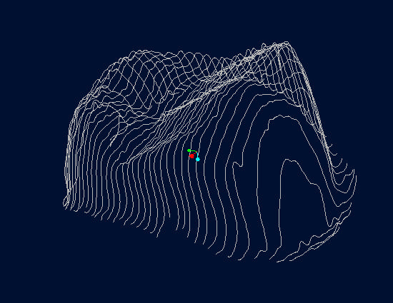
Contour curves
(scan lines)

Figure 1. Low-density scan curve projection of a tooth surface.

5.2 Surface Creation

Once the low-density scan curve is created, the next step is to add a surface to the scanned image. To do this, the Style Crv Set option in Scantools is accessed and the number of points per scan line is set. For our scans, we typically use approximately 50 points per line. The more points per line that are selected, the closer the style curve lines approximate the actual scan curve lines. After this is completed, we select the scan lines to create a style curve surface. Once the lines are selected, the final step is to create the style surface. The Style Surface option in Scantools is accessed, and the style curve lines are selected in order. The order is important because Pro/ENGINEER 2000 generates the surface in the same order that the lines are selected. After completion of this step, Pro/ENGINEER 2000 now recognizes the image as a typical part. This means that it can be modified or analyzed using any of the tools available on Pro/ENGINEER 2000. Figure 2 below shows the scanned tooth with a style surface:

Figure 2. Scanned tooth with incorporated style surface.

6. Simple Geometries

6.1 Rotational Scan of A Simple Object

A rotational scan of a simple object was done to evaluate the accuracy and the effectiveness of the instructions the team made up. The simple object chosen was a fuse. The fuse was loaded onto the digitizer where it was scanned using the instructions for a rotational scan that the team derived. The fuse was scanned and rotated 359 degrees before being closed to ensure that the whole object was captured in the scan. The scanning went pretty smoothly, except for the fact that as the scan density increased, the scan took longer to complete.

The scanned fuse was then converted to where it could be accessed by Pro/Engineer 2000. After completing this without any problems it was time to create a surface for the fuse. This is where a problem was encountered. The instructions for creating a surface that the team derived were accurate, however the computers in the Manufacturing Building crashed every time the team tried to create a surface for the fuse. This is likely because the computers that the team had access to were not powerful enough to handle this operation. The scanned fuse, without the surface, can be seen below:

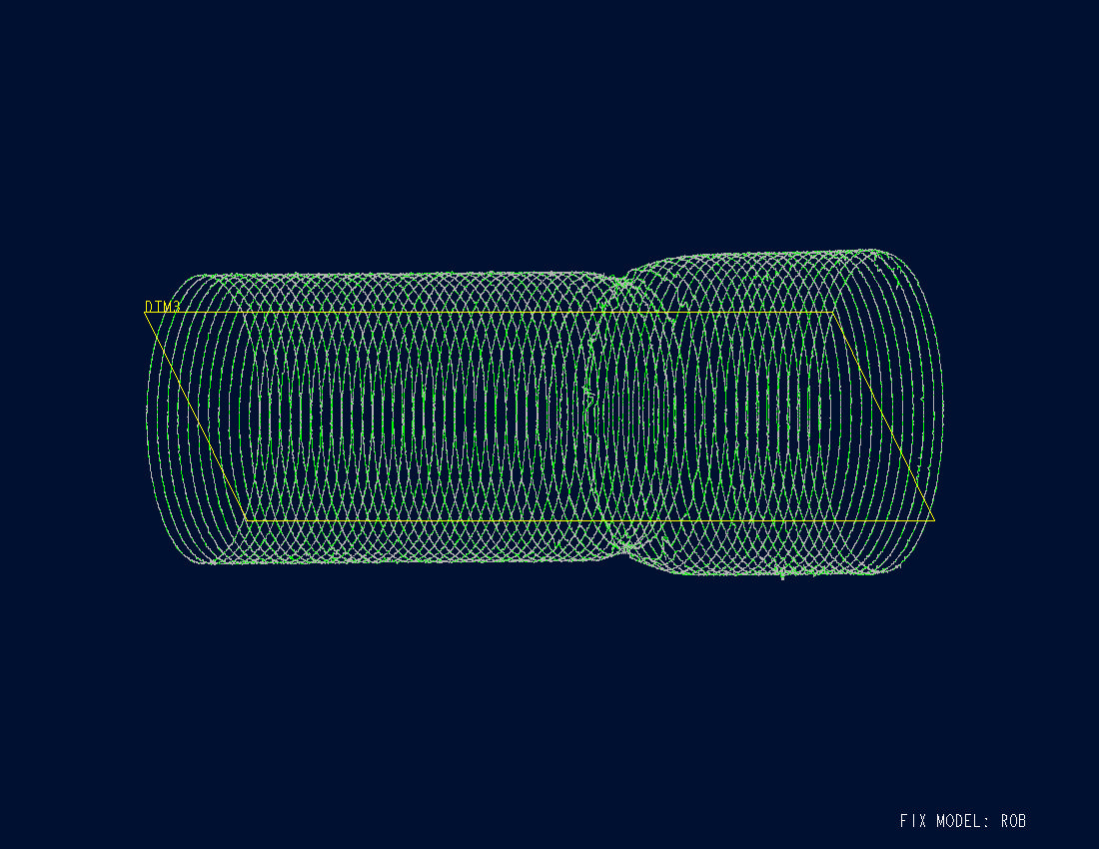

Figure 3. Scan Line Curve Set of a rotational scan of half of a fuse.

6.2 Flat Scan of A Simple Object
Flat scanning of an object was done to demonstrate just how easily anyone can use the 3D Laser Digitizer to scan objects for editing. The first object that was attempted was a circular disk with a hole in it made from aluminum. It was scanned five times, and each time when the laser approached the hole the laser had problems recognizing it. Thus, yellow points (bad points) appear on the computer screen preventing file conversion into Pro/ENGINEER. In these attempts, several changes were made in the setup of the scan in order to avoid these problems. First, the area of the scan window was changed from the outer edge of the disk to a corner point away from the disk. Then, adjustments were made to the scan height of the disk. This was done because the laser was scanning the disk as if it were a flat object and without any thickness. The laser, however, when it got to the hole was not able to read it and gave more yellow points. Since aluminum is so shiny, the laser might have had problems scanning it as well. After five failed attempts, another object was chosen for the flat scan.

A cutout of a block with a T shaped side view made from steel was chosen thinking that since the laser had problems with a hole in a object and that steel was not as shiny. The edges of the T were the basis for the scan window, but the laser had problems recognizing the pattern and, thus, another object was chosen.

Since there was so many problems with the aluminum disk and the steel T, a plastic CAPS LOCK key was chosen for the simple scan. This object was successfully scanned after adusting the scan height in order for the laser to read the pattern accurately. The wire mesh of the CAPS LOCK“ key is seen below in Figure 4:

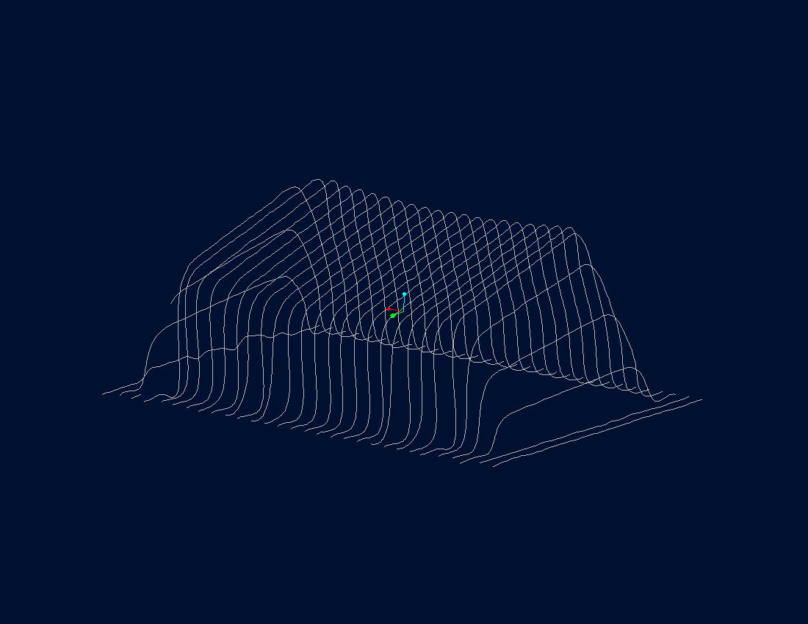

Figure 4 Scan Line Curve Set of a flat scan of a CAPS LOCK key.

The file was rendered to show a surface view and this is shown below in Figure 5:

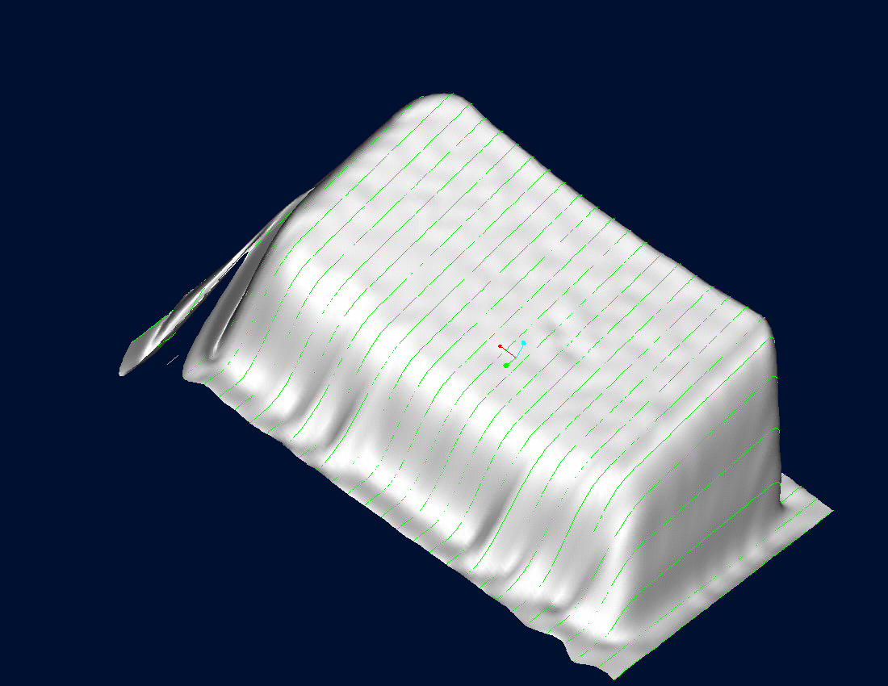
Figure 5. Style curve surface implemented on the CAPS LOCK key.

For the most part, scanning flat objects is relatively simple to do. The key to a successful scan is to know a good scan height of the object and to create an accurate scan window.

7. Future Work With Huxley
7.1 Recommendations
To the best of our knowledge, we are the first group of undergraduates to conduct research on the Laser Design Surveyor 3000 at the University of Maryland. Most of our work this semester is designed to allow future teams to quickly and efficiently learn the basics associated with Huxley and its accompanying software packages. While working on this project this semester, we formulated a series of recommendations for future work associated with the laser digitizer.

One suggestion is obtain a Windows based digitizer program. The current program is MS-DOS based and is severely outdated and not user friendly. All incoming students are going to be much more familiar with Windows than DOS. Students should contact Laser Design, Inc. (http://www.laserdesign.com/) and see if they sell a Windows compatible program for the Laser Design Surveyor 3000. If the program exists, the students should ask the Engineering Department to purchase the program.

The next suggestion is to equip a single computer with all of the programs necessary to complete the scanning process. These programs include the laser digitizer program, DataSculpt, Microsoft Office 2000, an FTP program, and ProEngineer/2000. The computer should be equipped with the fastest processor available and a large amount of memory in order to efficiently deal with larger scan files that have many scan curve lines. A network connection would also be helpful. We often felt frustrated because individual tasks could only be completed on specific computers. Replacing the computer next to Huxley with a brand new, fully equipped computer will be extremely beneficial to all future users. Using Dell Online, we built a computer using up to date and necessary components for the digitizing process for less than $2,000. The printout of the customized computer is given as Appendix F.

We also thought of several projects that future ENME 414 teams can complete for their semester project. One idea is to have other teams apply our instructions to bigger, more complex objects. During the process, they may be able to create their own instructions for various other functions involved with laser digitizer. Future groups can import files into the SLA machine in order to reproduce an object. Teams working on a project like Team 3 is this semester can use Huxley to create a much more accurate solid model of a tooth in order to conduct finite element analyses or other processes. Another idea is for teams to scan objects and then use the G-code generation in Pro/ENGINEER so the object can be reproduced in the CNC machine. Other courses, like ENME 371, may find the laser digitizer to be very useful for creating a solid model of a component of a DeWalt product that can be imported and modified in the Pro/ENGINEER environment. The possibilities for future projects are numerous, and our work this semester should be instrumental in getting all groups started with their future endeavors with the Laser Design Surveyor 3000.

7.2 Specific Project Proposal for the Spring of 2000

Because of the many possibilities for continued research with the 3D laser digitizer, we decided to propose a specific team project for the Spring of 2000 ENME 414 class:

Undergraduate research on the 3D Laser Design Surveyor 3000 began during the Fall 1999 semester. Ground breaking work was completed on simplifying scanning, integration, and editing procedures. However, many problems with the laser digitizer system were encountered, and solutions need to be implemented. The first task is to update the system by purchasing a new computer that can meet the demands of the 3D digitizing process. The new system should be equipped with all required software that is Windows NT compatible. The team should then design a simple assembly made of 2 or 3 components with Pro/E or use an existing assembly if so desired. If components are designed, they should then be manufactured (out of wood, at a machine shop, etc.). The assembly components should then be scanned, edited, imported into Pro/E, and reproduced via CNC or SLA. The goals for this project are to test the accuracy of the scanner, to become familiar with digitizing, and to gain experience with rapid prototyping.
8. References
Chikofsky, E. J., & Cross, J. H. II. (1990). Reverse engineering and design recovery: A
taxonomy. IEEE Software, 7, 13-17.

Kellogg, Leann. BioVisualization Laboratory User Manual. BioVisualization Laboratory, National Zoological Park, 20 Dec. 1996.

Tsou, Y-C. System Design for Object Reconstruction Using Information-Based Manufacturing. Thesis Report. University of Maryland, College Park, 1997.

Wills, L. (1993). Flexible control for program recognition. In Working Conference on
Reverse Engineering (pp. 134-143).

9. Appendices

9.1 APPENDIX A - Using the Laser Digitizer

To Set-Up The Program
- Turn on computer.
- Type ‘user’ for the password.
- Type ‘scan’ at D: prompt.
- Choose ‘Create Scan Window’ (Option 1).

To Home the Laser

- Press CTRL-Y to set X/Y coordinates. (CTRL-R sets rotational coordinates.)
- Press CTRL-U to change units to millimeters.
- Press CTRL-H to begin homing process.
- Type ‘XYZA’, and then press ENTER. This determines which axes will be homed.
- Type ‘M’ to turns on the motors.
- Type ‘X’ then type ‘-457.2’ and press ENTER to move the laser to the proper X coordinate.
- Type ‘Y’ then type ‘-274.6736’ and press ENTER to move the laser to the proper Y coordinate.
- Type ‘L’ to activates the Laser.
- Press TAB then type ‘0’ for up direction, press ENTER, type ‘150’ for down direction, press ENTER.
- Press TAB until L = 4.06146.
- Press F8 and then type ’85.0443’ for the H coordinate.

To Focus the Laser

- Press ‘L’ until the Laser is in VISIBLE mode.
- Type ‘I’, type ‘1’, press ENTER, type ‘1’, press ENTER to set the increments.
- Move the Laser with the arrow keys over to the first corner of the scan window.
- Press ‘L’ until the Laser is in BAD mode.
- Press TAB and move the laser DOWN (as in step 8 of To Home the Laser) until it no longer says BAD and L is equal to some number.
- Press TAB until L = 4.06146.

To Set the Scan Window

- Press F9 to begin the scan window procedure.
- Press CTRL-S at the first corner of the scan window (press ENTER twice.)
- Press ‘L’ until the Laser is in VISIBLE mode.
- At first corner of scan window, press INSERT. Move to the other corners around the object to be scanned in a clockwise or counterclockwise manner and press INSERT at each corner.
- After the fourth corner is made, press CTRL-HOME to return to the first position and then INSERT to close the window.

To Set the Parameters

- Press ‘P’ until P = RASTER ALIGN in the upper right of the computer screen.
- Press ‘T’ until T = PT-to-PT in the upper right underneath of P.
- Press CTRL-D, type ‘90’, press ENTER to set the machine to scan at 90 degrees to the x-axis.
- Press CTRL-Z to set the scan height (mm).
- Press D to set the scan density.
- Press N to name the scan window file.

To Scan the Object

- Press F10 to return to the main menu
- Type ‘2’ to begin the scan.
- Highlight the desired window and parameters to scan (which was named in step 5 of To Set the Parameters) and type ‘D’.
- Type in the file name to be saved and press ENTER.

To Save to a Floppy Disk
- After the object is scanned, press F10 to return to the main menu. Type ‘4’ to quit to the DOS prompt.
- The file of the scanned object will be in d: and will be called (from step 4 of To Scan the Object) filename.scn.
- Insert a good floppy into the b: drive.
- At the d:\ prompt type ‘copy d:\filename.scn b:’.
9.2 APPENDIX B - Using DataSculpt to Close the Scan Curves

Flat Scans

Importing the File into DataSculpt

- Obtain permission to use DataSculpt from an administrator through the team# login.
- Login to a Silicon Graphics machine using the team# login.
- Copy filename.scn (in all lower case letters) to the /team# folder.
- Make sure the files master1.run and 150.run are in the /dsculpt/run folder.
- Type ‘ds’ in a console to load DataSculpt.
- In the DataSculpt window, press the GET button and type ‘filename.scn’.
- Type ‘y’, ENTER, ‘y’, ENTER, ‘y’, ENTER.
- Press CTRL-W to scale the window.
- Press CTRL-R to rotate the object.
- The object can be rotated about only one axis at a time.
- Click the left mouse button to turn on x-axis rotation. Move the mouse left and right to rotate.
- Click the left mouse button again to turn the rotation off.
- The middle mouse button toggles y-axis rotation.
- The right mouse button toggles z-axis rotation.

Closing the Scan Curves

- Click the S-A button.
- Press CTRL-Q to start the latch and poly function.
- The goal is to connect the endpoints of each individual scan curve line. On the endpoint (or preferably off the line right next to the endpoint), click the middle mouse button.
- Click the right mouse button.
- Click the middle mouse button near the opposite endpoint of the same curve line.
- Click the left mouse button.
- Repeat steps 3 through 6 for each scan curve line.
- After all of the individual scan line curves are closed, click S+A to select all of the components.
- Click STORE SCAN
- Enter any desired filename such as filename.scn and make sure all letters are in lowercase. Press ENTER.
- Type ‘y’, ENTER, ‘y’, ENTER.
- Copy filename.scn to the team directory on the network.
9.3 APPENDIX C - Wrapping Rotational Scans

- Login to a Silicon Graphics machine as team#.
- Copy filename.scn into the /team# folder.
- Type ‘run master1’.
- Type ‘filename’ without the .scn extension at the SCANFILE? prompt. DataSculpt converts the rotational coordinates into Cartesian coordinates.
- Edit the file as necessary using the procedures described in the DataSculpt User Manual.
- Click the S+A button after editing.
- Click STORE SCAN.
- Enter any desired filename such as filename.scn and make sure all letters are in lowercase. Press ENTER.
- Type ‘y’, ENTER, ‘y’, ENTER.
- Copy filename.scn to the team directory on the network.
9.4 APPENDIX D - Converting the Scanned Files

- Insert the disk with the .scn file into the a: drive.
- Load CuteFTP.
- Press EXIT on the first menu that appears.
- Press the lightning bolt for Quick Connect.
- In the Host Address Window, type ‘cad.umd.edu’.
- Type the Team 6 User ID and Password.
- In the Host window, open the ‘teamproj’ directory.
- In the Local window, go to the a: drive and highlight the FILENAME.SCN file that you are going to convert.
- Press the Upload button (the button to the right of the lighting bolt).
- Load Telnet.exe.
- Connect to cad.umd.edu
- Use the Team 6 User ID and password.
- Type ‘cd teamproj’.
- Type ‘dspost ibl.opt FILENAME.SCN filename.ibl’.
- Go back to the CuteFTP window.
- Press the Refresh button (which is next to the Stop button).
- Highlight the filename.ibl file in Host window.
- In the Local window, change the directory to c:\proeng19\bin.
- Press the Download button (which is to the right of the upload button).
- Load Pro/ENGINEER 2000.
- Click New, Part, and name the part.
- Feature-Create-Datum-Coord Sys.
- Click on Applications on the top of the Pro/E screen.
- Choose Scantools.
- Scan Crv Set – Create Set – Low Density
- Choose the CSO.
- Go to the folder with filname.ibl, highlight it, and press open.

9.5 APPENDIX E - Using ProE/2000 Scantools To Create A Surface

To Import the File
- Select file->New->Part
- Create a Coordinate System.
- Select Applications->Scantools.
- Select Scan Crv Set->Create->Low Density
- Select the Coordinate System
- Pick the file that you wish to open must be in .ibl format

To Create the Scan Points
- Select Style Crv Set->Create
- Type Name of Style Curve
- Select Automatic->Number of Pnts
- Enter the number of points you wish (usually 50-100) and press ENTER
- Select Pick
- Pick all the curve lines that you wish to use for the surface
- Select Done

To Create Surface
- Select Style Surface->Create->style Crv Surf
- Select First Dir->Add Item->Curve->Pick
- Pick all the curve lines that you wish to use for the surface (the lines must be selected in order).
- Select Done Curves->Ok->Done Return

