Topic: Rivers, Creeks and Ponds Classroom: Blue Jay

Starting Date: August 2, 2010 Week 6 Teachers: Ms. Gonzalez & Ms. Wiest

Discussions and Activities  During Meeting Time | Fieldwork/Research | Representation/Integrated Curriculum
1 – Begin Mural  2 – Pontoon Boat Trip and Nature Center Talk.  3 –What did you learn from the fieldtrip?  How can we make individual pizzas?  4 –What would you like to study in the future? What do we need for our Picnic at LaPlata Beach?  5- Do you remember the Sting Game rules? | A Naturalist will talk to the children in the nature center and on the boat trip so that we can learn about the Anacostia River  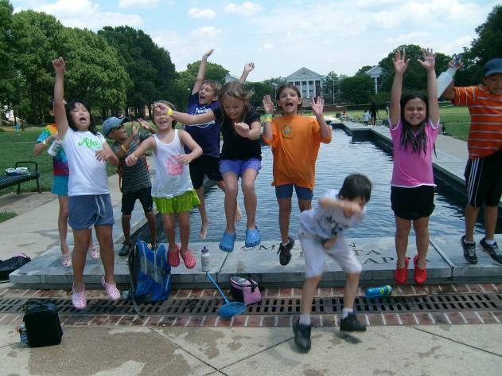  We will play a game to find out more about each other and what we found most interesting this summer. | Children will create a mural depicting what we have learned about rivers, creeks and ponds in a time line fashion.  Children will write what they remembered about the fieldtrip.  We will list other possible study topics of interest to the children for future studies.  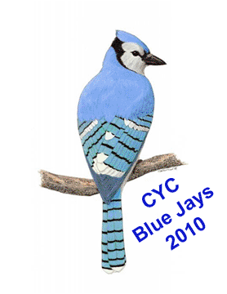

Field Trips: Tuesday we will go to the Bladensburg Water Front Park for a boat trip
Thursday we will have a picnic at LaPlata Beach after swimming.
Language and Literacy: We will be reading Australian Folk Tales from
Monday we will make ice cream sundaes. We will make individual pizzas for snack on Wednesday.
Reminders: Look for updates on our Web Site at: http://www.education.umd.edu/CYC/project/projectindex.html

