Topic: Rivers, Creeks and Ponds Classroom: Blue Jay

Starting Date: July 26, 2010 Week 5 Teachers: Ms. Gonzalez & Ms. Wiest

Discussion Questions  During Meeting Time | Fieldwork/Research | Representation/Integrated Curriculum
1 –Share Reports-Children will share research reports done at home. Mr. Mundy will talk on Astronomy.  2 – Paint Branch Creek trip  3 –What do you want to know about crayfish?  4 – How can we culminate our study?  5- Let’s plan a mural to share our knowledge of Rivers, Creeks and Ponds. | We will travel by bus to revisit the Paint Branch Creek at a more southern location on campus. The PH, depth, velocity and temperature of the Paint Branch Creek will be checked for our chart.  A crayfish expert, Dr. Heberholz, from the University will answer our questions in his lab.  Biologist A. Bely will magnify some of the water from our creek and pond visits to see what kind of microscopic life live in it. | 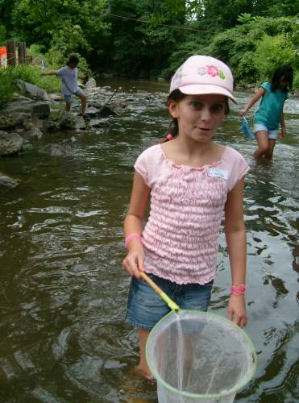  Children will list ways to share their new knowledge.

Field Trips: Tuesday, Paint Branch Pond trip. Wednesday, Crayfish expert
Language and Literacy: We will be reading European folk tales from Shake it Up Tales by M. MacDonald.
We will write Thank you notes to the expert.
Social Studies: Eli’s Dad will share French Pastries.
Thursday we will be tie dying t-shirts to wear on class color day the last week of camp.
Reminders: Wednesday, Thursday and Friday are pool days. Wear your swimsuit to school!
Look for updates on our Web Site at: http://www.education.umd.edu/CYC/project/projectindex.html
Don’t forget your water bottle every day!

