Topic: Rivers, Creeks and Ponds Classroom: Blue Jay

Starting Date: July 19, 2010 Week 4 Teachers: Ms. Gonzalez & Ms. Wiest

Discussion Questions  During Meeting Time | Fieldwork/Research | Representation/Integrated Curriculum
1 –What do we need to build a miniature fishing camp around our pond?  2 – What do we need for our Northwest Branch Stream trip?  3 – Children will continue working on our fishing camp.  4 – What type of rocks did we collect from the Northwest Branch Stream?  5- We will view the movie, Wetlands with Bill Nye. Look for homework to follow. | Fieldwork: Children will visit a stream and collect rocks and other specimens to examine more closely.  Research: Children will look at books and the Internet to determine what kinds of rocks etc. they have found. An expert from the Geology Dept. has been contacted to help.  Research: We will discuss new facts learned from the Bill Nye video.  Research: Children will take a question about our study home to research, bring back and share. | Representation:  Children will collect materials to build a miniature fishing camp around their pond.  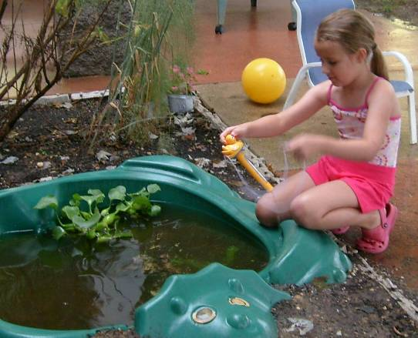  Checking the temperature of our pond.

Field Trips: Tuesday we will ride a bus to Northern Branch Creek near University Hills off 193. Wear water shoes and old clothes.
Friday We will ride a bus to the dairy for ice cream at 12:30.
Language and Literacy: We will be reading African folk tales from Beat the Story Drum, Pum-Pum by Ashley Bryan.
Social Studies: Ms Gonzalez will share stories and artifacts from her trip to Africa
Math: We will cook catfish and corn on the cob Thursday.
Reminders: Wednesday, Thursday and Friday are pool days. Wear your swimsuit to school!
Look for updates on our Web Site at: http://www.education.umd.edu/CYC/project/projectindex.html
Don’t forget your water bottle every day!

