Topic: Rivers, Creeks and Ponds Classroom: Blue Jay

Starting Date: July 12, 2010 Teachers: Ms. Gonzalez & Ms. Wiest

Discussion Questions  During Meeting Time | Fieldwork/Research | Representation/Integrated Curriculum
1 – We will view the movie, Rivers and Ponds with Bill Nye. We will organize our questions  2 – How do you keep score in bowling?  3 – We will read poems about ponds and try to make some of our own.  4 – Children will share the poems they have written.  5- What type of medium would you like to use for your observational drawings? | Children will walk to the Stamp Student Union to go bowling and learn how to keep score.  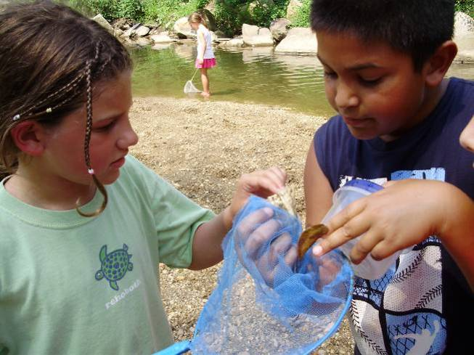  Science  The PH, depth, velocity and temperature of the CRC pond will be checked. | Research  Children will discuss what they learned from the movie.  Writing  Children will write and illustrate their own pond poem and share them at a meeting after reading the book Song of the Water Boatman by Joyce Sidman.  Art  We will walk to the CRC pond with art materials and create art inspired by the pond.

Field Trips: Tuesday we will go bowling at the Stamp Student Union.
Friday we will do observational drawings at the pond behind CRC.
Language and Literacy: We will be reading Asian folk tales from Japanese Children’s Favorite Stories by Florence Sakade
Social Studies: Risa’s Mom will share some Chinese culture activities with us including cooking dumplings!
Reminders: Wednesday, Thursday and Friday are pool days. Wear your swimsuit to school!
Look for updates on our Web Site at: http://www.education.umd.edu/CYC/project/projectindex.html
Don’t forget your water bottle every day!

