Topic: Rivers, Creeks and Ponds Classroom: Blue

Starting Date: July 6, 2010 Teachers: Ms. Gonzalez & Ms. Wiest

Discussion Questions  During Meeting Time | Fieldwork/Research | Representation/Integrated Curriculum
1 –What do you want to know about Rivers, Creeks and Ponds?  2 –Lets compare the CSPAC pond with the Paint Branch Creek.  3 – How can we create a natural habitat for the specimens we are collecting? How long should we keep them for observation?  4 – Children will begin research to answer some of the questions pondered on Tuesday. | We will take a field trip Tuesday to the Paint Branch Creek near the View apartments, to collect specimens, do observational drawings, and explore.  Children will work on improving the pond they started located in the Blue Room garden.  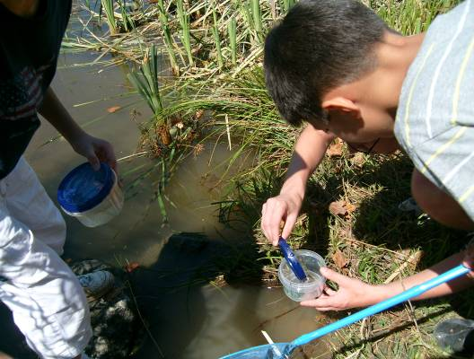 | List- Children will generate a list of questions they would like to research about Rivers, Creeks and Ponds.  Graph- We will create a graph comparing the pond and creek that we have visited.  Discussions- Children will discuss how they can improve on the pond habitat they have been working on outside of the Blue Room.  Research- Children will use books, computers etc. to find the answers to some of their questions.

Field Trips: Tuesday we will go to Paint Branch Creek (See above for more details.) Thursday we will walk to McKeldin Library to make our own selection of children’s books.
Sharing: Bring in CD’s, Books, Pictures, Games, etc. for sharing time to increase the availability of materials for this age group and to give the children a chance to practice public speaking techniques.
Language and Literacy: Folk tales this week will come from the continent of South America, including: The Princess of the Springs, The Boy and the Violin, The Little Sister of the Giants and The Adventures of a Fisherman’s Son.
Science: Children will learn to take the PH balance of water with a water kit, to determine if the aquarium and river are safe for fish.
Math: “Brain Work” each morning there will be a story math problem using adding, subtracting, multiplication and division for children to solve. While making pancakes for snack on Friday, children will discuss and practice doubling recipes.
Technology: During writers/readers workshop, the teacher will work with small groups to add words to the Week 2 page of our web site at: http://www.education.umd.edu/CYC/project/projectindex.html
Reminders: Wednesday, Thursday and Friday are pool days. Wear your swimsuit to school! Bring a towel, too.
Movement will be Thursday this week at 10:10. We will leave for the pool at 10:40 directly after Movement.

Presidents Physical Fitness Challenge- We are encouraging the children to participate in this program. Each child has a log to fill out in their journal. The program lasts six weeks and requires 60 minutes of activity for 5 days out of each week. If you are doing activities at with your children please encourage them to use these as part of our six week experience together. The log can be found at: http://www.presidentschallenge.org/pdf/pala_activity_log.pdf. We can order patches for those that have completed the log.

Splash Into Reading- This is a program put on by the public library. There is a list of activities and everytime a child finishes five of their choice they may go in for a prize. We have the logs at school and campers are given a choice to fill this log out. If you would like to assist your child in this endeavor please visit their web site at: http://www.prge.lib.md.us/Current/MayJun10/SRP-SPPgms.html

