Blue Room Summer Camp

Topic: Energy Teachers: Vera Wiest and Timisa Johnson Date: 7/30/2018
Monday | Tuesday |  | Wednesday | Thursday |  | Friday
Project Meeting  What questions do you have about our field trip tomorrow?  We will begin working on our culmination projects today!  Crazy Hair/Hat Day! | Project Meeting  We will visit the Maryland Science Center!  The bus will leave at 9:45 and return at 2:00. Please bring your own lunch.  Costume Day! |  | Project Meeting  Did we answer all of your questions?  Let’s continue to work on our culmination projects!  Terps and Sports Day! | Project Meeting  We will watch a video about Energy.  Let’s go on a picnic!  Pajama Day! |  | Project Meeting  What would you like to study next?  Class Color Day!
Daily Writing  What is the best silly food combination you can think of? Would you try it? | Daily Writing  What was your favorite part of the field trip? |  | Daily Writing  What makes you really happy and why? | Daily Writing  What do you plan to do for the rest of the summer? |  | Daily Writing  Free Write!
Language Arts: We will continue reading folktales from around the world. On a map, we will identify which countries we have read stories from.  Science: Children will create a display to showcase some of the things they learned during their energy study.  Gross-Motor Skills Game: We will play a Twister grid game! |  | 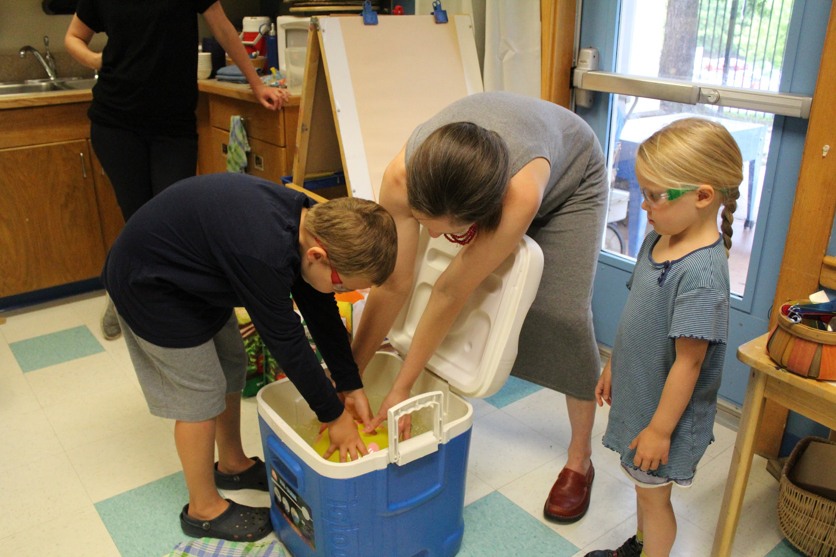  What happens when you put a balloon in cold water? |  |  | Literacy: We will play a sight word egg flip game!  Math: We will measure and double a recipe to make an “Energy Balls” snack.  Art: We will work on creative designs we would like to see painted on the piano. We will also decorate bandanas with fabric markers to keep as a souvenir from camp.
Reminder:
- Bring a water bottle every day!
- There will be a music performance for families at 4:30 on Thursday. Children will also have a display about energy for parents to see before the performance.

