Blue Room Summer Camp

Topic: Energy Teachers: Vera Wiest and Timisa Johnson Date: 7/16/2018
Monday | Tuesday |  | Wednesday | Thursday |  | Friday
Project Meeting  Let’s talk more about chemical energy!  What questions do you have for the chemists on our field trip tomorrow? | Project Meeting  Field trip to the Chemistry Lab! |  | Project Meeting  How do robots get energy? Dr. Bergbrieter, a robot expert will visit and talk to the children about it. | Project Meeting  Today we will have an aerospace engineer teach us more about wind (thermal) energy and airplanes! |  | Project Meeting  A mechanical engineer will be coming in to help us learn about potential and kinetic energy!
Daily Writing  Tell us about an animal that you would like to have as a pet! Why would you like to have that animal as your pet? | Daily Writing  What was your favorite part of our trip to the chemistry lab? |  | Daily Writing  If you could go on vacation anywhere in the world, where would you go? | Daily Writing  Tell us about your favorite sport! What do you like about it? |  | Daily Writing  Give us an example of potential energy and an example of kinetic energy!
Language Arts: We will read Ananse Stories from The Pot of Wisdom by Adwoa Badoe and Baba Wague Diakite  Science: Children will attempt to make a lava lamp.  Gross-Motor Skills Game: Children will have an opportunity to tumble on the mats in the great room. |  | 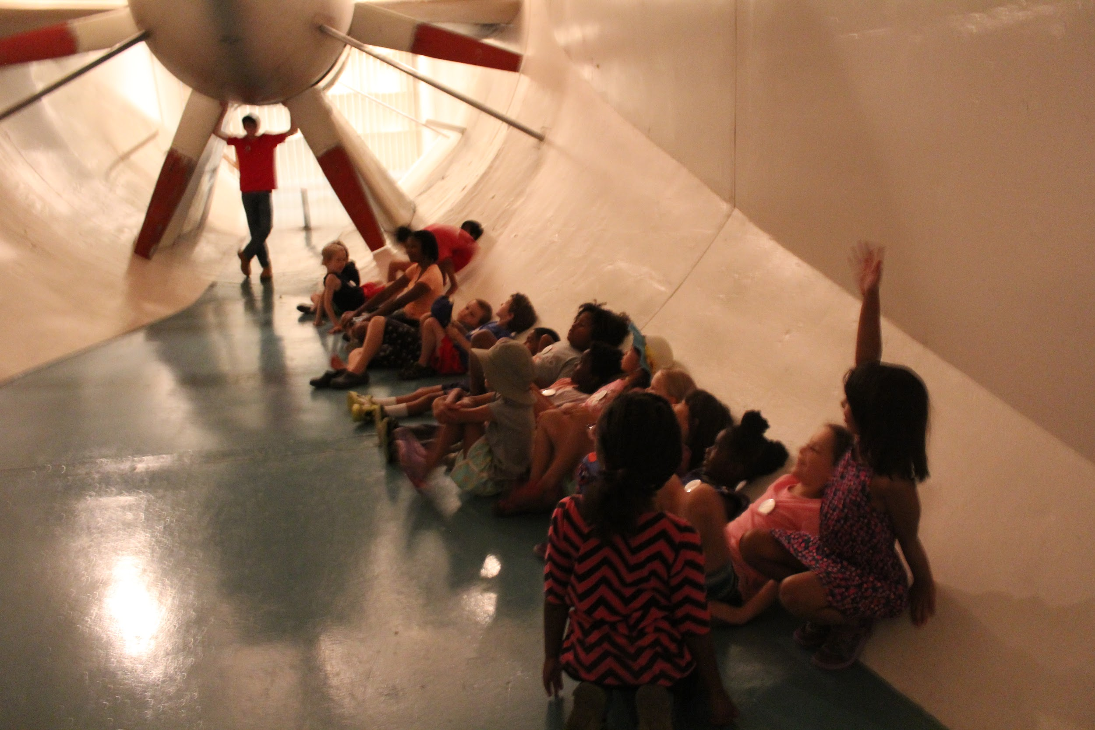 |  |  | Math: We will work on telling time during our day.  Cooking: Children will measure ingredients to make a yogurt cake from a recipe that Eva brought in.  Art: Watercolors will be available.  Music: We will use a decibel meter to measure acoustics!
Reminder:
- There will be a walking field trip this Tuesday, July 17th. We will need two chaperones! A chaperone sign-up sheet is posted on the blue room door.
- We will go to the pool Wednesday, Thursday, and Friday. Parents apply sunscreen in the am. Wear swimsuits to camp.
- Music is on Mondays from 9:30-10:00 a.m. Music with instruments is on Tuesdays from 3:15-3:45 p.m.

