SOCY498C—Introduction to Computing for Sociologists
Neustadtl—Spring 2008

Graphing Data
Stata has a large number of graphic types and options upon options for each graphic. Two good resources are Mitchell’s book A Visual Guide to Stata Graphics (Stata Press 2004) and the following UCLA Web site: www.ats.ucla.edu/stat/Stata/library/GraphExamples/default.htm.
We will examine four types of graphic and some of the complications. Our goal is not to produce publication ready graphics (yet), but to learn about the basic graphic types and related issues. Most but not all Stata graphics are subsumed under the general command graph twoway followed by a specific graphic type (e.g. scatter, histogram, etc.) However, not all graphics are twoway graphics (i.e. graph box).
histogram (help graph twoway histogram)
- histogram produces a frequency histogram and by default makes guesses about how many intervals and how wide the intervals should be.
- You can control the number and width of the intervals or use the discrete option to force one interval for each unique value (useful for variables with a small number of response outcomes).
- You can scale the histogram by density (the default), fractions, percentages, or frequencies)
- kdensity is a popular alternative.
box (help graph box)
- AKA box-and-whisker plot.
- Summarizes five numbers: the smallest and largest observations, Q1, Q2, and Q3.
- Also shows outliers.
bar (help graph bar)
- graph bar draws vertical bar charts.
- The y-axis is numerical, and the x-axis is categorical.
- be default the height of the bars is equal to the mean but many statistics are allowed
  - mean, median, percentiles, standard deviation, standard error of the mean, sum, count, max, min
- Like box the over option can be used
scatter (help graph twoway scatter)
- Cartesian coordinates are used to display values for two variables
- Typically used for two continuous variables.
- Can be difficult to interpret if the variables are not truly continuous (but, plot means or jitter).

histogram
Histograms provide an overview of the distribution of a single variable. They can be used to compare a single measure across subgroups (e.g. men compared to women) and can provide visual confirmation of the normality assumption of the dependent variable in regression analyses. See the help file for kdensity for a popular alternative.
Often the default histogram in Stata is sufficient but Stata makes assumptions about how to collapse your data. The simplest command is hist varname and I use it often. But, graph twoway provides more options. Consider the following examples:
#delimit ;
graph twoway (hist age), title("No Options") name(hist1, replace);

graph twoway (hist age, bin(10)), title("Bin=10")
name(hist2, replace);

graph twoway (hist age, width(5)), title("Width=5")
name(hist3, replace);

graph twoway (hist age, discrete), title("Discrete Option")
name(hist4, replace);

graph twoway (hist age, discrete percent),
title("Discrete/Percent Options") name(hist5, replace);

graph combine hist1 hist2 hist3 hist4 hist5, nocopies;

graph twoway (hist age, by(race) width(10) discrete percent),
title("By Option") name(hist6, replace);

#delimit cr
Note that names have been assigned to every graph. Without this option the default name is graph. Each time a graph command is executed it will write over graph. This is avoided by assigning names to each graph. These graphs also use the title option to describe the difference between these examples. You can control the axis labels and use other annotation on every graphic.
Read the online help (help twoway histogram) to understand the other options.
- Create and interpret a frequency histogram of the sociability scale you created.
- Compare histograms of sociability for white and black respondents (use the by option).

graph box
Box plots are interesting plots that provide information about the distribution of a variable. Typically box plots are used to compare distributions across groups.
Use the following graph box commands to produce four plots:
graph box age, over(marital) name(box1, replace)

graph box age, over(marital) over(sex) name(box2, replace)
graph box age, over(sex) over(marital) name(box3, replace)

graph hbox age, over(marital) over(sex) name(box4, replace)
graph hbox age, over(sex) over(marital) name(box5, replace)
The box represents the middle 50% of the distribution of the variable. The line in the middle of the box is the median—half of the distribution lies below this line and half above the line. The whiskers extend 1.5 times the interquartile range (the distance between the 25th and 75th percentiles—the bottom and top of the box). Any points that exceed the whiskers are plotted as points and considered extreme outliers.
- Create a box plot analogous to box1 (above) with sociability. Interpret the distribution of the sociability variable across martial groups.
- The box plots box2 and box3 are difficult to read so we repeated these plots using hbox. Replicate the plots box4 and box5 using the sociability scale measure. Describe the difference between these plots.
- Interpret the information contained in your last box plot (i.e. sociability over sex over marital).

bar
In Stata, bar graphs are not the same as histograms. Bar graphs typically require a continuous variable—a measure where the arithmetic average is meaningful—and a discrete variable (used as the over variable). For example, a bar graph could be used to graphically show the difference in average age (continuous) over marital status (discrete). Consider the following examples:
graph bar age, over(sex) over(marital) name(bar1, replace)
graph bar age, over(sex) over(marital) asyvars name(bar2, replace)
graph bar (p75) age, over(sex) over(marital) asy name(bar3, replace)
graph hbar (p75) age, over(sex) over(marital) asy name(bar4, replace)
The first two plots show the average of age as the height of the bar over marital status and then over sex. The second plot treats sex as a y-variable. The second two plots use the 75th percentile as the height of the bar. The last plot used hbar to create a horizontal bar graph.
- Create and interpret a horizontal bar graph for the median of the sociability scale over race and over marital status.

scatter
Producing scatterplots can be easy if you have truly continuous data. But, they are more complicated with typical survey data like the GSS. I will run through several examples to show some of the complexity with accompanying Stata code.

Scatterplots in Stata

Old Faithful
The following Stata code and scatterplot show many of the features available in Stata. The data were taken from a standard dataset showing the relationship between the duration of an Old Faithful eruption and the interval to the next eruption.
#delimit ;  graph twoway (lfitci interval duration)  (scatter interval duration)  (lfit interval duration),  legend(off);  graph export faithful.tif,  replace width(800) height(600);  #delimit cr | 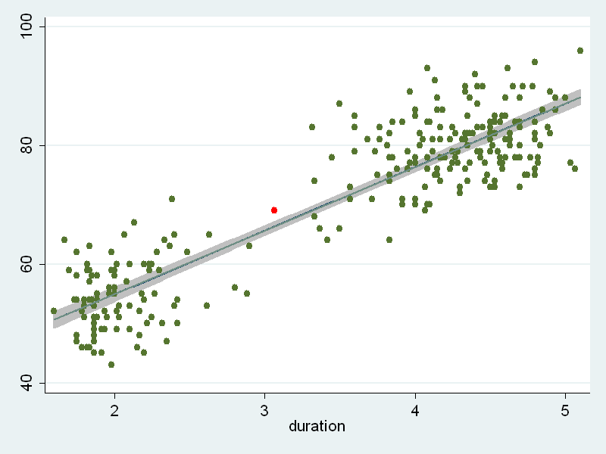
Each point is placed using a coordinate. For example, the red point in this plot was placed at X=3.067 and Y=69. The code above will not produce this “red” point to keep the example simple. The line through the scatterplot corresponds to the linear best fitting line based on a regression analysis of interval regressed on duration. The grey shaded area represents the 95% confidence interval for the predicted values of this regression (i.e. the regression line).
This example shows the power of graph twoway by combining three separate graphs in one. The first graph, lfitci, shows the confidence interval. The second graph, scatter, plots the points in two-dimensional space. The third graph, lfit, plots the best fitting line. The order matters. If the confidence interval was plotted last it would cover both the points under it as well as the line.  As you can imagine, almost every aspect of this graph can be changes—the colors (points, line, confidence interval, background, etc.; the shape and size of the marker symbols; titles; axis marking and labels, and more and more and more! Here is a version using some of those features: | 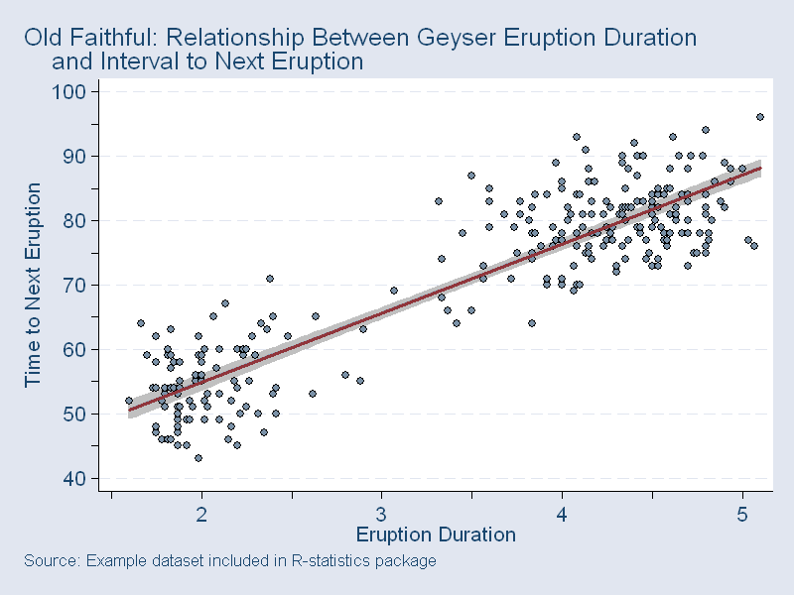

GSS: Sexual Frequency and Age

Typical Scatterplot
Consider the following Stata code and resulting graphic:
#delimit ;
graph twoway (scatter sexfreq age) (lfit sexfreq age),
legend(off)
nodraw
name(sexfrq1, replace);

graph twoway (scatter sexfreq age, jitter(10))
(lfit sexfreq age),
legend(off)
nodraw
name(sexfrq2, replace);

graph combine sexfrq1 sexfrq2, nocopies name(sexfrqcmb, replace);
#delimit cr
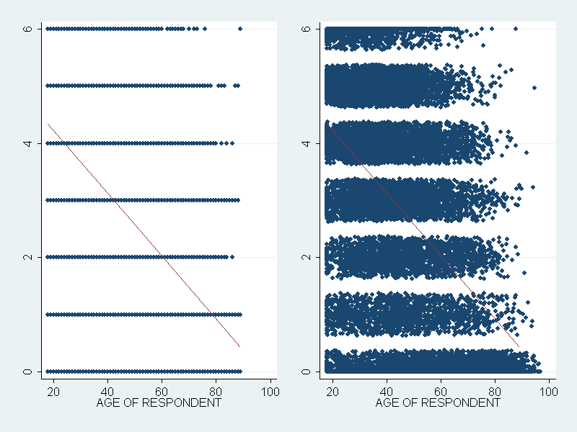
From a Stata perceptive two scatterplots were created and combined into one graphic for easier comparison. Several new options are used. The nodraw option prevents the graph from being displayed. Since the plots will be combined they did not have to be displayed. The nocopies option (in graph combine) is undocumented but speeds up drawing the combined graph. Finally, the plot on the right uses the jitter option.
This example shows one of the difficulties of plotting discrete measures (sexual frequency) that aspire to be continuous variables. The fitted line shows that as age increases there is an associated decrease in average reported sexual frequency. However, without the fitted line could you determine that from the plot on the left? Sometimes symbols are plotted on top of one another so much that the relationship is obscured—the left plot. “Jittering” introduces random perturbations to provide some “spread” to the plotted points. Sometimes this will help clarify the relationship. In this example—on the right—we do learn a little more by jittering.

Plotting Means
There are other ways to clarify this relationship. First let’s create a new variable that converts the GSS measure to a yearly reported sexual frequency measure.

#delimit ;
recode sexfreq (0=0)
(1=1.5)
(2=12)
(3=30)
(4=52)
(5=130)
(6=237), gen(sexfreq1);
#delimit cr
This Stata code converts the GSS categories “NOT AT ALL”, “ONCE OR TWICE”, etc. into numbers that approximately reflect the category. These are estimates and definitely inaccurate but useful with qualification. For example, all respondents who reported have sex “ONCE A MONTH” were assigned the value of 12 in the variable sexfreq1 which is a yearly estimate. Obviously if we plotted this measure by age we would have the same overlap problem shown above. However, plotting the mean reported sexual frequency for each age group (every age) will reduce the clutter of the original scatterplot.
The Stata command tabstat sexfreq1, by(age) format(%6.1f) produces these values some shown below:
Summary for variables: sexfreq1
by categories of: age (AGE OF RESPONDENT)
age mean
18 64.9
19 57.6
20 73.9
. .
. .
. .
87 3.7
88 4.8
89 OR OLDER 3.0
We want to plot age on the X-axis and average reported sexual frequency on the Y-axis without data input or too much trouble. Stata provides a way to do this but you need two new commands—preserve/restore and collapse.
We are going to create a new dataset that contains the values shown by tabstat. Do to this we need to write over (i.e. destroy) the data in memory. But I don’t want to lose these data. The commands preserve and restore deal with the programming problem where the data must be changed to achieve the desired result but, when the program concludes, the damage done to the data is undone. The following example preserve the data, creates a new variable, drops an existing variable and anything else you might want to do. When the program ends the dataset you began with is restored. Anything between preserve and restore is undone at the end of the program. The indentation is just to improve the readability of the program.
preserve
generate age=age^2
drop age
…MORE STATA COMMANDS…
restore
The collapse command converts the dataset in memory into a dataset of means, sums, medians, etc. Putting these two commands together produces the following Stata code and plot:
preserve
collapse sexfreq1, by(age)
graph twoway (scatter sexfreq1 age, msymbol(i) connect(l))
restore
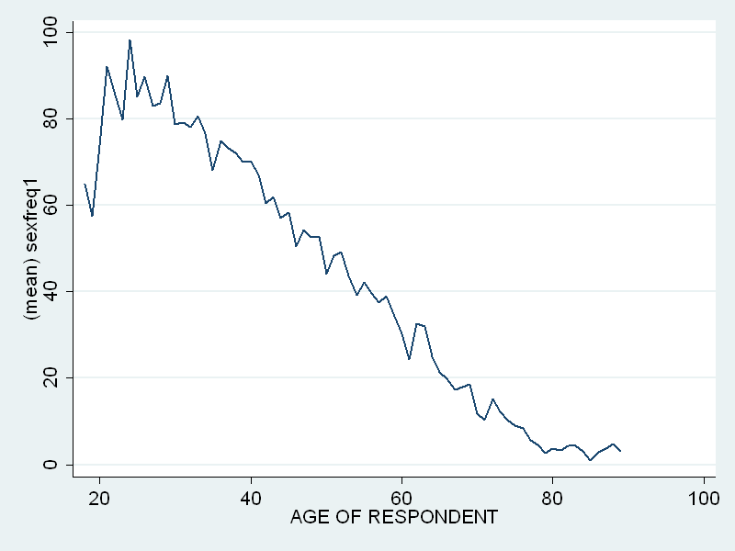
This plot can be cleaned up (titles, labels, ticks, colors, etc.) but clearly shows the decline in average yearly reported sexual frequency as age increases. How is this line plot a scatter plot? Note the options msymbol(i) and connect(l). The first suppresses the display of the marker symbols (“i” means invisible) and the second connects (the invisible) markers with a line.
This command is very flexible. Look at the following Stata code and accompanying graph that shows how to plot parallel trend lines:
preserve
collapse sexfreq1, by(sex age)
#delimit ;
graph twoway (scatter sexfreq1 age if sex==0, msymbol(i) connect(l))
(scatter sexfreq1 age if sex==1, msymbol(i) connect(l));
#delimit cr
restore
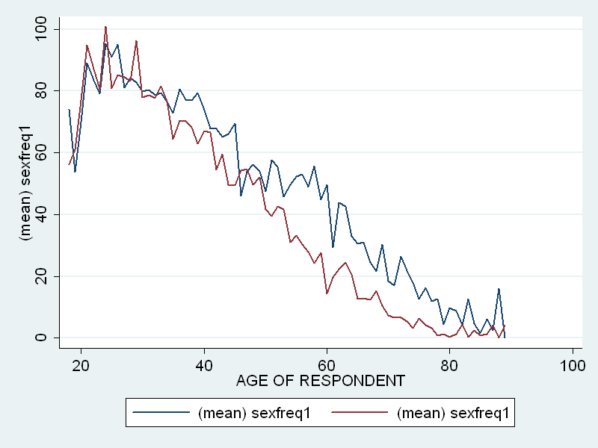
- Create and interpret a scatterplot of the sociability scale over time.
- Replicate this plot but plot two series—one for married respondents and one for respondents who have never been married.

