University of Maryland
College Park MD 20742-3511
TEL: 301 405 1417 FAX 301 405 1678
hassam@umd.edu
www.ireap.umd.edu

Professor Adil Hassam

Department of Physics

University Science Books
111 Prospect Place
South Orange, NJ 07079
Fax:(973) 378-3925

TWIMC

I am an adopting Professor. Using Taylors Classical Mechanics for Fall 2016. Can you send me an Instructors Manual and other pertinent info? Thank you.

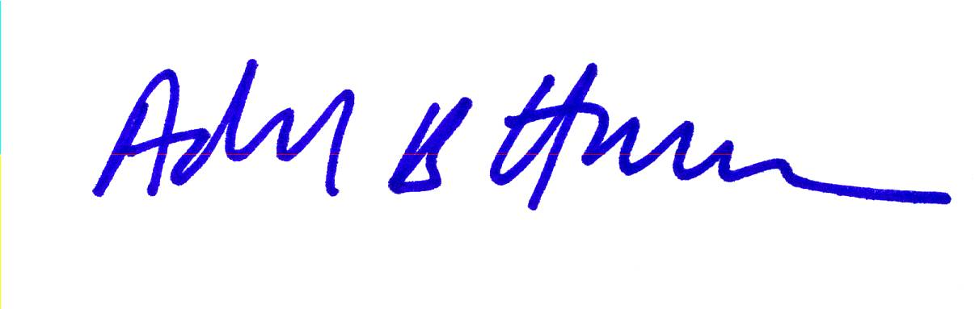

____________________
Adil Hassam
Professor of Physics
UMCP

July 6, 2016

