Quote:

They believed that prediction was just a function of keeping track of things. If you knew enough, you could predict anything. That’s been cherished scientific belief since Newton.

*And?*

Chaos theory throws it right out the window.

*Jurassic Park* – Michael Crichton

GENERAL OVERVIEW OF OEO

The idea of chaos has been out of our reach for a very long time. A butterfly flaps its wings in New Mexico and causes a hurricane in Japan, but could we ever understand why? In recent years, scientists have been able to take chaos and corral it into an easily observable laboratory experiment. An **opto-electronic oscillator** (OEO) is a looped circuit that uses light and electricity to produce chaotic behavior. The device was introduced in 1991 and has since been used to further the fields of encryption and machine learning. Explore the diagram below to understand how the different components of an OEO work together to create chaos in the lab.

Laser – This circuit uses a steady beam of light from a laser to create an optical signal. Lasers are advantageous for several reasons: the intensity and wavelength of the optical signal is easily controlled and optical fiber, the medium in which the optical signal travels, is cheap, long lasting, and immune to several types of interference.

Figure – Laser diode action

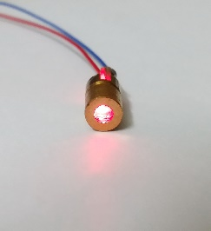

Mach-Zehnder Modulator – The Mach-Zehnder Modulator (MZM) allows scientists to manipulate an incoming optical signal using electricity. Lasers (Component 1) often emit constant intensity light that is easily predictable. We want to study chaos in this system, so we must turn this linear signal into a nonlinear signal using voltage. Voltage is a measure of potential energy between charged particles, similar to how gravity causes a force to exist between the Earth and the Moon. As we vary the voltage we are applying to the MZM, the constant intensity of light changes from a linear signal (figure 1) to a sinusoidal wave signal (figure 2). The MZM also includes a radiofrequency (RF) port that will eventually import the signal that travels through the closed loop of the circuit with a time delay (Component 3). At certain time delay values, the behavior of the system will become extremely sensitive to small changes and initial conditions.

Figure 1 – Input Intensity (Linear)

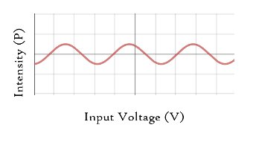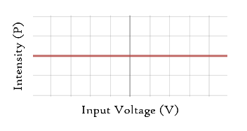Figure 2 – Output Intensity (Nonlinear)

Delay – This is just a really long optical fiber. By adding more fiber, we make the distance and, therefore, the time travelled by the optical signal much greater. Generally, for a 1 millisecond delay, we need about 190 miles of optical fiber. This delay, combined with the nonlinearity created by the Mach-Zehnder Modulator (Component 2), allows chaotic behavior to emerge in the system. If no delay were introduced to the system, the circuit would simply loop the same signal over and over.

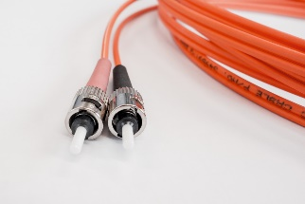Figure - Optical Fiber

Photodiode – A photodiode is a device that converts optical signals into electrical signals. This component of the system is extremely important as the Mach-Zehnder Modulator’s radiofrequency port (Component 2) will only recognize electrical voltage signals. The photodiode focuses the energy of the incoming light beam onto a semiconductor. This energy, which travels in the form of photons, essentially knocks electrons off their atomic orbitals, allowing them to move along a wire causing a controllable electric current. These orbitals get electron refills from the battery connected to the photodiode (figure). The more energetic the photons are that hit the material, the more electric current travels through the wire.

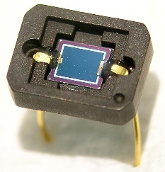Figure – Typical photodiode

Operational Amplifiers – Operational Amplifiers (Op Amps) allow us to convert the current signal coming out of the photodiode (Component 4) into a voltage signal. They also are used to amplify that signal. It is important that we control the magnitude of the voltage coming out of the photodiode because it must be fed into the radiofrequency port (RF) of the Mach-Zehnder Modulator (MZM - Component 2) which only recognizes a certain range of voltage values. Once the op amp amplifies the voltage signal to an acceptable range, the nonlinear signal previously produced by the MZM is fed back into itself through the RF port with a time delay. By varying the parameters of the system, we can induce chaos.

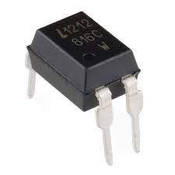Figure – Operational Amplifier