A Model of Traffic Flow

Everyone has had the experience of sitting in a traffic jam, or of seeing cars bunch up on a road for no apparent good reason. MATLAB and SIMULINK are good tools for studying models of such behavior. Our analysis here will be based on so-called "follow-the-leader" theories of traffic flow, about which you can read more in Kinetic Theory of Vehicular Traffic, by Ilya Prigogine and Robert Herman, Elsevier, New York, 1971, or in The Theory of Road Traffic Flow, by Winifred Ashton, Methuen, London, 1966. We will analyze here an extremely simple model that already exhibits quite complicated behavior. We consider a one-lane, one-way, circular road with a number of cars on it (a very primitive model of, say, the Inner Loop of the Capital Beltway around Washington, DC, since in very dense traffic, it is hard to change lanes and each lane behaves like a one-lane road). Each driver slows down or speeds up on the basis of his own speed, the speed of the car ahead of him, and the distance to the car ahead of him. But human drivers have a finite reaction time. In other words, it takes them a certain amount of time (usually about a second) to observe what is going on around them and to press the gas pedal or the brake, as appropriate. The standard "follow-the-leader" theory supposes that
${\overset{¨}{u}}_{n}(t+T)=λ\left({\overset{˙}{u}}_{n−1}(t)−{\overset{˙}{u}}_{n}(t)\right)$, (∗)
where t is time, T is the reaction time, u_{n} is the position of the nth car, and the "sensitivity coefficient" λ may depend on $u_{n−1}(t)−u_{n}(t)$, the spacing between cars, and/or ${\overset{˙}{u}}_{n}(t)$, the speed of the nth car. The idea behind this equation is this. A driver will tend to decelerate if he is going faster than the car in front of him, or if he is close to the car in front of him, and will tend to accelerate if he is going slower than the car in front of him. In addition, a driver (especially in light traffic) may tend to speed up or slow down depending on whether he is going slower or faster (respectively) than a "reasonable" speed for the road (often, but not always, equal to the posted speed limit). Since our road is circular, in this equation u₀ is interpreted as u_{N}, where N is the total number of cars.
The simplest version of the model is the one where the "sensitivity coefficient" λ is a (positive) constant. Then we have a homogeneous linear differential/difference equation with constant coefficients for the velocities ${\overset{˙}{u}}_{n}(t)$. Obviously there is a "steady state" solution when all the velocities are equal and constant (i.e., traffic is flowing at a uniform speed), but what we are interested in is the stability of the flow, or the question of what effect is produced by small differences in the velocities of the cars. The solution of (∗) will be a superposition of exponential solutions of the form ${\overset{˙}{u}}_{n}(t)$ = exp(α t) v_{n}, where the v's and α are (complex) constants, and the system will be unstable if the velocities are unbounded, i.e., there are any solutions where the real part of α is positive. Using vector notation, we have
$\overset{˙}{u}(t)$= exp(α t) v, $\overset{¨}{u}(t+T)$ = α exp(α T) exp(α t) v.
Substituting back in (∗), we get the equation
α exp(α T) exp(α t) v = λ ( S − I ) exp(α t) v,
where
S = $\left(\begin{matrix}\begin{matrix}0 & \text{.} & \text{.} & \text{.} & 0\end{matrix} & 1 \\ \begin{matrix}1 & 0 & \text{.} & \text{.} & \text{.} \\ 0 & 1 & \text{.} & \text{.} & \text{.} \\ \text{.} & \text{.} & \text{.} & \text{.} & \text{.} \\ \text{.} & \text{.} & \text{.} & 1 & 0 \\ \text{.} & \text{.} & \text{.} & 0 & 1\end{matrix} & \begin{matrix}0 \\ \text{.} \\ \text{.} \\ \text{.} \\ 0\end{matrix}\end{matrix}\right)$
is the "shift" matrix that, when it multiplies a vector on the left, cyclically permutes the entries of the vector. We can cancel the exp(α t) on each side to get
α exp(α T) v = λ ( S − I ) v, or ( S − (1 + ((α / λ) exp(α T) )I ) v = 0, (∗∗)
which says that v is an eigenvector for S with eigenvalue$1+ \frac{α}{λ} e^{αT}$. Since the eigenvalues of S are the Nth roots of unity, which are evenly spaced around the unit circle in the complex plane, and closely spaced together for large N, there is potential instability whenever $1+ \frac{α}{λ} e^{αT}$has absolute value 1 for some α with positive real part; that is, whenever $\frac{α T}{λ T} e^{αT}$ can be of the form e^{iθ} − 1 for some α T with positive real part. Whether instability occurs or not depends on the value of the product λ T. We can see this by plotting values of z exp(z) for z = α T = i y a complex number on the critical line Re z = 0, and comparing with plots of λ T ( e^{iθ} − 1 ) for various values of the parameter
λ T.

syms y; expand(i*y*(cos(y) + i*sin(y)))

ans =
i*y*cos(y)-y*sin(y)

ezplot(-y*sin(y), y*cos(y), [-2*pi, 2*pi]); hold on
theta = 0:0.05*pi:2*pi;
plot((1/2)*(cos(theta) - 1), (1/2)*sin(theta), '-');
plot(cos(theta) - 1, sin(theta), ':')
plot(2*(cos(theta) - 1), 2*sin(theta), '--');
title('iye^{iy} and circles \lambda T(e^{i\theta}-1)'); hold off

Here the small solid circle corresponds to λT = ½, and we are just at the limit of stability, since this circle does not cross the spiral produced by z exp(z) for z a complex number on the critical line Re z = 0, though it "hugs" the spiral closely. The dotted and dashed circles, corresponding to λT = 1 or 2, do cross the spiral, so they correspond to unstable traffic flow.
We can check these theoretical predictions with a simulation using SIMULINK. We'll give a picture of the SIMULINK model and then explain it.
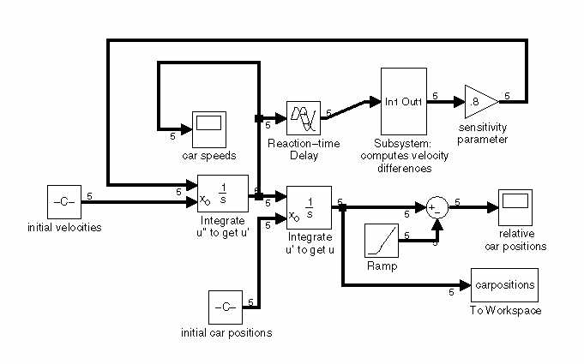
Here the Subsystem, which corresponds to multiplication by S − I, looks like this:
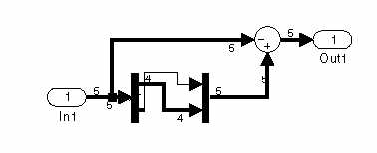
Here are some words of explanation. First of all, we are showing the model using the options Wide nonscalar lines and Signal dimensions in the Format menu of the SIMULINK model, in order to show which quantities are vectors and which are scalars. The dimension 5 on most of the lines is the value of N, the number of cars. Most of the model is like the example in Chapter 8, except that our unknown function (called u), representing the car positions, is vector-valued and not scalar-valued. The major exceptions are these:
- We need to incorporate the reaction-time delay, so we've inserted a Transport Delay block from the Continuous block library.
- The parameter λ shows up as the value of the gain in the "sensitivity parameter" Gain block in the upper right.
- Plotting car positions by themselves is not terribly useful, since only the relative positions matter. So before outputting the car positions to the Scope block labeled "relative car positions," we've subtracted off a constant linear function (corresponding to uniform motion at the average car speed) created by the Ramp block from the Sources block library.
- We've made use of the option in the Integrator blocks to input the initial conditions, instead of having them built into the block. This makes the logical structure a little clearer.
- We've used the subsystem feature of SIMULINK. If you enclose a bunch of blocks with the mouse and then click on "Create subsystem" in the model's Edit menu, SIMULINK will package them as a subsystem. This is helpful if your model is large or if there is some combination of blocks that you expect to use more than once. Our subsystem sends a vector v to ( S − I ) v = S v − v. A Sum block (with one of the signs changed to a −) is used for vector subtraction. To model the action of S, we’ve used the Demux and Mux blocks from the Signals and Systems block library. The Demux block, with "number of outputs" parameter set to [4, 1], splits a 5-dimensional vector into a pair consisting of a 4-dimensional vector and a scalar (corresponding to the last car). Then we reverse the order of these and put them back together with the Mux block, with "number of inputs" parameter set to [1, 4].
Once the model is assembled, it can be run with various inputs. The following pictures show the two scope windows with a set of conditions corresponding to stable flow (though, to be honest, we've let two cars cross through each other briefly!):

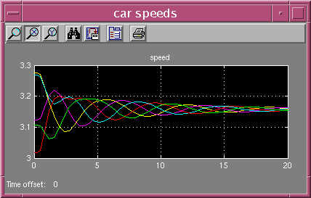

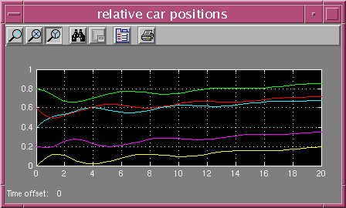

As you can see, the speeds fluctuate but eventually converge to a single value, and the separations between cars eventually stabilize.
On the other hand, if λ is increased by changing the "sensitivity parameter" in the Gain block in the upper right, say from 0.8 to 2.0, one gets this sort of output, typical of instability:

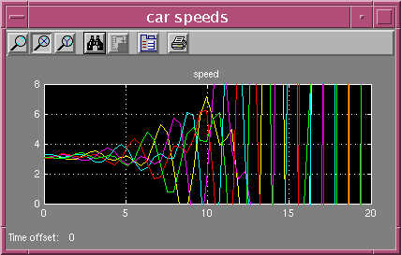

We encourage you to go back and tinker with the model (for instance using a sensitivity parameter that is also inversely proportional to the spacing between cars) and study the results. We should mention that the To Workspace block in the lower right has been put in to make it possible to create a movie of the moving cars. This block sends the car positions to a variable called carpositions. This variable is what is called a structure array. To make use of it, you can create a movie with the following script M-file:

theta = 0:0.025*pi:2*pi;
for j = 1:length(tout)
plot(cos(carpositions.signals.values(j, :)*2*pi), ...
sin(carpositions.signals.values(j, :)*2*pi), 'o');
axis([-1, 1, -1, 1]);
hold on; plot(cos(theta), sin(theta), 'r'); hold off;
axis equal;
M(j) = getframe;
end

The idea here is that we have taken the circular road to have radius 1 (in suitable units), so that the command plot(cos(theta),sin(theta),'r') draws a red circle (representing the road) in each frame of the movie, and on top of that the cars are shown with moving little circles. The vector tout is a list of all the values of t at which the model computes the values of the vector u(t), and at the jth time, the car positions are stored in the jth row of the matrix carpositions.signals.values. Try the program!
We should mention here one fine point needed to create a realistic movie. Namely, we need the values of tout to be equally spaced — otherwise the cars will appear to be moving faster when the time steps are large, and will appear to be moving slower when the time steps are small. In its default mode of operation, SIMULINK uses a variable-step differential equation solver based on MATLAB's command ode45, so the entries of tout will not be equally spaced. To fix this, open the Simulation Parameters dialog box using the Edit menu in the model window, choose the Solvers tab, and change the Output options box to read: Produce specified output only, chosen to be something like [0:0.5:20]. Then the model will output the car positions only at multiples of t = 0.5, and the MATLAB program above will produce a 41-frame movie.

