Numerical Solution of the Heat Equation

In this section we will use MATLAB to numerically solve the heat equation (also known as the diffusion equation), a partial differential equation that describes many physical processes including conductive heat flow or the diffusion of an impurity in a motionless fluid. You can picture the process of diffusion as a drop of dye spreading in a glass of water. (To a certain extent you could also picture cream in a cup of coffee, but in that case the mixing is generally complicated by the fluid motion caused by pouring the cream into the coffee, and is further accelerated by stirring the coffee.) The dye consists of a large number of individual particles, each of which repeatedly bounces off of the surrounding water molecules, following an essentially random path. There are so many dye particles that their individual random motions form an essentially deterministic overall pattern as the dye spreads evenly in all directions (we ignore here the possible effect of gravity). In a similar way, you can imagine heat energy spreading through random interactions of nearby particles.

In a three-dimensional medium, the heat equation is
$\frac{¶u}{¶t}=k\left(\frac{¶^{2}u}{¶x}+\frac{¶^{2}u}{¶y}+\frac{¶^{2}u}{¶z}\right)$.
Here u is a function of t, x, y, and z that represents the temperature, or concentration of impurity in the case of diffusion, at time t at position (x, y, z) in the medium. The constant k depends on the materials involved, and is called the thermal conductivity in the case of heat flow, and the diffusion coefficient in the case of diffusion. To simplify matters, let us assume that the medium is instead one-dimensional. This could represent diffusion in a thin water-filled tube or heat flow in a thin insulated wire; let us think primarily of the case of heat flow. Then the partial differential equation becomes
$$\frac{¶u}{¶t}=k\frac{¶^{2}u}{¶x}$$
where u(x, t) is the temperature at time t a distance x along the wire.

A Finite-Difference Solution

To solve this partial differential equation we need both initial conditions of the form u(x, 0) = f(x), where f(x) gives the temperature distribution in the wire at time 0, and boundary conditions at the endpoints of the wire, call them x = a and x = b. We choose so-called Dirichlet boundary conditions u(a, t) = $T_{a}$ and u(b, t) = $T_{b}$, which correspond to the temperature being held steady at values $T_{a}$ and $T_{b}$ at the two endpoints. Though an exact solution is available in this scenario, let us instead illustrate the numerical method of finite differences.

To begin with, on the computer we can only keep track of the temperature u at a discrete set of times and a discrete set of positions x. Let the times be 0, Δt, 2Δt, …, ΝΔt, and let the positions be a, a + Δx, …, a + JΔx = b, and let $u_{j}^{n}$ = u(a + jΔt, nΔt). Rewriting the partial differential equation in terms of finite difference approximations to the derivatives, we get
$\frac{u_{j}^{n+1}−u_{j}^{n}}{Dt}=k\frac{u_{j+1}^{n}−2u_{j}^{n}+u_{j−1}^{n}}{Dx}$.
(These are the simplest approximations we can use for the derivatives, and this method can be refined by using more accurate approximations, especially for the t derivative.) Thus if for a particular n, we know the values of $u_{j}^{n}$ for all j, we can solve the equation above to find $u_{j}^{n+1}$ for each j:

$$u_{j}^{n+1}=u_{j}^{n}+\frac{kDt}{Dx}\left(u_{j+1}^{n}−2u_{j}^{n}+u_{j−1}^{n}\right)=s\left(u_{j+1}^{n}+u_{j−1}^{n}\right)+\left(1−2s\right)u_{j}^{n}$$

where s = kΔt/(Δx)². In other words, this equation tells us how to find the temperature distribution at time step n+1 given the temperature distribution at time step n. (At the endpoints j = 0 and j = J, this equation refers to temperatures outside the prescribed range for x, but at these points we will ignore the equation above and apply the boundary conditions instead.) We can interpret this equation as saying that the temperature at a given location at the next time step is a weighted average of its temperature and the temperatures of its neighbors at the current time step. In other words, in time Δt, a given section of the wire of length Δx transfers to each of its neighbors a portion s of its heat energy and keeps the remaining portion 1−2s of its heat energy. Thus our numerical implementation of the heat equation is a discretized version of the microscopic description of diffusion we gave initially, that heat energy spreads due to random interactions between nearby particles.

The following M-file, which we have named heat.m, iterates the procedure described above.

function u = heat(k, x, t, init, bdry)
% solve the 1D heat equation on the rectangle described by
% vectors x and t with u(x, t(1)) = init and Dirichlet boundary
% conditions u(x(1), t) = bdry(1), u(x(end), t) = bdry(2).

J = length(x);
N = length(t);
dx = mean(diff(x));
dt = mean(diff(t));
s = k*dt/dx^2;

u = zeros(N,J);
u(1, :) = init;

for n = 1:N-1
u(n+1, 2:J-1) = s*(u(n, 3:J) + u(n, 1:J-2)) + (1 - 2*s)*u(n, 2:J-1);
u(n+1, 1) = bdry(1);
u(n+1, J) = bdry(2);
end

The function heat takes as inputs the value of k, vectors of t and x values, a vector init of initial values (which is assumed to have the same length as x), and a vector bdry containing a pair of boundary values. Its output is a matrix of u values. Notice that since indices of arrays in MATLAB must start at 1, not 0, we have deviated slightly from our earlier notation by letting n=1 represent the initial time and j=1 represent the left endpoint. Notice also that in the first line following the for statement, we compute an entire row of u, except for the first and last values, in one line; each term is a vector of length J-2, with the index j increased by 1 in the term u(n,3:J) and decreased by 1 in the term u(n,1:J-2).

Let's use the M-file above to solve the one-dimensional heat equation with k = 2 on the interval -5 ≤ x ≤ 5 from time 0 to time 4, using boundary temperatures 15 and 25, and initial temperature distribution of 15 for x < 0 and 25 for x > 0. You can imagine that two separate wires of length 5 with different temperatures are joined at time 0 at position x = 0, and each of their far ends remains in an environment that holds it at its initial temperature. We must choose values for Δt and Δx; let's try Δt = 0.1 and Δx = 0.5, so that there are 41 values of t ranging from 0 to 4 and 21 values of x ranging from -5 to 5.

tvals = linspace(0, 4, 41);
xvals = linspace(-5, 5, 21);
init = 20 + 5*sign(xvals);
uvals = heat(2, tvals, xvals, init, [15 25]);
surf(xvals, tvals, uvals)
xlabel x; ylabel t; zlabel u

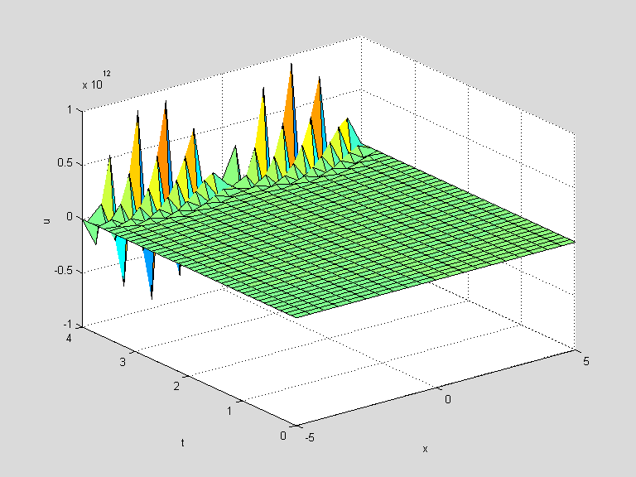

Here we used surf to show the entire solution u(x, t). The output is clearly unrealistic; notice the scale on the u axis! The numerical solution of partial differential equations is fraught with dangers, and instability like that seen above is a common problem with finite difference schemes. For many partial differential equations a finite difference scheme will not work at all, but for the heat equation and similar equations it will work well with proper choice of Δt and Δx. One might be inclined to think that since our choice of Δx was larger, it should be reduced, but in fact this would only make matters worse. Ultimately the only parameter in the iteration we're using is the constant s, and one drawback of doing all the computations in an M-file as we did above is that we do not automatically see the intermediate quantities it computes. In this case we can easily calculate that s = 2(0.1)/(0.5)² = 0.8. Notice that this implies that the coefficient 1−2s of $u_{j}^{n}$ in the iteration above is negative. Thus the "weighted average" we described before in our interpretation of the iterative step is not a true average; each section of wire is transferring more energy than it has at each time step!

The solution to the problem above is thus to reduce the time step Δt; for instance, if we cut it in half, then s = 0.4, and all coefficients in the iteration are positive.

tvals = linspace(0, 4, 81);
uvals = heat(2, tvals, xvals, init, [15 25]);
surf(xvals, tvals, uvals)
xlabel x; ylabel t; zlabel u

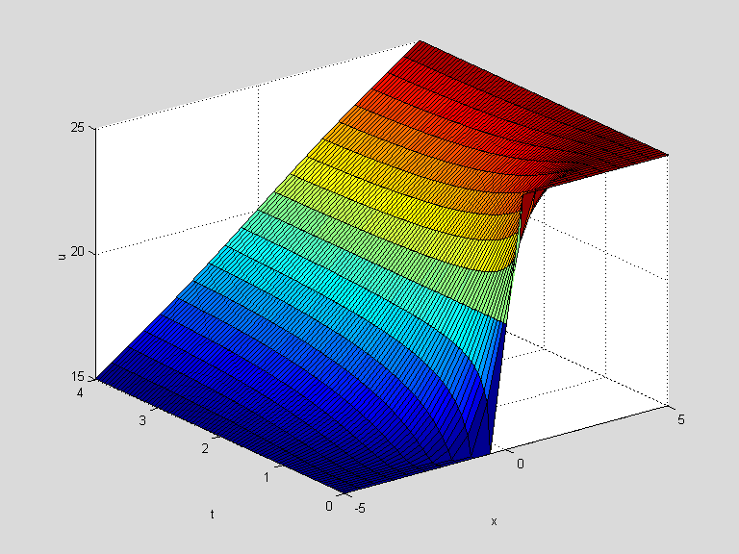

This looks much better! As time increases, the temperature distribution seems to approach a linear function of x. Indeed u(x, t) = 20 + x is the limiting "steady state" for this problem; it satisfies the boundary conditions and it yields 0 on both sides of the partial differential equation.

Generally speaking, it is best to understand some of the theory of partial differential equations before attempting a numerical solution like we have done here. However for this particular case at least, the simple rule of thumb of keeping the coefficients of the iteration positive yields realistic results. A theoretical examination of the stability of this finite difference scheme for the one-dimensional heat equation shows that indeed any value of s between 0 and 0.5 will work, and suggests that the best value of Δt to use for a given Δx is the one that makes s = 0.25. Notice that while we can get more accurate results in this case by reducing Δx, if we reduce it by a factor of 10 we must reduce Δt by a factor of 100 to compensate, making the computation take 1000 times as long and use 1000 times the memory!

The Case of Variable Conductivity

Earlier we mentioned that the problem we solved numerically could also be solved analytically. The value of the numerical method is that it can be applied to similar partial differential equations for which an exact solution is not possible or at least not known. For example, consider the one-dimensional heat equation with a variable coefficient, representing an inhomogeneous material with varying thermal conductivity k(x),
$\frac{¶u}{¶t}=\frac{¶}{¶x}\left(k(x)\frac{¶u}{¶x}\right)=k(x)\frac{¶^{2}u}{¶x^{2}}+k^{'}(x)\frac{¶u}{¶x}$.
For the first derivatives on the right-hand side, we use a symmetric finite difference approximation, so that our discrete approximation to the partial differential equations becomes

$\frac{u_{j}^{n+1}−u_{j}^{n}}{Dt}=k_{j}\frac{u_{j+1}^{n}−2u_{j}^{n}+u_{j−1}^{n}}{Dx}+\frac{k_{j+1}−k_{j−1}}{2Dx}\frac{u_{j+1}^{n}−u_{j−1}^{n}}{2Dx}$,

where $k_{j}$ = k(a + jΔx). Then the time iteration for this method is

$u_{j}^{n+1}=s_{j}\left(u_{j+1}^{n}+u_{j−1}^{n}\right)+\left(1−2s_{j}\right)u_{j}^{n}+0\text{.}\text{25}\left(s_{j+1}−s_{j−1}\right)\left(u_{j+1}^{n}−u_{j−1}^{n}\right)$,

where $s_{j}$ = $k_{j}$Δt/(Δx)². In the following M-file, which we called heatvc.m, we modify our previous M-file to incorporate this iteration.

function u = heatvc(k, x, t, init, bdry)
% solve the 1D heat equation with variable coefficient k on the rectangle
% described by vectors x and t with u(x, t(1)) = init and Dirichlet boundary
% conditions u(x(1), t) = bdry(1), u(x(end), t) = bdry(2).

J = length(x);
N = length(t);
dx = mean(diff(x));
dt = mean(diff(t));
s = k*dt/dx^2;

u = zeros(N,J);
u(1,:) = init;

for n = 1:N-1
u(n+1, 2:J-1) = s(2:J-1).*(u(n, 3:J) + u(n, 1:J-2)) + ...
(1 - 2*s(2:J-1)).*u(n,2:J-1) + ...
0.25*(s(3:J) - s(1:J-2)).*(u(n, 3:J) - u(n, 1:J-2));
u(n+1, 1) = bdry(1);
u(n+1, J) = bdry(2);
end

Notice that k is now assumed to be a vector with the same length as x, and that as a result so is s. This in turn requires that we use vectorized multiplication in the main iteration, which we have now split into three lines.

Let's use this M-file to solve the one-dimensional variable coefficient heat equation with the same boundary and initial conditions as before, using k(x) = 1 + $(x/5)^{2}$. Since the maximum value of k is 2, we can use the same values of Δt and Δx as before.

kvals = 1 + (xvals/5).^2;
uvals = heatvc(kvals, tvals, xvals, init, [15 25]);
surf(xvals, tvals, uvals)
xlabel x; ylabel t; zlabel u

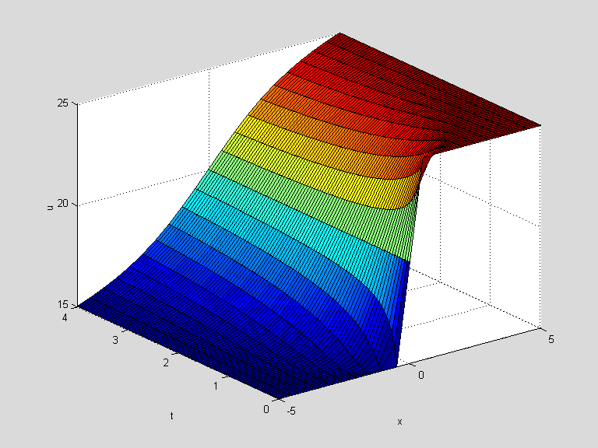

In this case the limiting temperature distribution is not linear; it has a steeper temperature gradient in the middle, where the thermal conductivity is lower. Again one could find the exact form of this limiting distribution, u(x, t) = 20(1 + (1/π)arctan(x/5)), by setting the t derivative to zero in the original equation and solving the resulting ordinary differential equation.

You can use the method of finite differences to solve the heat equation in two or three space dimensions as well. For this and other partial differential equations with time and two space dimensions, you can also use the PDE Toolbox, which implements the more sophisticated finite element method.

A SIMULINK Solution

We can also solve the heat equation using SIMULINK. To do this we continue to approximate the x-derivatives with finite differences, but think of the equation as a vector-valued ordinary differential equation, with t as the independent variable. SIMULINK solves the model using MATLAB's ODE solver, ode45. To illustrate how to do this, let's take the same example we started with, the case where k = 2 on the interval 5 ≤ x ≤ 5 from time 0 to time 4, using boundary temperatures 15 and 25, and initial temperature distribution of 15 for x < 0 and 25 for x > 0. We replace u(x,t) for fixed t by the vector u of values of u(x,t), with, say, x = -5:5. Here there are 11 values of x at which we are sampling u, but since u(x,t) is pre-determined at the endpoints, we can take u to be a 9-dimensional vector, and we just tack on the values at the endpoints when we're done. Since we're replacing $\frac{∂^{2}u}{∂x}$by its finite difference approximation and we've taken Δx = 1 for simplicity, our equation becomes the vector-valued ODE
$\frac{∂ u}{∂ t} = k(Au + c)$.
Here the right-hand side represents our approximation to k$\frac{∂^{2}u}{∂x}$ . The matrix A is:
$A = \left(\begin{matrix}−2 & \begin{matrix}1 & ⋯ & 0\end{matrix} \\ \begin{matrix}1 \\ ⋮ \\ 0\end{matrix} & \begin{matrix}−2 & ⋱ & ⋮ \\ ⋱ & ⋱ & 1 \\ ⋯ & 1 & −2\end{matrix}\end{matrix}\right)$, since we are replacing $\frac{∂^{2}u}{∂x}$ at (n, t) with u(n−1,t) − 2u(n,t) + u(n+1, t). We represent this matrix in MATLAB's notation by:
-2*eye(9) + [zeros(8,1),eye(8);zeros(1,9)] + [zeros(8,1),eye(8);zeros(1,9)]'
The vector c comes from the boundary conditions, and has 15 in its first entry, 25 in its last entry, and 0's in between. We represent it in MATLAB's notation as [15;zeros(7,1);25]. The formula for c comes from the fact that u(1) represents u(−4,t), and $\frac{∂^{2}u}{∂x}$at this point is approximated by
u(−5,t) − 2u(−4,t) + u(−3, t) = −15 −2 u(1) + u(2),
and similarly at the other endpoint. Here's a SIMULINK model representing this equation:

Note that one needs to specify the initial conditions for u as Block Parameters for the Integrator block, and that in the Block Parameters dialog box for the Gain block, one needs to set the multiplication type to "Matrix". Since u(1) through u(4) represent u(x, t) at x = −4 through −1, and u(6) through u(9) represent u(x, t) at x = 1 through 4, we take the initial value of u to be [15*ones(4,1);20;25*ones(4,1)]. (20 is a compromise at x = 0, since this is right in the middle of the regions where u is 15 and 25.) The output from the model is displayed in the Scope block in the form of graphs of the various entries of u as function of t, but it's more useful to save the output to the MATLAB Workspace and then plot it with surf. To do this, go to the menu item Simulation Parameters… in the Simulation menu of the model. Under the Solver tab, set the stop time to 4.0 (since we are only going out to t = 4), and under the Workspace I/O tab, check the box to "save states to Workspace", like this:
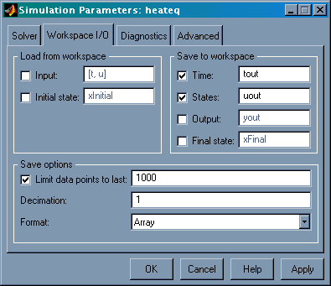

After you run the model, you will find in your Workspace a 53×1 vector tout, plus a 53×9 matrix uout. Each row of these arrays corresponds to a single time step, and each column of uout corresponds to one value of x. But remember that we have to add in the values of u at the endpoints as additional columns in u. So we plot the data as follows:

u = [15*ones(length(tout),1), uout, 25*ones(length(tout),1)];
x = -5:5;
surf(x, tout, u)
xlabel('x'), ylabel('t'), zlabel('u')
title('solution to heat equation in a rod')

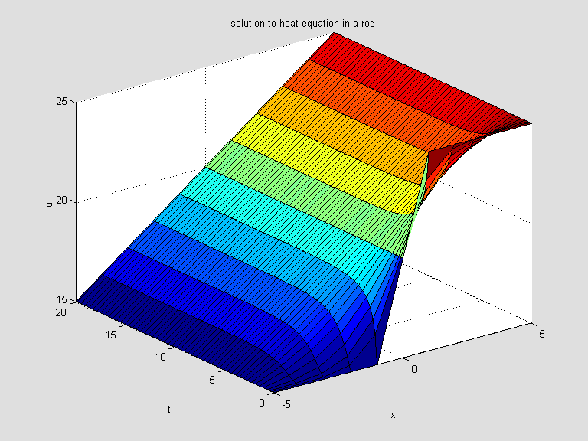

Note how similar this is to the picture obtained before. We leave it to the reader to modify the model for the case of variable heat conductivity.

Solution with pdepe
A new feature of MATLAB 6.0 is a built-in solver for partial differential equations in one space dimension (as well as time t). To find out more about it, read the online help on pdepe. The instructions for use of pdepe are quite explicit but somewhat complicated. The method it uses is somewhat similar to that used in the SIMULINK solution above; i.e., it uses an ODE solver in t and finite differences in x. The following M-file solves the second problem above, the one with variable conductivity:

function heateqex2
%Solves a sample Dirichlet problem for the heat equation in a rod,
%this time with variable conductivity, 21 mesh points
m = 0; %This simply means geometry is linear.
x = linspace(-5,5,21);
t = linspace(0,4,81);
sol = pdepe(m,@pdex,@pdexic,@pdexbc,x,t);
% Extract the first solution component as u.
u = sol(:,:,1);
% A surface plot is often a good way to study a solution.
surf(x,t,u)
title('Numerical solution computed with 21 mesh points in x.')
xlabel('x'), ylabel('t'), zlabel('u')
% A solution profile can also be illuminating.
figure
plot(x,u(end,:))
title('Solution at t = 4')
xlabel('x'), ylabel('u(x,4)')
% --------------------------------------------------------------
function [c,f,s] = pdex(x,t,u,DuDx)
c = 1;
f = (1 + (x/5).^2)*DuDx;% flux is variable conductivity times u_x
s = 0;
% --------------------------------------------------------------
function u0 = pdexic(x)
% initial condition at t = 0
u0 = 20+5*sign(x);
% --------------------------------------------------------------
function [pl,ql,pr,qr] = pdexbc(xl,ul,xr,ur,t)
% q's are zero since we have Dirichlet conditions
% pl = 0 at the left, pr = 0 at the right endpoint
pl = ul-15;
ql = 0;
pr = ur-25;
qr = 0;

Running it gives:

heateqex2
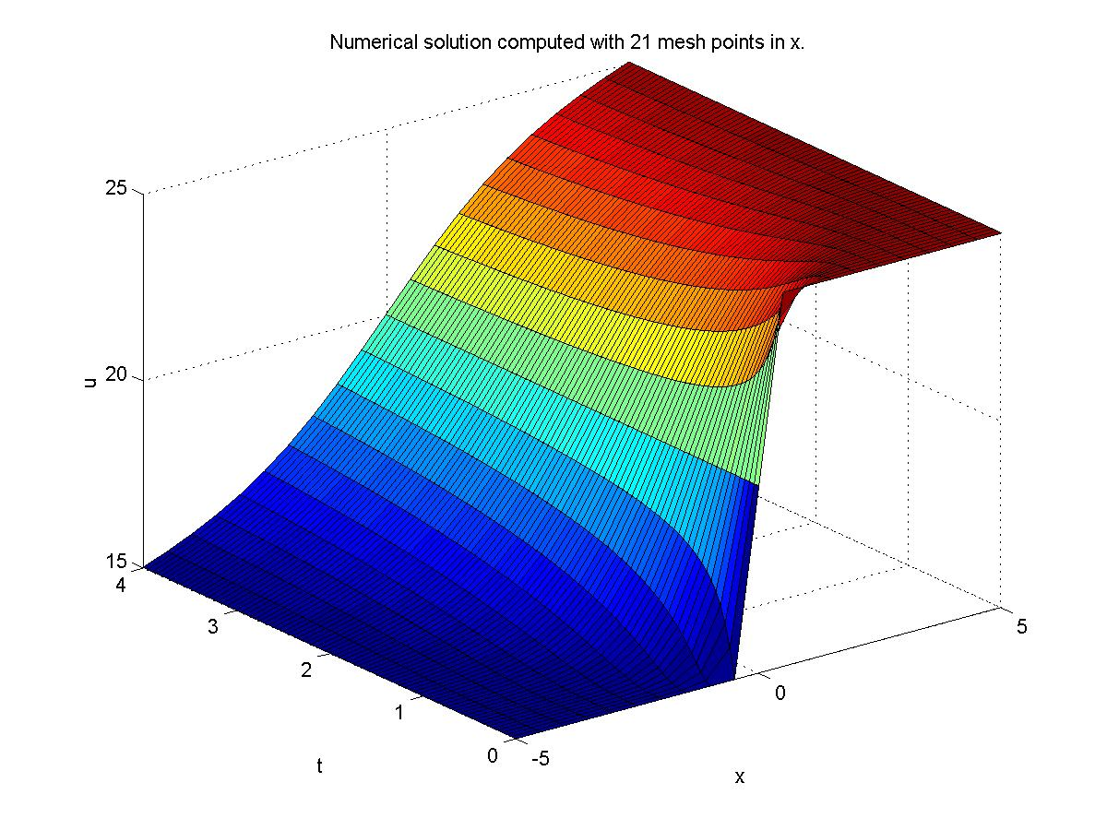

Again the results are very similar to those obtained before.

Walter A. Strauss, Partial Differential Equations: An Introduction, John Wiley & Sons (1992).

