Project: Fishery Statistics System

Students: Jon Eser and Noriaki Suzuki
Date: September 2003 -- December 2004
TABLE OF CONTENTS
I. Project Philosophy
II. Introduction
III. Goals, Scenarios, Use Cases
IV. Generation of Requirements First Iteration
V. Model of System Behavior and System Structure
VI. Requirements to Quantitative Specifications
VII. Quantifying Effectiveness
VIII. Trade-Off Analysis
IX. Phase One Conclusions
X. Visual Aid to State chart diagrams
XI. LTSA Tool
XII. Concurrency Analysis
XIII. Activity Diagram Modifications
XIV. Requirements Modifying System
XV. LTSA tool limitation
XVI. Solution for concurrency problem
XVII. Requirements Analysis
XVIII. Tracing requirements to behavior
XIX. Phase Two Conclusions
XX. Temporal Analysis
XXI. UPPAAL Introduction
XXII. Simplified Example Walk-through
XXIII. Time as Represented by Local and Global Clocks
XXIV. Temporal Representation of Fishery Statistics System
XXV. Temporal Analysis Results
XXVI. Limitations of UPPAAL Tool
XXVII. Verification Based Changes
XXVIII. Phase Three Conclusions
XXIX. Project Conclusions
XXX. References and Web Resources

I. Project Philosophy

The series of courses ENSE 621/622/623 taught at the University of Maryland at College Park are an introduction to systems analysis. This sequence utilizes a central project to tie together the elements and techniques of systems analysis discussed in each class. The key topics introduced in each phase of the project are listed below:

Phase 1
- Introduction to system decomposition
- Universal Modeling Language (UML)
- Requirements elicitation
- Trade off analysis with linear programming

Phase 2
- Concurrent behavior analysis
- Labeled Transition State Analyzer (LTSA)
- Detailed requirements analysis
- State chart representation of system

Phase 3
- Dynamic behavior analysis
- (UPPAAL) modeling tool

II. Introduction

1. Description
We aim to improve the Fishery Development Center’s (FDC) statistics system for the Ministry of Agriculture in the nation of El Salvador. By collecting statistical information on the fish caught per year in El Salvador, inferences can be made about biological data such as the population of various species of fish, their maturity, their gender, and their size. After compiling the data provided by local offices and regional collectors, the Fishery Development Center (FDC) will analyze the data. Results from this study will go on to support an annual report published by the organization, recommendations to the national legislature for fishing restrictions, and installation of artificial reefs to act as sanctuaries for many fish. Moreover, data analysis will help to determine if modifications within the system in particular dealing with data collection will help to increase the future precision of data.

2. Problems
- Currently the performance of collectors is very low; collection errors are common.
- Fishery data have not been accurate in the past. According to results from the annual report of 1998 consumption was 1.96 kg/person. This statistic is nonsense. If 1 fish weighs about 0.2 kg, this means that the average person eats just 10 fish in a year, and given that fish is a major portion of the average diet, this statistic is simply false.
- Because of problem #2, there is little confidence in the fishery statistical data. Without confidence in the statistical outputs there is no hope in using those data for a recommendation on changing current fishing practices.
- It has taken in the past almost 2 years to publish the annual report, a sign of significant inefficiency.
- The current method for determining appropriate fishing restriction does not take into account in a quantitative way the actual condition of marine resources. Laws should be passed only after consideration of facts.

3. Goals
- Establish a system that can survive with a fixed budget.
- Collectors must perform at a high level.
- Minimize variance of collected data so that it is reliable.
- Publish an annual report within 6 months of completing data collection.

4. Risks / Difficulties
- The majority of the operating staff is inexperienced.
- Operators have little to no computer experience.
- Within the next five years the system must achieve financial independence from the El Salvadoran government
- It has been five years since the most recent fishery census was carried out to identify number of fisherman, the number of boats, and the number of commercial buyers there are for fish products.
- There is some resistance by fisherman to a fishery statistical system because of the fear of more taxes.
- A training program must be developed to educate data collectors on how to obtain the necessary information and from what locations.
- How and who should maintain the computer system?
- What is the appropriate method to monitor local and industrial fishermen?
- Some landing points are far from the collectors' houses. How do we prepare transportation to these locations?
- How should the fish information database be structured?

5. Terminology

Terminology | Definition
FDC | Fishery Development Center
Ministry of Agriculture | Government agency for which the FDC works
Small Scale Fisherman | Fishermen that catch in mostly costal waters
Fisherman (corporate) | Fishermen that catch in deep ocean water
Fisherman (farmer) | Managers of landed fish farms
Local Office | Regional collection hub for system, there are four
Local Manager | Head of local office
Statistician | Employees dedicated to manipulating and analyzing data
Program Director | At headquarters, in charge of determining system strategy
Operator | Data entry workers
Monitor | Employee concerned with evaluating collector performance
Collector types | Full time collectors travel to localities for collection  Part time collectors live at the locations of collection
Landing points | Local docking hubs for fishermen these locations are fixed
Data variance | Statistical variation of data between sampling events at the same or similar landing points
Sampling rate | How many samples are taken per landing point per time
Marine Engineering | Engineering firm specializing in installing artificial reefs
Legislature | National law making body
Annual Report | System publication indicating work by system and state of fish
Economic Advisor | Financial analyst providing economic perspective of situation
International Organization | Outside support agency (universities, outside governments)

6. Systems framework and boundary
The fishery statistics systems can be pictured of as the composition of three coupled systems. In the current report the subsystem of “Manipulate data based on analysis and strategy” is focused on. Some interfaces with the other subsystems are necessary in order for the subsystem of interest to operate correctly.

Figure 1. Systems Framework and Boundary

III. Goals, Scenarios, and Use Cases

1. Goals and Scenarios
This case study will focus on small-scale fishing in El Salvador because of its direct impact on the local coastal and intercoastal marine environment. The Fishery Development Center (FDC) has four local offices and each a fixed number of cognizant landing points. The system involves collectors, operators, local managers and their functionality and interrelations. Diagrams will graphically depict this functionality. High level system goals are involved in all scenarios. For the nominal information collection and analysis scenario, high level goals are involved as shown below:

Goals:
- Establish a system that can survive with a fixed budget.
- Collectors must perform at a high level.
- Minimize variance of collected data so that it is reliable.
- Publish an annual report within 6 months of completing data collection.

1. Establish a system that can survive with a fixed budget.
 | Scenario 1-1. | FDC states requirements of fishery collection program
 | Scenario 1-2. | Local manager makes collection schedule
 | Scenario 1-3. | Local manager arranges transportation for the data collectors
 | Scenario 1-4. | Fulltime collectors and part time collectors arrive at a landing point
 | Scenario 1-5. | Collectors contact boat and find proper boat (collecting time relates to budget)
 | Scenario 1-6. | Retrieve boat information (collecting time relates to budget)
 | Scenario 1-7. | Retrieve fishing method information (collecting time relates to budget)
 | Scenario 1-8. | Retrieve number of fish, fish name and fish maturity according to type (collecting time relates to budget)
 | Scenario 1-9. | Monitors travel to landing points (monitor travel cost)
 | Scenario 1-10. | Monitoring scheduled work (monitoring cost)
 | Scenario 1-11. | Evaluation of collectors’ performance (determines if training is needed)
 | Scenario 1-12. | Find the number of boats at every landing point from fishermen register
 | Scenario 1-13. | Evaluate variance of collected data and find sampling rates
 | Scenario 1-14. | Find the average number of types of fish and number of fish per boat
 | Scenario 1-15. | Determine fish endangerment levels at landing points
 | Scenario 1-16. | Classify data types and their cost of collection
 | Scenario 1-17. | Make a proposal to ministry of agriculture for annual budget

2. Collectors must perform at a high level.
 | Scenario 2-1. | Local manager makes a collection schedule
 | Scenario 2-2. | Collectors can modify schedule, providing their input
 | Scenario 2-3. | Fulltime collectors and part time collectors arrive at a landing point (greater distances of travel cause collectors to be tired)
 | Scenario 2-4. | Collectors contact boat and find proper boat (collection speed relates to performance)
 | Scenario 2-5. | Retrieve boat information (collection speed relates to performance)
 | Scenario 2-6. | Retrieve fishing method information (collection speed relates to performance)
 | Scenario 2-7. | Retrieve number of fish, fish name and fish maturity according to type (collection speed relates to performance)
 | Scenario 2-8. | Monitoring of scheduled work (monitoring pressure)
 | Scenario 2-9. | Evaluation of collectors’ performance (determines if training is needed)
 | Scenario 2-10. | Monitor report shows results of collector performance
 | Scenario 2-11. | Find the number of boats at every landing point from fishermen register
 | Scenario 2-12. | Evaluate variance of collected data and find sampling rates
 | Scenario 2-13. | Find the average number of types of fish and number of fish per boat
 | Scenario 2-14. | Classify data types and their difficulty of collection

3. Minimize variance of collected data so that it is reliable.
 | Scenario 3-1. | Local manager makes a collection schedule
 | Scenario 3-2. | Collectors contact boat and find proper boat (collecting speed relate to collection data volume)
 | Scenario 3-3. | Retrieve boat information (collecting speed relate to collection data volume)
 | Scenario 3-4. | Retrieve fishing method information (collecting speed relate to collection data volume)
 | Scenario 3-5. | Retrieve number of fish, fish name and fish maturity according to type (collecting speed relate to collection data volume)
 | Scenario 3-6. | Find the number of boats at every landing point from fishermen register
 | Scenario 3-7. | Evaluate variance of collected data and find sampling rates that will ensure high precision
 | Scenario 3-8. | Find the average number of types of fish and number of fish per boat
 | Scenario 3-9. | Determine fish endangerment levels at landing points
 | Scenario 3-10. | Classify data types and their importance

4. Publish an annual report within 6 months of completing data collection.
 | Scenario 4-1. | Collect fishery data by schedule
 | Scenario 4-2. | Fulltime collectors hand in datasheet with fishery data (within specified time)
 | Scenario 4-3. | Part time collectors send datasheets by mail to local office (immediately after job)
 | Scenario 4-4. | Operator inputs data to database (must input a specified amount per day)
 | Scenario 4-5. | Input data is sent via the internet to the FDC, and data compiled for database
 | Scenario 4-6. | Data base program automatically manipulates and stores data
 | Scenario 4-7. | Generate queries and make cross tables
 | Scenario 4-8. | Statistician analyzes fishery data
 | Scenario 4-9. | Program director makes annual report
 | Scenario 4-10. | Annual report review
 | Scenario 4-11. | Published annual report on paper and on web site

2. Use Case Diagram

A use case describes system functionality in terms of users inputting work to or receiving work from the system. Although use cases are neither requirements nor functional specification, they do imply requirements, objects, and object interactions in the stories they tell. Use cases are textual descriptions of the interactions between external actors and a system.
Our initial use case diagram has five actors – Fisherman (small scale), Ministry of Agriculture, Legislature, Economic Adviser and Marine Engineering - and eight use cases (A) Schedule for Collection, (B) Collect data, (C) Training, (D) Manipulate fishery data, (E) Analyze fishery data, (F) Create external strategy, (G) Create internal strategy, and (H) Write report.

Figure 2. Initial Use Case Diagram for The Fishery Statistics System
3. Initial (Textual) Use Case Modeling and Activity Diagram

Use Case A. Schedule for collection
Description: Scheduling
Primary Actors: Ministry of Agriculture
Pre-Conditions:
- Employees are properly trained
- Local office knows what information must be collected from previous analysis

Flow of Events:
- Ministry of Agriculture requests that the fishery statistics program conduct its annual collection and analysis
- Local managers make collection schedules
- Schedule meets minimum sampling requirements per landing point
- Adequate numbers of full-time collectors are employed to travel to landing points
- Adequate numbers of part-time local collectors are employed to collect at inaccessible landing points
- Appropriate pay rates are included in the scheduling
- Local manager sends schedule/data sheets to collectors
- Full time data collector receives schedule and data sheet
- If the full time collector cannot perform the schedule the local manager and collectors iterate on its form
- Part time data collector receives sheets / data sheet
- Transportation is arranged for the collector to travel to the landing points
- The monitors are informed of the collection schedule
- Monitors prepare sheets for evaluation of collection

Post Conditions:
- Collectors have datasheets
- The schedule is disbursed to the collectors and monitors
- Transportation has been arranged for the collectors

Alternate Flow of Events: None

Assumptions:
- Local office has funds for conducting business
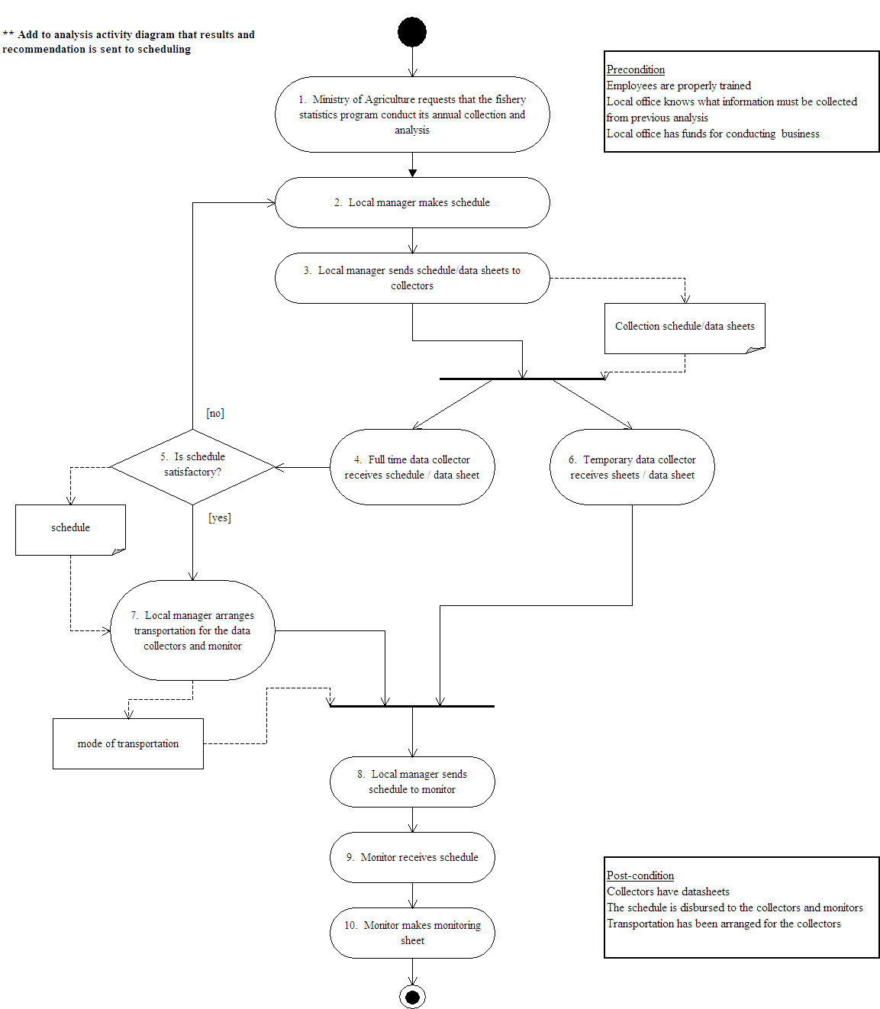

Figure 3. Activity Diagram for "Schedule for Collection (A)"
Use Case B. Collection of Data
Description: Collection
Primary Actors: Fishermen
Pre-Conditions:
- Collectors have data sheets for the information that is to be collected
- Employees are properly trained
- Correct schedule has been provided
- Transportation has been arranged

Flow of Events:
  - Collectors will arrive at the correct landing point per their schedule
  - Collectors will retrieve details on landing point including the location, population, date, total number of boats
  - Collectors then search for the proper boat to collect from based on the size of the boat and fishing method used.
  - Information is retrieved concerning details of the boat including the boat name, size, and fishing method.
  - Information on catches are retrieved including types of fish, numbers caught, size, and maturity.
  - Once all information has been collected from the boat another boat is contacted until the sampling requirements are met at the current landing point.
  - Other landing points are visited until the list of sampling points is completed.
  - Full time collectors return data sheets to the local office.
  - Part time collectors mail data sheets to the local offices.
  - The monitors travel to the landing points and monitor the collection process by some collectors.
  - The monitors fill out evaluation sheets.
  - Monthly reports are made by monitors on the performance of full time and part time collectors for decision on implementing training sessions or improvement of pay for exceptional performers.

Post Conditions:
- Correct information has been retrieved
- Data sent to local office
Alternate Flow of Events: None
Assumptions: None
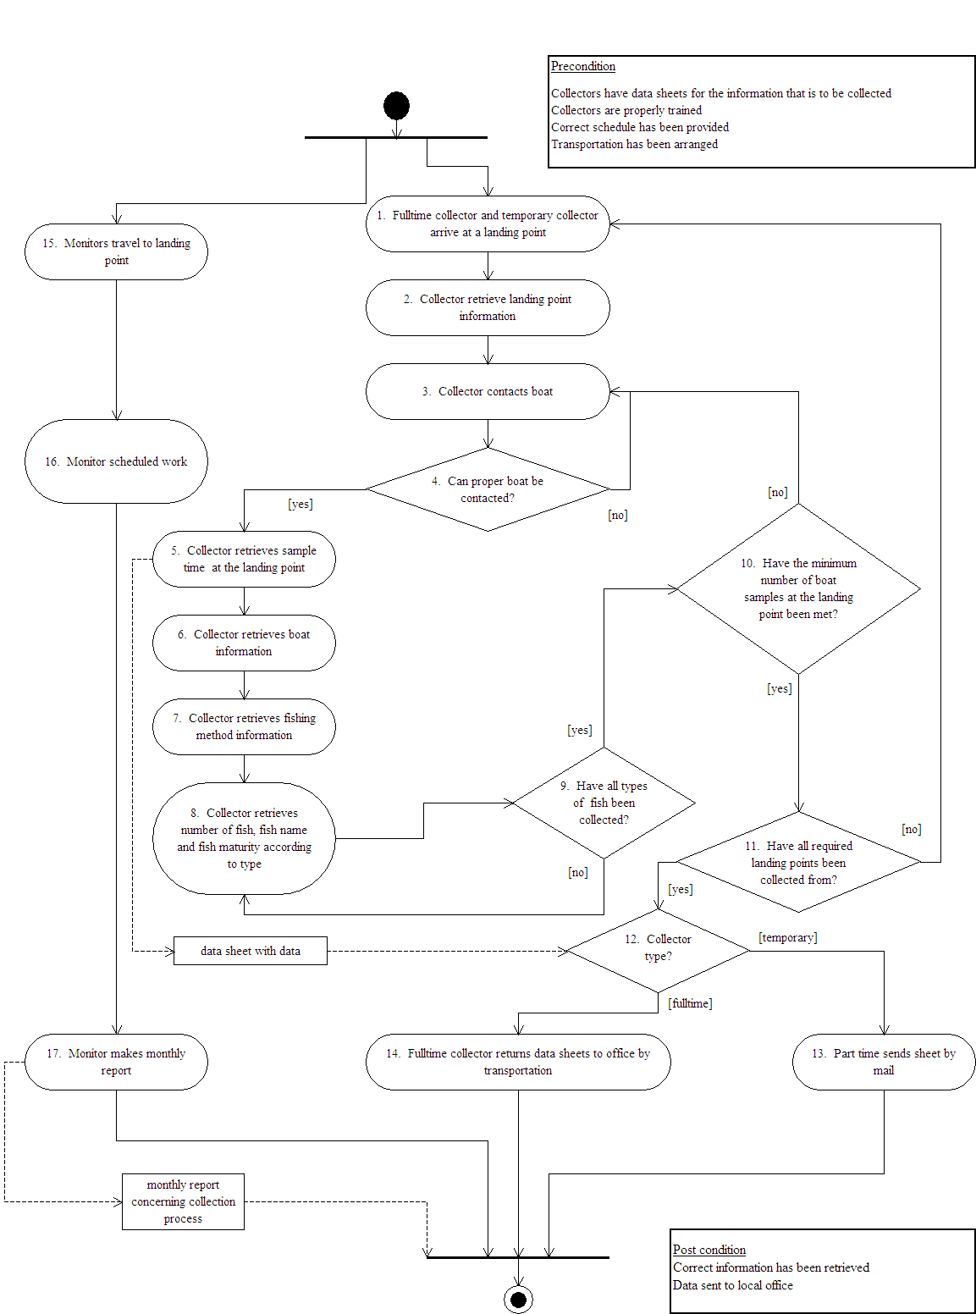
Figure 4. Activity Diagram for "Collection (B)"

Use Case E. Analyze fishery data
Description: Analyze stored data for trends in endangerment of fish
Primary Actors: Ministry of Agriculture

Pre-Conditions:
- Fish information database completed for the year at every landing point

Flow of Events:
  - The statistician receives fishing information for the previous year and past years from the fishing information database.
  - The statistician receives the historical fishing standard (the goal fish population) from the Ministry of Agriculture.
  - A list of recent fishing restrictions from the database are provide to the statistician along with locations of artificial reefs.
  - The statistician calculates the variance of the new data and a conservative average fishing profile for each landing point is created.
  - The statistician compares data of recent fishing profiles and the standard profile along with enacted fishing restrictions.
  - After comparing data sets the statistician determines the level of endangerment of various fish types per location.
  - The statistician creates the annual endangerment matrix which indicates which fish are endangered and to what levels per region along with specific fishing restrictions in that region.
  - The program director makes a proposal to ministry of agriculture for annual budget

Post Conditions:
- Endangerment matrix complete outlining the condition of the local fish populations (endangered/ thriving) as compared to historical levels at given locations

Alternate Flow of Events: None

Assumptions: None

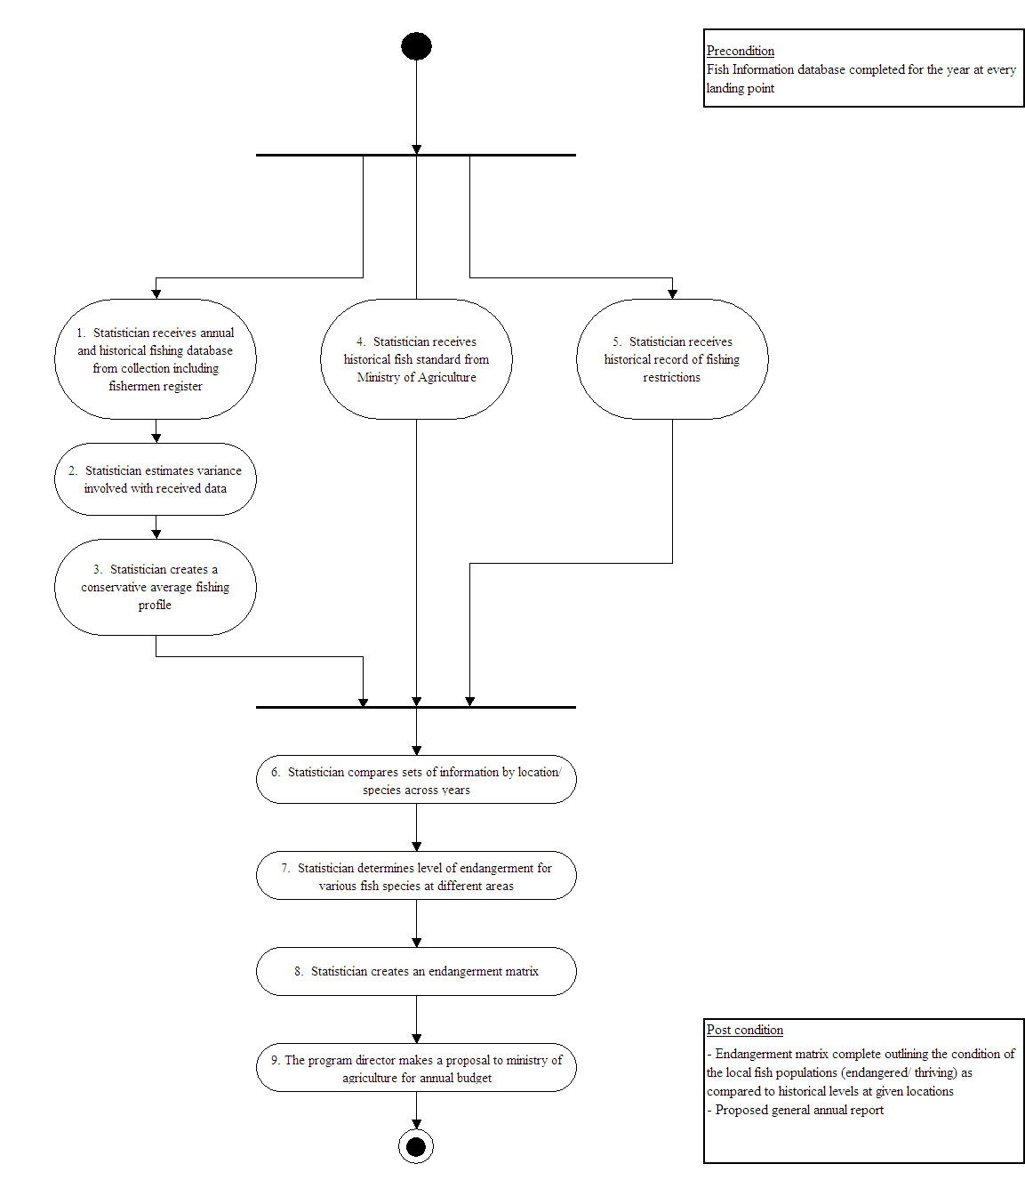
Figure 5. Activity Diagram for “Analyze fishery data (E)”

IV. Generation of Requirements First Iteration

After generating the textual use cases and the scenarios related to those use cases and goals, requirements can be evaluated. Requirements are derived in a top down sense from the goals and scenarios, it is important to understand the connection between requirements and use cases and maintain coherent traceability between them.

General Requirements:
- Should be operated with budget constraints (cost requirement)
- High performance of collectors (performance requirement)
- We would like high precision data (data reliability)

1. Flow down of Requirements from Use Cases/Scenarios
A detailed listing of requirements from use cases and scenarios is as follows:

Use Case | Scenario | No. Req. | Requirements Description
Scheduling  (A) | Scenario 1-1. Scenario 1-2. | Req. #1.1 | Appropriate pay rate and number of employees for fulltime collectors (cost)
Scheduling  (A) | Scenario 1-1. Scenario 1-2. | Req. #1.2 | Appropriate pay rate and number of employees for part time collectors (cost)
Scheduling  (A) | Scenario 1-1. Scenario 1-2. | Req. #1.3 | Assign collection to all landing points (cost)
Scheduling  (A) | Scenario 1-1. Scenario 1-2. | Req. #1.4 | Frequency of collection at a landing site and collectors visiting that site (cost concern)
Scheduling  (A) | Scenario 1-3. | Req. #1.5 | Transportation should be arranged for the collector to travel to the landing points (travel distance/cost)
Scheduling  (A) | Scenario 2-1.  Scenario 2-2. | Req. #2.1 | Number of full time collectors with adequate experience (performance)
Scheduling  (A) | Scenario 2-1.  Scenario 2-2. | Req. #2.2 | Number of part time collectors with adequate experience (performance)
Scheduling  (A) | Scenario 2-1.  Scenario 2-2. | Req. #2.3 | Local manager makes proper schedule
Scheduling  (A) | Scenario 3-1. | Req. #3.1 | Number of full time collectors with adequate experience (precision data)
Scheduling  (A) | Scenario 3-1. | Req. #3.2 | Number of part time collectors with adequate experience (precision data)
Scheduling  (A) | Scenario 3-1. | Req. #3.3 | Rates of collection are established to meet minimums (precision data)
Scheduling  (A) | Scenario 3-1. | Req. #3.4 | Assign collection to all landing points (precision data)
Scheduling  (A) | Scenario 3-1. | Req. #3.5 | Frequency of collection at a landing site and collectors visiting that site (precision data)
Collection  (B) | Scenario 1-4. | Req. #1.6 | Collectors should have proper trained (cost concern)
Collection  (B) | Scenario 1-4. | Req. #1.7 | Shorten travel time (travel distance/cost)
Collection  (B) | Scenario 1-5. | Req. #1.8 | Shorten time for finding proper boat (cost)
Collection  (B) | Scenario 1-6. Scenario 1-7. | Req. #1.9 | Shorten time for collecting boat information (cost)
Collection  (B) | Scenario 1-8. | Req. #1.10 | Shorten time for collecting fish character (cost)
Collection  (B) | Scenario 1-6. Scenario 1-7. Scenario 1-8. | Req. #1.11 | Retrieve necessary fish information types (boat, fish character) (cost in terms of time with each)
Collection  (B) | Scenario 1-9. | Req. #1.12 | Reduce number of monitors traveling (monitor cost)
Collection  (B) | Scenario 1-10. | Req. #1.13 | Reduce monitoring time (cost of monitoring)
Collection  (B) | Scenario 1-11. | Req. #1.14 | Reduce the number of collectors requiring additional training
Collection  (B) | Scenario 2-3. | Req. #2.4 | Collectors should only collect once they are properly trained
Collection  (B) | Scenario 2-3. | Req. #2.5 | Shorten travel time (shorten distance) (greater distances traveled cause collectors to tire, rate of tiring is dependent on distance)
Collection  (B) | Scenario 2-4. | Req. #2.6 | Shorten time for finding proper boat (shorter times indicate higher performance)
Collection  (B) | Scenario 2-5.  Scenario 2-6. | Req. #2.7 | Shorten time for collecting boat information (shorter times indicate higher performance)
Collection  (B) | Scenario 2-7. | Req. #2.8 | Shorten time for collecting fish characteristics (shorter time indicates higher performance)
Collection  (B) | Scenario 2-8. | Req. #2.9 | Monitor 5% of collectors (pressure encourages collector to work harder, minimum of 5% monitoring)
Collection  (B) | Scenario 2-9. Scenario 2-10. | Req. #2.10 | Evaluate collectors’ performance by ranking method
Collection  (B) | Scenario 3-2. | Req. #3.6 | Sample enough boats to meet minimum required per landing point (precision data)
Collection  (B) | Scenario 3-3. Scenario 3-4. | Req. #3.7 | Acquire boat information from all sampled boats
Collection  (B) | Scenario 3-5. | Req. #3.8 | Must collect information of all fish types caught
(E) Analysis | Scenario 1-12. | Req. #1.15 | Determine the number of boats at each landing point (reduce the number of boats collected to lower collection cost)
(E) Analysis | Scenario 1-13. | Req. #1.16 | Reduce sampling rates
(E) Analysis | Scenario 1-14. | Req. #1.17 | Reduce average number of fish and type of fish caught (the average comes from last year’s database)
(E) Analysis | Scenario 1-16. | Req. #1.18 | Reduce volume of information collected
(E) Analysis | Scenario 1-17. | Req. #1.19 | Write an effective proposal
(E) Analysis | Scenario 2-11. | Req. #2.11 | Attempt to reduce the number of boats collected per landing point (fewer number of boats causes collectors’ performance to become better)
(E) Analysis | Scenario 2-12. | Req. #2.12 | Reduce sampling rate (lower sampling rate causes collectors’ performance to become better)
(E) Analysis | Scenario 2-13. | Req. #2.13 | Reduce average number of fish and type of fish caught (the average comes from last year’s database, fewer the average causes collectors’ performance to become better)
(E) Analysis | Scenario 2-14. | Req. #2.14 | Reduce the volume of information collected (Less information collected increases collectors’ performance)
(E) Analysis | Scenario 3-6. | Req. #3.9 | Attempt to decrease the number of boats collected per landing point (fewer number of boats causes precision to improve)
(E) Analysis | Scenario 3-7. | Req. #3.10 | Increase sampling rate (greater sampling rate causes precision to improve)
(E) Analysis | Scenario 3-8. | Req. #3.11 | Reduce average number of fish and type of fish caught (the average comes from last year’s database, fewer the average causes precision to improve)
(E) Analysis | Scenario 3-10. | Req. #3.12 | Increase the volume of information collected (More information collected increases precision) or Require greater number of data types for collection

Table 1. Flow down of Requirements

2. Traceability of Requirements to Use Cases / Scenarios
Tracing of requirements back to originating use cases/scenarios is as follows:

#1. Should be operated with budget constraints

Req. # | Requirement Description | Use case | Scenario #
Req. #1.1 | Appropriate pay rate and number of employees for fulltime collectors (cost) | A | 1-1. 1-2.
Req. #1.2 | Appropriate pay rate and number of employees for part time collectors (cost) | A | 1-1. 1-2.
Req. #1.3 | Assign collection to all landing points (cost) | A | 1-1. 1-2.
Req. #1.4 | Frequency of collection at a landing site and collectors visiting that site (cost concern) | A | 1-1. 1-2.
Req. #1.5 | Transportation should be arranged for the collector to travel to the landing points (travel distance/cost) | A | 1-3.
Req. #1.6 | Collectors should have proper trained (cost concern) | B | 1-4.
Req. #1.7 | Shorten travel time (travel distance/cost) | B | 1-4.
Req. #1.8 | Shorten time for finding proper boat (cost) | B | 1-5.
Req. #1.9 | Shorten time for collecting boat information (cost) | B | 1-6. 1-7.
Req. #1.10 | Shorten time for collecting fish character (cost) | B | 1-8.
Req. #1.11 | Retrieve necessary fish information types (boat, fish character) (cost in terms of time with each) | B | 1-6. 1-7.  1-8.
Req. #1.12 | Reduce number of monitors traveling (monitor cost) | B | 1-9.
Req. #1.13 | Reduce monitoring time (cost of monitoring) | B | 1-10.
Req. #1.14 | Reduce the number of collectors requiring additional training | B | 1-11.
Req. #1.15 | Determine the number of boats at each landing point (reduce the number of boats collected to lower collection cost) | E | 1-12.
Req. #1.16 | Reduce sampling rates | E | 1-13.
Req. #1.17 | Reduce average number of fish and type of fish caught (the average comes from last year’s database) | E | 1-14.
Req. #1.18 | Reduce volume of information collected | E | 1-16.
Req. #1.19 | Write an effective proposal | E | 1-17.

Table 2. Traceability of Requirements for “Should be operated with budget constraints”

#2. High performance of collectors

Req. # | Requirement Description | Use case | Scenario #
Req. #2.1 | Number of full time collectors with adequate experience (performance) | A | 2-1. 2-2.
Req. #2.2 | Number of part time collectors with adequate experience (performance) | A | 2-1. 2-2.
Req. #2.3 | Local manager makes proper schedule | A | 2-1. 2-2.
Req. #2.4 | Collectors should only collect once they are properly trained | B | 2-3.
Req. #2.5 | Shorten travel time (shorten distance) (greater distances traveled cause collectors to tire, rate of tiring is dependent on distance) | B | 2-3.
Req. #2.6 | Shorten time for finding proper boat (shorter times indicate higher performance) | B | 2-4.
Req. #2.7 | Shorten time for collecting boat information (shorter times indicate higher performance) | B | 2-5. 2-6.
Req. #2.8 | Shorten time for collecting fish characteristics (shorter time indicates higher performance) | B | 2-7.
Req. #2.9 | Monitor 5% of collectors (pressure encourages collector to work harder, minimum of 5% monitoring) | B | 2-8.
Req. #2.10 | Evaluate collectors’ performance by ranking method | B | 2-9. 2.10.
Req. #2.11 | Attempt to reduce the number of boats collected per landing point (fewer number of boats causes collectors’ performance to become better) | E | 2-11.
Req. #2.12 | Reduce sampling rate (lower sampling rate causes collectors’ performance to become better) | E | 2-12.
Req. #2.13 | If the average number of types of fish is reduced per boat the collector performance will improve | E | 2-13.
Req. #2.14 | Reduce the information collected per individual fish such as maturity and size (Less information collected increases collectors’ performance) | E | 2-14.

Table 3. Traceability of Requirements for “High performance of collectors”

#3. High precision data

Req. # | Requirement Description | Use case | Scenario #
Req. #3.1 | Number of full time collectors with adequate experience (precision data) | A | 3-1.
Req. #3.2 | Number of part time collectors with adequate experience (precision data) | A | 3-1.
Req. #3.3 | Rates of collection are established to meet minimums (precision data) | A | 3-1.
Req. #3.4 | Assign collection to all landing points (precision data) | A | 3-1.
Req. #3.5 | Frequency of collection at a landing site and collectors visiting that site (precision data) | A | 3-1.
Req. #3.6 | Sample enough boats to meet minimum required per landing point (precision data) | B | 3-2.
Req. #3.7 | Acquire boat information from all sampled boats | B | 3-3. 3-4.
Req. #3.8 | Must collect information of all fish types caught | B | 3-5.
Req. #3.9 | Attempt to decrease the number of boats collected per landing point (fewer number of boats causes precision to improve) | E | 3-6.
Req. #3.10 | Increase sampling rate (greater sampling rate causes precision to improve) | E | 3-7.
Req. #3.11 | Reduce average number of fish and type of fish caught (the average comes from last year’s database, fewer the average causes precision to improve) | E | 3-8.
Req. #3.12 | Increase the volume of information collected (More information collected increases precision) or Require greater number of data types for collection | E | 3-10.

Table 4. Traceability of Requirements for “High precision data”

V. Simplified Models of System Behavior and System Structure

The fishery statistics system contains eight main subsystems: (A) Schedule for collection, (B) Collect data, (C) Training, (D) Manipulate fishery data, (E) Analyze fishery data, (F) Create external strategy, (G) Create internal strategy, (H) Write report. We focused on two subsystems – “(A) Schedule” and “(B) Collect Data”, which are important for developing internal system layout.

1. System Structure shown by Class Diagrams

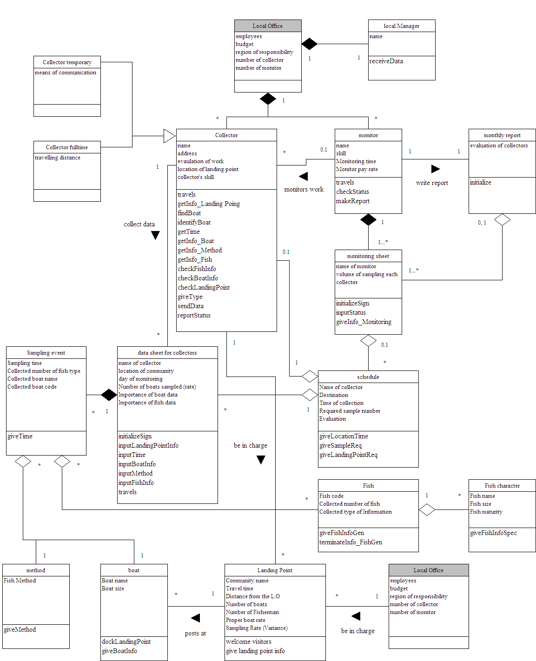
Figure 6. Class Diagram for “Schedule for collection (A)”

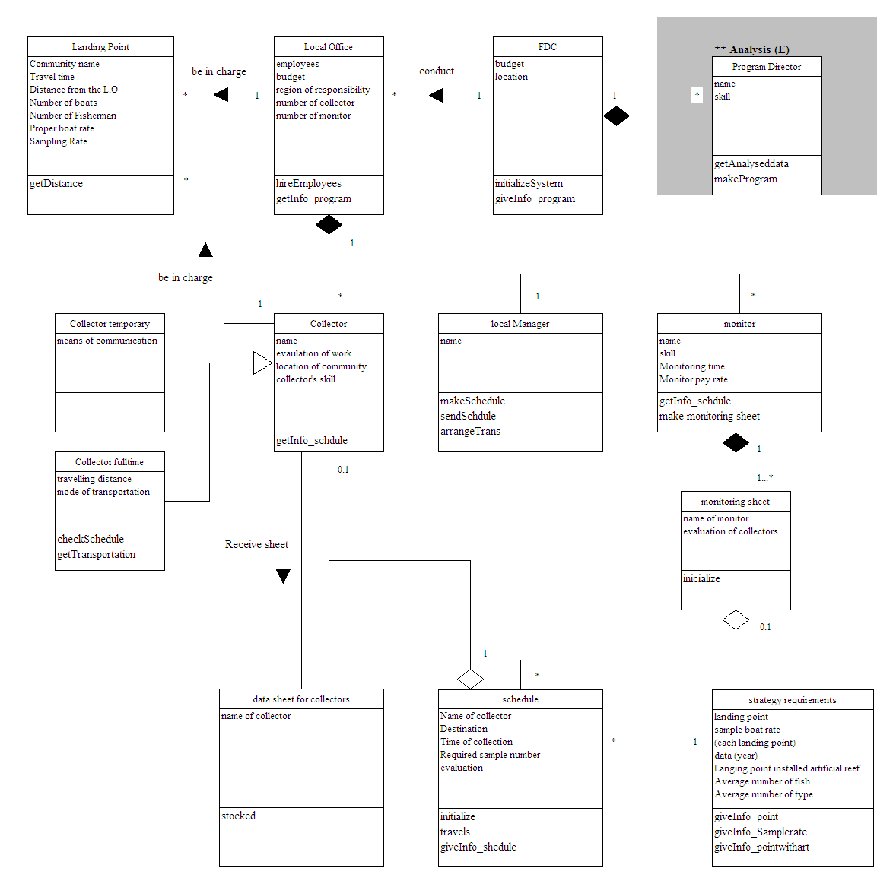

Figure 7. Class Diagram for “Collect Data (B)”

2. System Behavior shown by Sequence Diagrams

Sequence diagrams provide a graphical representation for how a task is accomplished by passing a sequence of messages between objects of the fishery statistics system. Item by item system behavior is highlighted by the object interactions. We are going to provide two sequence diagrams for a normal case of each subsystems – “(A) Schedule” and “(B) Collect Data” - as shown below:
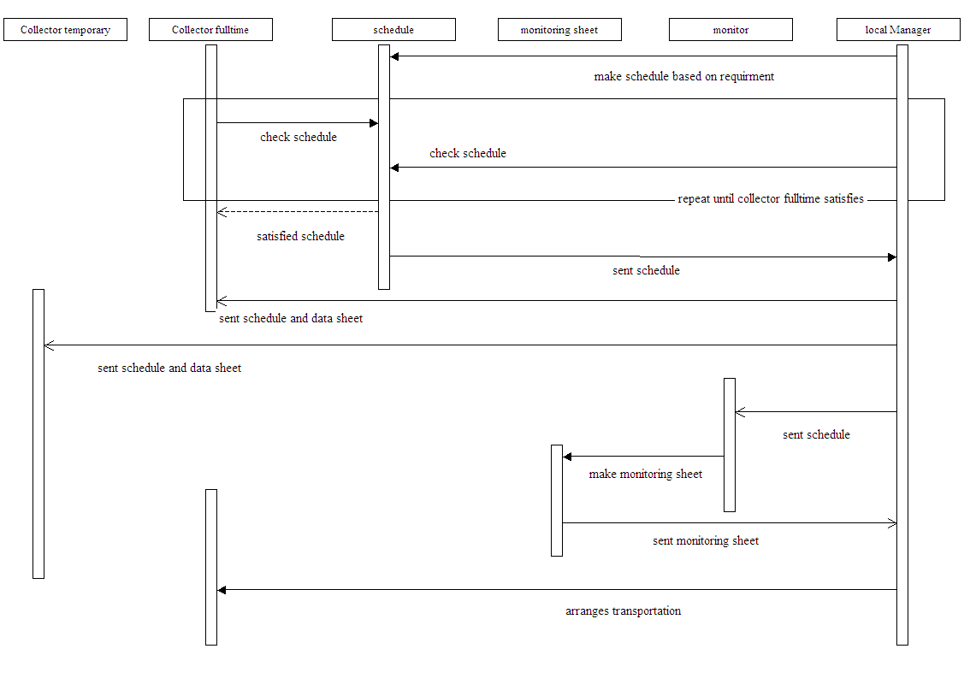

Figure 8. Sequence Diagram for “Schedule for collection (A)”

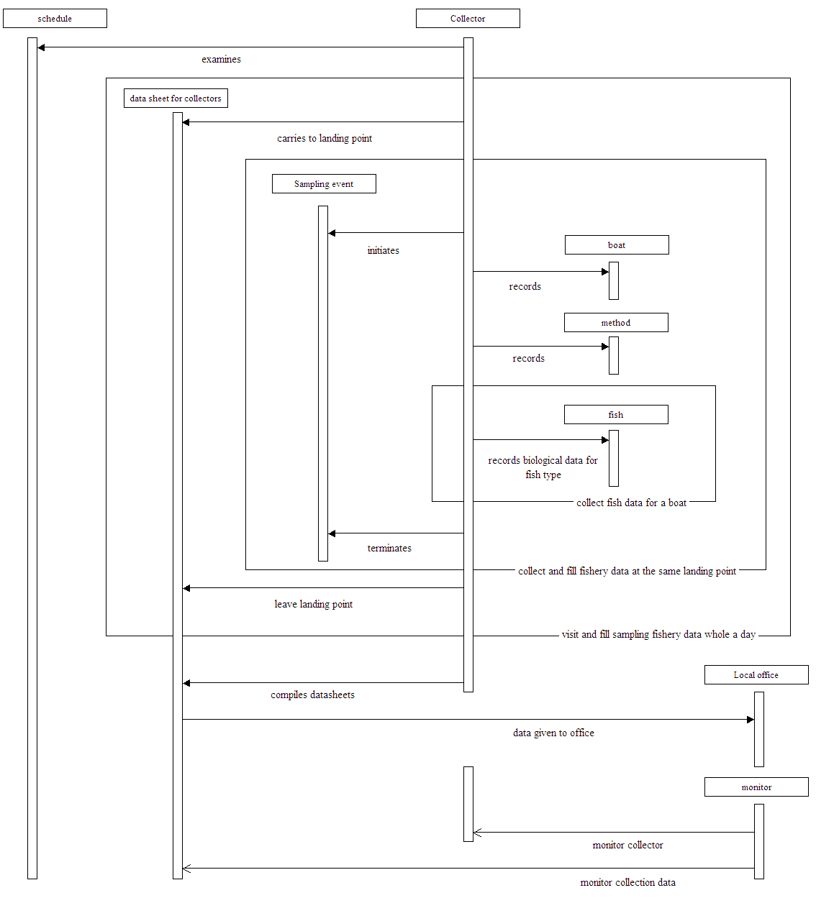
Figure 9. Sequence Diagram for “Collection of data (B)”

3. System Behavior shown by State Chart Diagrams

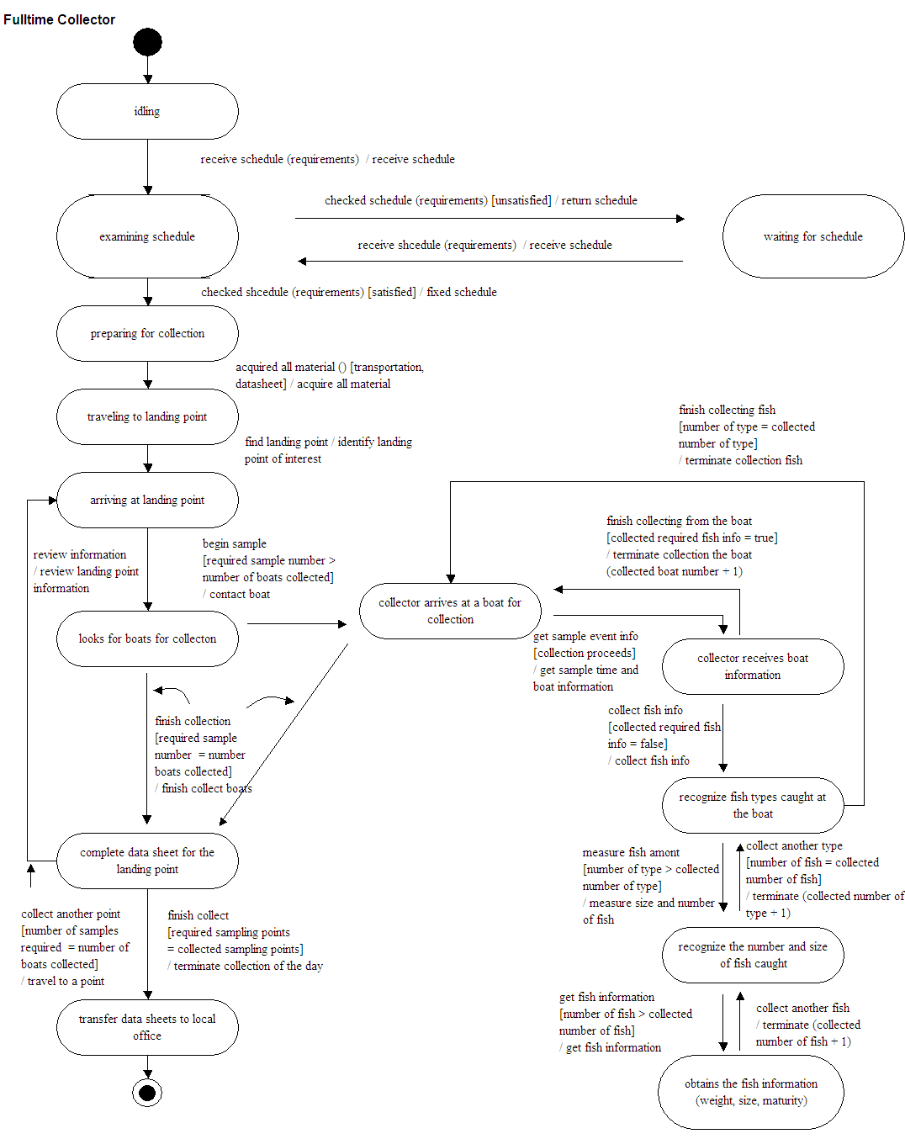
State charts show a behavioral view of the system. Object level changes are viewable as a scenario is stepped though. “Full time collectors” and “Data sheet for collectors” - are shown.
Figure 10. State Chart Diagram for “Full Time Collector”
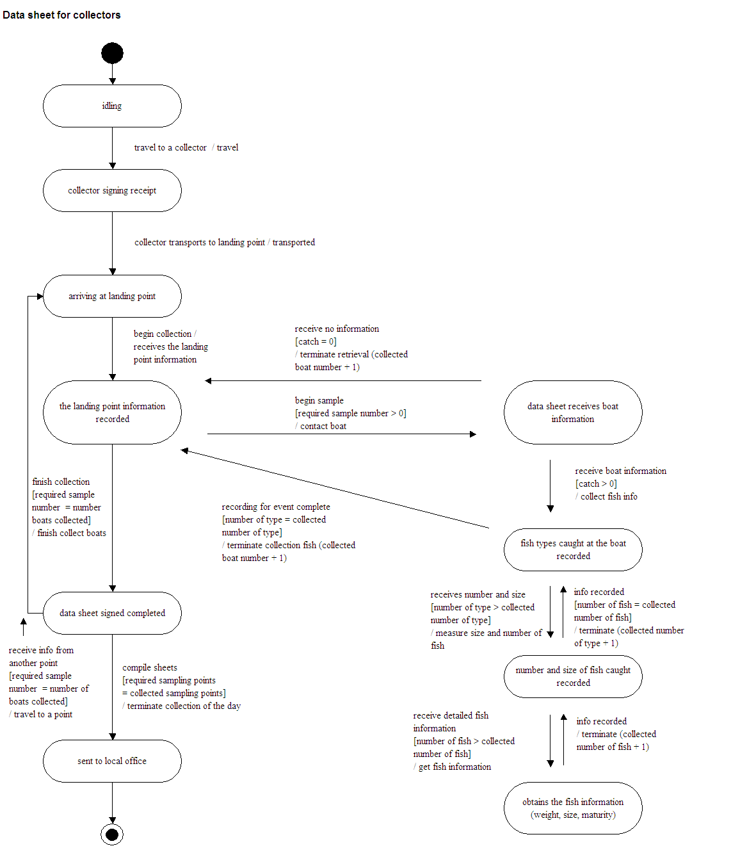

Figure 11. State Chart Diagram for “Data Sheet for Collectors”

4. Mapping between structure and behavior of the system

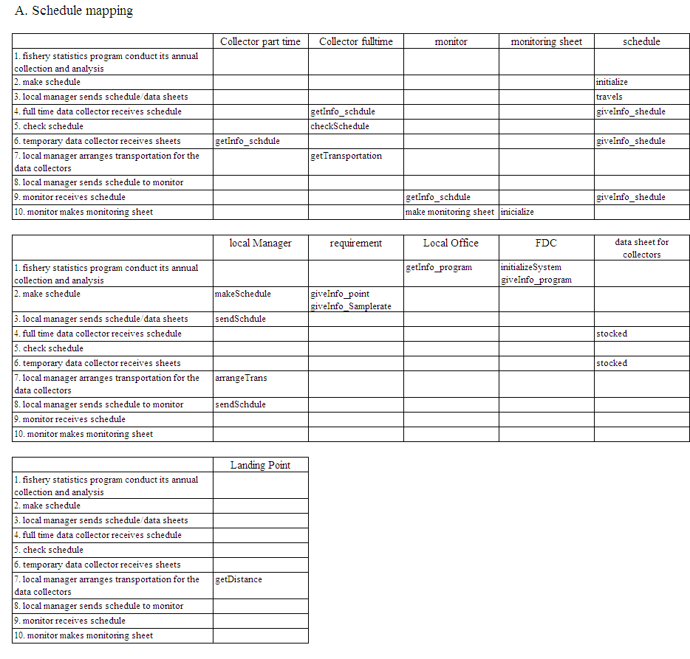
Proper mapping between system structures and behaviors identify system cohesiveness. The functionality of an object is provided by the operations that belong to that object, the scope of object operations should completely cover the necessary operations of the system as a whole. Mapping for objects involved in “Schedule for collection (A)” and “Collection of data (B)” are shown in tabular format and on activity diagrams. The table entries are object operations that belong to the column object and which are functioning in the row activities. The activity diagrams are modified for mapping between objects structures and behaviors. This method identifies the objects that are involved in various activities.
Table 5. Mapping of structure to behavior for “Schedule for collection (A)”
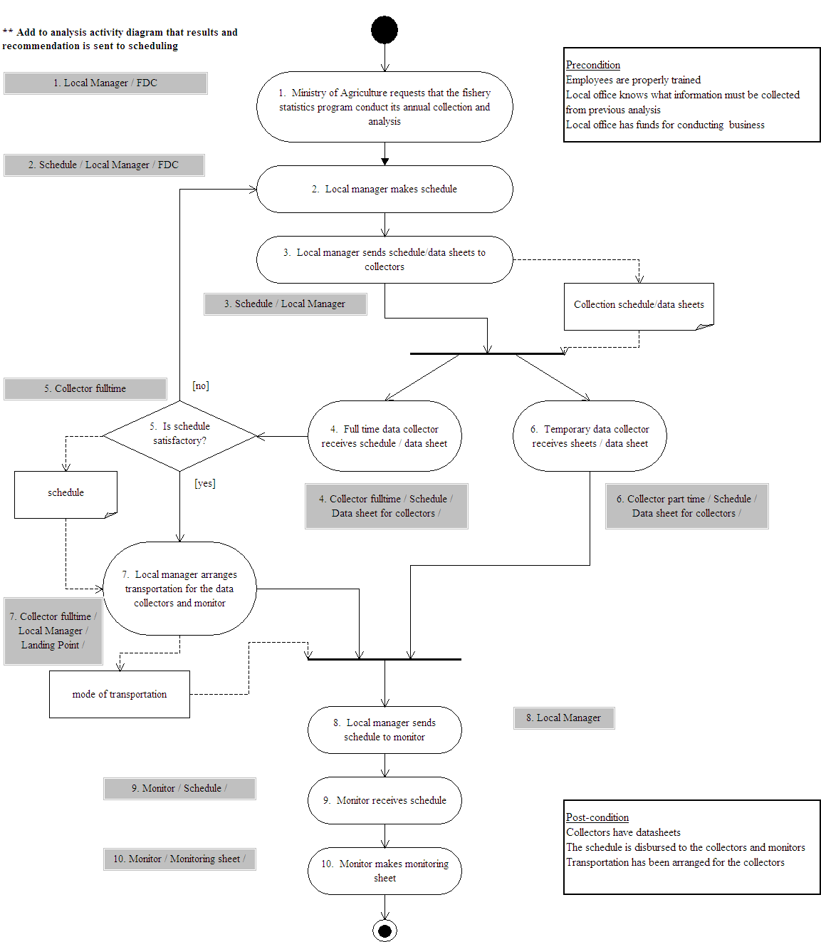

Figure 12. Mapping in Activity Diagram for "Schedule for Collection (A)"
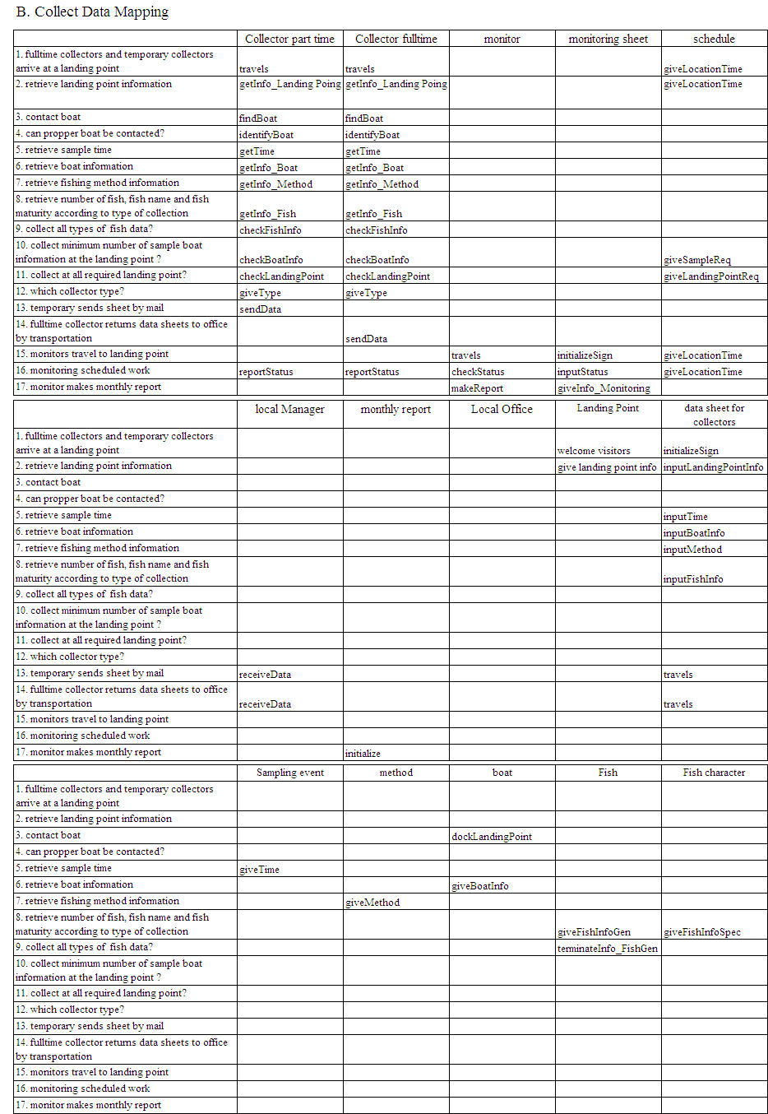
Table 6. Mapping of structure to behavior for “Collection of data (B)”
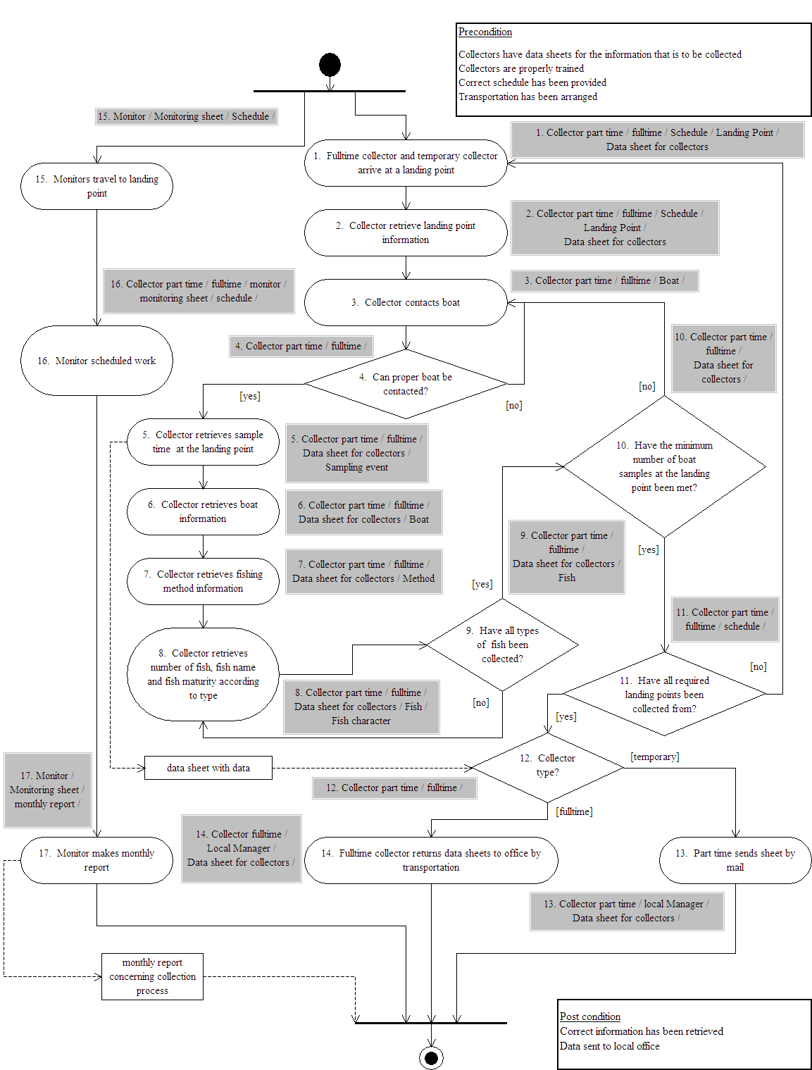
Figure 13. Mapping in Activity Diagram for "Collection (B)"

VI. Requirements and Specifications

1. Traceability of Requirements to Attributes and Functions
Once the system requirements are defined, system specifications are needed to set limits on the component design. Requirements determine specifications by stating what the component must do (Functions) and also what characteristics they must have (Attributes). Specifications are based on three general requirements:

#1. System should be operated with budget constraints
#2. A high performance of collectors is needed
#3. High precision data is needed

#1. Should be operated with budget constraints

Req. #1. | Requirement | Object | Attribute | Function
1 | Appropriate pay rate and number of employees for fulltime collectors (cost) | Full time collector | Pay rate ($2 - )
2 | Appropriate pay rate and number of employees for part time collectors (cost) | Part time collector | Pay rate ($2 - )
3 | Frequency of collection at a landing site and collectors visiting that site (cost concern) | Collectors | Frequency  (1 – 5)/week | Make schedule
4 | Assign collection to all landing points (cost) | Local Manager | Pay rate ($5 - ) | Make schedule
5 | Transportation should be arranged for the collector to travel to the landing points (travel distance/cost) | Collector | Meaning of transportation (Car or Bus) | Arranged transportation
5 |  | Local Office | Number of Local Offices  (1 - ) | Arranged transportation
5 |  | Local Office | Average of Distance from L.O  (10mile - ) | Provide distance from L.O to each landing point
6 | Collectors should have proper training (cost concern) | Full time collector | Pay rate ($2 - ) * pay rate depends on performance
6 | Collectors should have proper training (cost concern) | Part time collector | Pay rate ($2 - ) * pay rate depends on performance
11 | Retrieve necessary boat information (cost in terms of time with each) | Data sheet for collectors | Types of boat data ([Type B₁ = landing point, collecting time, method], [Type B₂ = boat code, boat name, boat size]) | Determine importance level for boat information
12 | Reduce number of monitors traveling (monitor cost) | Local Office | Number of Monitor (1 - ) | Monitor check collection status each landing point
14 | Reduce the number of collectors requiring additional training | Collectors | Number of training session (0 - ) | Evaluate collection status
16 | Reduce sampling rate | Landing points | Sampling rates (10% - ) | Retrieve Sampling rates
18 | Reduce volume of information collected | data sheet for collectors | Types of fish data ([Type F₁ = weight], [Type F₂ = number, size], [Type F₃ = maturity]) | Determine importance level for fish information

Table 7. Specification for Should be operated with budget constraints

#2. High performance of collectors

Req. #2. | Requirement | Object | Attribute | Function
3 | Local manager makes proper schedule | Local Manager | Pay rate ($5 - ) | Make schedule
4 | Collectors should only collect once they are properly trained | Full time collector | Pay rate ($2 - ) *performance depend on pay rate
4 |  | Part time collector | Pay rate ($2 - ) *performance depend on pay rate
5 | Shorten travel time (shorten distance) (greater distances traveled cause collectors to tire, rate of tiring is dependent on distance) | Collector | Frequency  (1 – 5)/week | Visit to a landing point
5 |  | Collector | Meaning of transportation (Car or Bus) | Visit to a landing point
5 |  | Local Office | Number of Local Office  (1 - ) | Visit to a landing point
5 |  | Local Office | Average of Distance from L.O  (10mile - ) | Provide distance from L.O to each landing point
9 | Monitor collectors (pressure encourages collector to work harder) | Local Office | Number of monitors (0 - ) | Monitor check collection status each landing point
10 | Evaluate collectors’ performance by ranking method | Collectors | Number of training session (0 - ) | Evaluate collection status

Table 8. Specification for High performance of collectors

#3. We would like high precision data

Req. #3. | Requirement | Object | Attribute | Function
5 | Frequency of collection at a landing site and collectors visiting that site (precision data) | Schedule | Frequency  (1 – 5)/week | Make schedule
6 | Sample enough boats to meet minimum required per landing point (precision data) | Schedule | Sampling rates (10% - ) | Make schedule
7 | Acquire boat information from all sampled boats | Data sheet for collectors | Type of boat data ([Type B₁ = landing point, collecting time, method], [Type B₂ = boat code, boat name, boat size]) | Collect boat information
8 | Must collect information of all fish types caught | data sheet for collectors | Type of fish data ([Type F₁ = weight], [Type F₂ = number, size], [Type F₃ = maturity]) | Collect fish information
10 | Reduce variance (less variance causes precision to improve) | Landing points | Sampling rates (10% - ) | Retrieve Sampling rate
12 | Increase the volume of information collected (More information collected increases precision) or Require greater number of data types for collection | Data sheet for collectors | Importance of fish data ([Type F₁ = weight], [Type F₂ = number, size], [Type F₃ = maturity]) | Determine importance level for fish information

Table 9. Specification for we would like high precision data

VII. Quantifying Effectiveness

1. System Performance Metrics

Success for the small-scale fishery statistics systems is based on the attainment of three goals identified above those being operation under a budget constraint, high performing collectors, and collection of high precision data. Optimal system design would result in the lowest system cost for various levels of collector performance and data precision. The decision must be made as to what levels of performance and precision are acceptable while bearing the cost of that system.

Cost
System cost in the current sense is isolated to the scheduling and collection phases of the fishery statistical system. Budget constraints placed on funding by the Fishery Development Center limit the number of collectors that can be employed, their pay, options for transportation, and other implementation of the system. A proper allocation of resources within the system will lead to a better system, while stilling living under a fixed costing scheme.

Performance of Collectors
A vital concern for the system is the collection of valid data. If misinformation is fed into the system later analysis and judgment cannot be effectively made. Therefore, it is critical that the physical collection of data is handled professionally and without error. All must understand an upper limit on collection errors per sampling events and the system must be designed such that this bound on error a realizable requirement. By adjusting system variables collection error can be lowered.

Precision Data
Another key requirement of the system is the precision of data; this is different than the accuracy of the data because precision deals with how much variance there exists in a particular statistic. Natural fluctuations are expected in the collection of information, but by concentrating collection efforts into certain areas the overall variance of data can be reduced. Added confidence in results is gained when the collected sets of data are smooth and consistent.

2. System Variables

A collection of 11 variables has been chosen to represent the system configuration. These variables are the key variables that determine the system performance metrics. Increases in all of these variables directly increase cost, but also have an impact on the two other metrics of performance defined in terms of (errors/sampling event) and data precision defined in terms of (variance of data). In general as collectors are paid more they perform better in their job. As collection is performed at a higher frequency the collectors actually improve in their job and the greater volume of data reduces variance. Additionally collecting different types of data has different effects on the final average variance of the set. More monitors create additional pressure for collectors to perform well. Sampling at greater rates brings in more information and lowers variance. Having more training sessions improves performance along with taking a car to the landing points, which improves comfort more than taking the bus. Skilled managers are paid more and have a better handle on their employees improving overall performance. More local offices increases overhead costs, but reduces average traveling distances and cost helping collector comfort and thus performance.

Variables | Cost | Performance | Precision
Collector pay rate ($2 - )/hr  / Static | ☺ | ☺
Frequency (1 – 5)/week  / Dynamic | ☺ | ☺ | ☺
Fish data ([Type F₁ = weight], [Type F₂ = number, size], [Type F₃ = maturity])  / Dynamic | ☺ |  | ☺
Boat data ([Type B₁ = landing point, collecting time, method], [Type B₂ = boat code, boat name, boat size])  / Dynamic | ☺ |  | ☺
Number of Monitors (1 - )  / Static | ☺ | ☺
Sampling rate at average landing point (10 - )  / Dynamic | ☺ |  | ☺
Number of training sessions (0 - )  / Static | ☺ | ☺
Meaning of transportation (Bus(0) or Car(1))  / Dynamic | ☺ | ☺
Local manager pay rate ($5 - )/hr  / Static | ☺ | ☺
Number of Local Office (1 - )  / Static | ☺ | ☺

Table 10. System Variables

VIII. Trade-off Analysis

In order to determine the appropriate system configuration understanding how the system performance metrics respond to changes in the system variables is necessary. Of course with limitations on the system budget having the absolute lowest error and lowest variance may not be a realistic goal. By using multi-criteria optimization a collection of equally optimal trade-off points (Pareto points) can be determined. A final decision on system configuration is made between these Pareto points.

1. Conducting trade-off

The first step in conducting the trade-off analysis was to gather the variables for the system and understand how the variables affect the system performance metrics. Those being:

    - Cost
    - Performance of collectors (error / event)
    - Precision data (variance %)

Second, the multi-criteria optimization problem is cast in a suitable format for analysis with CPLEX. The basic goal is to minimize cost, for levels of performance and precision. Approximations to the system response functions in the ranges of interest were written as linear functions. These linear functions were developed as the foundation of the analysis and structured as follows:
Y1 = a0 + a1*x1 + a2*x2 + a3*x3 + …

Coefficients for the variables are shown below along with the bounds on the variables and units for the variables. The value of a0 for cost was 0, for performance was 2.198 and for precision was 35.
Table 11. Decision Variable’s Coefficients each Product and Constrains

To limit the scope of the problem and allow only realistic solutions, bounds were placed on the variables as shown below. Further, some variables were restricted to integers and Booleans. Variables x2, x3, x5, and x8 were limited to integer values, and x6, x9, x10, and x11 were limited as Booleans. Preferable limits on the values of the system performance metrics were also determined. Ideally, the system should operate under these constraints; however, the final trade-off points must be examined before a final system configuration is decided.

Bounds
2 < x1 < 15 | 10 < x4 < 100 | 5 < x7 < 25 | x10 = 0 or 1
1 < x2 < 5 | 0 < x5 < 30 | 1 < x8 < 12 | x11 = 0 or 1
1 < x3 < 25 | x6 = 0 or 1 | x9 = 0 or 1

Table 12. Products Acceptable Range

The following table shows minimum and maximum values of the system performance metrics at extreme values of the variables.

Table 13. Maximum (high cost and performances) and Minimum (low cost and performances) values

CPLEX was then utilized to find the system configuration that would result in the minimum system cost. The following constraints were placed on the system to find the minimum cost.

Plot # | 1 | 2 | 3 | 4 | 5 | 6 | 7 | 8 | 9 | 10
Performance (error/event) | 0.07 | 0.07 | 0.07 | 0.07 | 0.07 | 0.22 | 0.22 | 0.22 | 0.22 | 0.22
Precision (%) | 5 | 10 | 15 | 20 | 25 | 5 | 10 | 15 | 20 | 25
Plot # | 11 | 12 | 13 | 14 | 15 | 16 | 17 | 18 | 19 | 20
Performance (error/event) | 1.01 | 1.01 | 1.01 | 1.01 | 1.01 | 0.55 | 0.55 | 0.55 | 0.55 | 0.55
Precision (%) | 5 | 10 | 15 | 20 | 25 | 5 | 10 | 15 | 20 | 25

Table 14. Plot Points

2. Result of Trade-off

After performing the CPLEX calculations with various sets of constraints on performance and precision the following system configurations with minimized cost resulted.

Results of CPLEX Runs

Table 15. Result of CPLEX

The following plots show the Pareto trade-off points for the system. With slices through trade-off space of either performance or precision.

Figure 14. Result of CPLEX: System Cost vs. Performance (Pareto Points)

Figure 15. Result of CPLEX (System Cost vs. Variance Pareto Points)

Points of Interest

The plot in figure 15 with different curves of performance shows well the set of interesting points within the red oval. Within this set all of the points have variance at or below the 20% max and are near the $1,000,000 cap with no more than 1 error per 2 sampling events.

Point | Cost ($M) | Error/Event | Variance
7 | 1.094 | .22 | 10
8 | 1.024 | .22 | 15
9 | 0.954 | .22 | 20
17 | 0.987 | .55 | 10
18 | 0.917 | .55 | 15
19 | 0.847 | .55 | 20

Table 16. Main Trade-off Points

Comparing the trade-off points the marginal cost to lower errors from .55 to .22 per event (a 50% improvement) is approximately $100,000 (a 10% increase in cost) and the marginal cost of lower variance by 5% from the specification of 20% (a 25% improvement) is approximately $70,000 (a 7% increase in cost). By specifying point ‘8’ a 50% improvement can be made from .55 error/event and a 25% improvement in variance can be made by only breaking the cost cap by $24,000 (2.4%). Point ‘8’ is the optimal system design considering the system performance metrics.

TRADE OFF RESULT
According to the analysis, the final choice is "point 8" which has best results for the specifications.

Attributes of Point 8
Cost = $1.024M, Error/Event = 0.22, Variance = 15%
System Configuration:
- Collector pay rate is set at $14/hr this is costly to the system but provides additional performance incentive.
- Frequency of collection is at 1 day/week, this has the effect of lower cost without sacrificing performance and precision.
- Number of monitors goes to the maximum of 25, which means that performance is strongly improved by monitoring.
- Sampling rate is set at 75%, this is an intermediate value so the bounds are on this variable are not active.
- Training sessions goes to the maximum of 30 sessions/year, this variable strongly improves performance without a heavy price.
- Transportation is arranged for using the bus. The added comfort and improvement in performance offered by the car does not outweigh the low cost of the bus.
- Management pay rate is set at $24.62/hr
- Number of local offices goes to 9 offices. This value offers both a shorter distance to travel which helps performance
- Fish information is limited to collecting the catch weight, number of fish/species and their relative size. Maturity did not offer any benefit towards precision with its high cost of retrieval.
- Boat information was set positive for both landing point information including name and time and also boat specific information including boat size and fishing method.

IX. Phase One Conclusions

This current fishery statistics system was designed through by traditional means. The system design did not take into consideration current systems design procedures. There was little thought put into precisely mapping out system processes and showing linkage to requirements. Through this project, the fishery statistics system was analyzed from a systems engineering perspective. Key structure and behavior was identified and an optimal system design was discovered that took into consideration important system goals and requirements.

X. Visual Aid for State Chart Diagram

State charts vs. State diagrams

In order to properly interpret the system, an effective visual representation must be used that satisfies two requirements. The visual formalism must be able to capture all necessary information for conveyance of relationships and transitions within the system and the visual formalism must be able to represent the information in an easy to understand format that is not overly cluttered as many diagrams in systems engineering may become. Prior work utilized a state diagram representation of system states. While the state diagram tool is effective at identifying state transitions it does so in a flat and linear fashion that confines the system to sequential transitions and does not show depth, hierarchy, or modularity. With a large system, the state diagram representation becomes over crowded with linkages and guards. Because of the sequential perspective of the state diagram there is also no way to create timing within the state diagram for synchronized transitions. Figure 16 displays the state diagram for the “full-time collector” throughout the subsystems in question, the limitations of such a representation are clear when a higher level diagram such as figure 18 is displayed, which considers more state transitions, but does so in a simpler format.

An improved method of representing system states is with a state chart, which depicts the same information as a state diagram, but also is capable of showing concurrent behavior and nested relationships. State charts are the preferred method for describing reactive systems that respond to inputs with an organized set of actions and state conditions. By allowing for depth and orthogonal design, state charts can describe not only links between states but also relationships providing some insight on how states with similar transitions may be seen as a modular unit. Triggers and guards allow for the same conditions for transition that state diagrams have, but the broadcasting functions in state charts allow for synchronized behavior between concurrent processes.

Figure 16. State Chart Diagram for Fulltime Collector (Previous Version)

State Chart (Current Version)

State charts = state diagrams + depth + orthogonality + broadcast communication
Figure 17. State Chart Concept (Current Version)
Figure 17 depicts in simplified form the distinct methods for describing relationships in a state chart. Depth is depicted in the figure by nesting states A and C together in D. As the figure depicts the black dot shows where within an accumulation of states the initial state resides. Here upon entering the system A is entered and either A or C can lead to B through transition ‘f’. The advantage to demonstrating depth is that now states A and C are no longer seen completely independent, but are shown to have a commonality in how they transition to B. Aspects of orthogonal design and broadcasting are also displayed. Orthogonal design effectively allows for all the combinations of states divided by a dashed line irrespective of order. Concurrent design can be easily depicted by showing transitions as independent within the system as a whole. While on process within the system sits in state A another parallel process can transition between B and D following the correct triggers. Synchronization of behavior across concurrent processes are made possible with broadcasting communications. As is shown above, the nomenclature of transitions ‘f/g’ means that once ‘f’ occurs ‘g’ will occur immediately. This effectively show that state C,B cannot transition directly to A,B because once ‘f’ occurs ‘g’ will immediately follow leading from C,B to A,D. Communication between parallel processes is a useful tool for accurately describing real world concurrent systems.

Figure 18 shows the system high level state transition viewpoint. A state chart representation is utilized so that the inherent concurrent behavior can be accurately described. Beginning with system activation, the scheduling aspects of the system are entered and revolve around communications and sharing of messages between four main state groupings the local office/manager, both the full-time and part-time collector, and the monitor. Here, these state groupings are convenient because they also correspond to objects within the system. By using the state chart tool these types of groupings are possible utilizing the depth of the visual formalism. Understanding is improved by seeing that states can be grouped according to the object they relate to and how those objects interact within the overall system state. Concurrency is also displayed within the scheduling state between states occupied for part-time scheduling and full-time scheduling. The diagrams are also consistent with the positive/negative scenario analysis afforded by the LTSA tool. It should not be possible to exit the scheduling states without having the schedules complete and sending them to the monitor.

On exiting the scheduling states, the collection states are entered that display relationships between collection states of the collector and contact with the boat where data is gained and finally with the data sheets where the data is entered. While the collector gains and enters data the concurrent feature of this use case is displayed by the monitoring that occurs simultaneously.

This state chart representation is limited to the scheduling and collecting subsystems within the fishery statistics program and does not display all the guards and triggers that would be needed to automate such a finite state representation. An interesting improvement of such a representation would be the direct transfer of the Label Transition State (LTS) diagrams offered by the LTSA tool into the state chart representation. Such an improvement would allow behavior analysis within the LTSA environment to directly transition to the lucid state chart format.

State chart representation of arrived states
Figure 18. State Chart for “Schedule for Collector (A)”, “Collection Data (B)” (Current Version)

XI. LTSA Tool

LTSA

LTSA (Labeled Transition System Analyzer) is a verification tool for concurrent systems. It mechanically checks that the specification of a concurrent system satisfies the properties required of its behavior. In addition, LTSA supports specification animation to facilitate interactive exploration of system behavior. A system in LTSA is modeled as a set of interacting finite state machines. LTSA performs analysis to exhaustively search for violations of the desired properties. Each component of a specification is described as a Labeled Transition System (LTS), which contains all the states a component may reach and all the transitions it may perform. We aim to use LTSA (Labeled Transition System Analyzer) tool for detecting the presence of concurrency problem (implied scenarios) in our system:
- Schedule
- Collecting Data
Before presenting usage of LTSA tool, we show what the concurrency system problem is (Figure 19). LTSA encounters a difficulty with shared resources. The concurrency problem causes a safety error and deadlocks
Figure 19. Example of Concurrency Problem

XII. Concurrency Analysis

The verification architecture in the LTSA tool is formed from two viewpoints to find implied scenario.
Specification
Implementation (no examined)
Specification is created as part of the requirements for the composition. The specification consists of a message sequence chart, and the FSP representation of the composition for verification. The MSC (Message Sequence Chart) allows models to be described by graphically editing sets of scenarios in the form of message sequence charts. The LTSA can be used to detect the presence of implied scenarios in the system as part of an iterative design process. Using LTSA-MSC allows capture of workflow behavior desired by user in the form of message sequence charts.
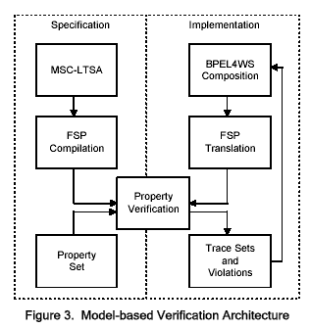
Untouched Area
Figure 20. Model-based Verification Architecture
1. LTSA model checker to detect possible additional (implied) scenarios

2. Examine the trace results of the FSP model checking and iterate tracing resolution until no violations or deadlocks are discovered.

The verification process to our project is as follow.

Step 1. Describe by graphically editing sets of scenarios in the form of message sequence charts

Step 2. Compile and Implied Scenario check

Step 3. Use Animation aid to examine the implied scenario presented

Step 4. Fix our system behavior to eliminate the problem in the form of message sequence charts

Step 5. Review the new architecture (LTS) look like with the revised sequence diagrams

Step 6. Iterate tracing resolution (Step 2. To Step 5.)

Implied scenarios are shown on the following pages.

Schedule for Collector (Implied Scenario)
Figure 21. Implied Scenario for Schedule (A.1)

Schedule for Collector (Architecture Model)

Figure 22. Architecture Model for Schedule 1
Figure 23. Architecture Model for Schedule 2

Collection Data (Implied Scenario)

Figure 24. Implied Scenario for Collection Data 1 (B-1)
Figure 25. Implied Scenario for Collection Data 2 (B-2)
Figure 26. Implied Scenario for Collection Data 3 (B-3)

Collection Data (Architecture Model)
Figure 27. Architecture Model for Collection Data 1
Figure 28. Architecture Model for Collection Data 2

Figure 29. Architecture Model for Collection Data 3
XIII. Activity Diagram Modifications

Considering the breadth of activities that the system conducts and main stakeholder requirements that it fulfills, only two use cases are discussed that of “scheduling” and “collection”. These use cases are examined in depth for both design behavior and structure using a semi automated iterative procedure complete with requirements analysis. The new scheme for behavior analysis considering both positive (desired) and negative (undesired) behavior has resulted in several behavior improvements as noted in “red” in figures 30 and 31 below.

Activity Diagram for "Schedule for Collection (A)"

Figure 30. Activity Diagram for Use Case “Schedule for Collection (A)”

Activity Diagram for "Collect Data (B)"

Figure 31. Activity Diagram for Use Case “Collection Data (B)”

XIV. Requirements Modifying the System

Requirements are added to solve the implied scenarios encountered with use of the LTSA tool. The requirements were developed as part of the requirements analysis discussed next and are shown in Table 17 below.
Schedule for Collector (A)
Requirement | Implied Scenario relate the requirement
The monitor should not begin to work from the monitor schedule until the part time scheduling is complete. | A-1: Monitor checked schedule to make the monitor sheet before part time collector fixed the schedule.

Collection Data (B)
Requirement | Implied Scenario relate the requirement
Monitor must evaluate the data after collectors scribe the data to the datasheet. | B-1: Monitor checks the data sheet before collectors acquire data.
 | B-3: Monitor can not evaluate incomplete collected data
Monitor should contact collector not to landing point. | B-2: Once collectors fail to contact boat, they have to look for another boat monitor doesn't recognize. In this case, it is impossible for monitor to contact with collectors
Table 17. Requirements as a result of the Implied Scenarios

XV. LTSA Tool Limitation

Compiling
No more than 6 instances | When it compliles, computer may freeze
No more than 10 transitions in High level MSC | When it compliles for drawing, there is a shortage of memory
No more than 7 or 8 bMSC | When it compliles for drawing, there is a shortage of memory

Draw View
No more than 62 states | More than 62 states will be not displayed
LTS draw isn't able to copy or select | LTS draw isn't able to copy or select

Editing
Changing instance name affects all transition contained in the instance | bMSC editing
"." isn't available for lavels | bMSC editing
Sequence diagram isn't able to copy or select | Sequence diagram isn't able to copy or select

Table 18. LTSA Tool Specification

XVI. Solution for Concurrency Problem

Figure 32. Solution for Concurrency Problem

XVI. Requirements Analysis

Method for requirements analysis
Figure 33. Method for Requirement Analysis
Requirements analysis for the fishery statistics system follows the same style as presented in the ENSE 622 class notes. Stakeholder goals and high level requirements are gathered and used to form high level use cases. The design intent at this point is that the system should perform a job that interested parties request and sufficient behavior should exist to ensure the goals are fulfilled, structure should be derived from behavior. Textual use cases are then written outlining the specific scenarios of nominal system behavior over which the use cases will cover. Paths of behavior should follow from individual scenarios. A visual representation of the scenarios can be made with activity diagrams outlining several paths of behavior that may be intertwined and meet a decision junctions or across synchronized behavior. From the activity path vantage point, necessary structure should be derived with an analysis outlining related classes of components and how the classes of components and objects are related. Object characteristics including static variables and behavioral dynamic variables must also be noted. Traces of scenarios can be represented by showing exactly how objects pass messages and communicate to perform a task, such a trace is called a sequence diagram. Objects are introduced with the intent of performing certain tasks leading to the ultimate goals of the system. Tracking the object characteristics and behavior to how they can meet the high level goals of the system needs a requirements set. Requirements are the detailed specification of values that object traits must posses. Without direct requirements, specification traits would not be constrained and stakeholder goals would not be met. In addition to determining requirements based on mandating objects to perform activities, requirements can also be developed by mandating objects to avoid performing certain other behaviors. By considering both the ‘shoulds’ and he ‘should nots’ a fully coherent set of requirements can be developed that will ensure desired behavior and exclude undesired behavior. As noted in Figure 33 the LTSA tool used for analyzing behavior played an integral part in the development of consistent requirements that do not serve cross purposes and coherent in that both positive (desired) scenarios and negative (undesired) scenarios are taken into consideration.

Requirements Hierarchy

From such an iterative requirements design scheme that considers both positive and negative scenarios, requirements are internally and externally consistent with imposed high level goals. Iteration is a necessary aspect of the requirements analysis method because the steps for identifying requirements needed to ensure behavior is still manual. Future system design methods may be capable of assigning quantitative values for system objects once proper behavior is identified, but currently the best source of system behavioral knowledge is still the involved cognizant engineer.

Requirements are divided for purposes of tracing into various categories for hierarchy adjustment. First level requirements imposed on the system by the government of El Salvador include the necessity of quality data, low cost, and timeliness in the system. Subcategories at the project level ensure their respective first level requirement is met and are identified by the adjacent table 19 in the second digit. Detailed requirements and quantitative limits on object characteristics are noted in third and fourth level requirements.

R1 Quality Data | R2 Low Cost | R3 Timeliness
1. Adequate data volume  2. Needed data  3. Few errors | 1. Minimize travel expense  2. Minimize training expense  3. Set employee pay rate | 1. Reliable employees  2. Deadlines to work
Table 19. High Level Specification for the Project

XVIII. Tracing Requirements to Behavior
Table 20. High Level Tracing Requirement table
With requirements set through an iterative scheme of fulfilling positive scenarios and denying negative scenarios, there is considerable overlap between the high level requirements across different scenarios. The overlap is not surprising given that general system operation necessitates a whole host of requirements each from a different high level goal. For instance, in order to implement proper scheduling a base of properly qualified employees is required that are assigned deadlines for their work and whom collect the proper type of data and at the right location and frequency. Despite the overlapping of many requirements, there are some needs within the system that are more useful. These most used requirements are evident when the scenarios are traced to the requirements that implement them.

Two requirement sets that are most useful are the need for qualified employees that have proper training for their job assignments and also the setting and maintenance of deadlines for work. Within every functional level of the system there are repeated needs for jobs to be performed correctly and under the constraint of deadlines. When trade-off analysis is performed on these system design, special consideration must be taken for these two requirement sets. They are crucial for the proper operation to the system; however they are both factors that would increase cost. Implementation of requirements does not come cheaply; only after quantitative arguments are presented can the proper level of employee training and work load be determined.
The following table outlines many of the requirements derived for the system. The supported scenario is marked with column “SCENARIO” and related high level requirement is referenced in the column “REQ”. In the column “OBJECT” the object that controls the behavior is listed and in the “STATIC/DYNAMIC VARIABLE” column the quantitative specification is made for the object attribute or a comment is made outlining the appropriate limit when no quantitative value is reasonable. Several requirements also support preventing negative scenarios and besides them a “***” indication is made.

SCENARIO |  |  | REQ | OBJECT |  | STATIC/DYNAMIC VARIABLE
Full time collector is scheduled
A.1.1 | Ministry of Agriculture requests annual collection and analysis |  | R.1.1 | local manager |  | receive information
 |  |  | R.1.3 | local manager |  | arrange transportation
 |  |  | R.3.2 | local manager |  | make schedule
 |  |  |  | local manager |  | make data sheets
 |  |  |  | local manager |  | make schedule
A.1.2 | Local managers make collection schedules/data sheets |  | R.1.1 | local manager |  | make schedule
 |  |  | R.1.2 | local manager |  | make schedule; takes < 2 weeks
 |  |  | R.1.3 | full time collectors |  | Number
 |  |  | R.2.1 | full time collectors |  | number of full time = roundup(avg tot collections per week/ 4.5)
 |  |  | R.2.2
 |  |  | R.3.2 | schedule |  | min sampling freq
 |  |  |  | data sheets |  | type of info
 |  |  |  | schedule |  | sampling freq > min sampling freq
 |  |  |  | data sheets |  | type of info = req type of info
 |  |  |  | full time collectors |  | qualifications
 |  |  |  | full time collectors |  | number of full time = roundup(avg tot collections per week/ 4.5)
 |  |  |  | full time collectors |  | Education >= high school
 |  |  |  | full time collectors |  | qualifications > experience with fish industry
 |  |  |  | full time collectors |  | Training
 |  |  |  | full time collectors |  | trained >= initial training
 |  |  |  | full time collectors |  | trained >= annual training
 |  |  |  | full time collectors |  | trained >= additional
 |  |  |  | full time collectors |  | trained >= additional if (error > 1 error per site)
 |  |  |  | landing points |  | sampling rate > 0
 |  |  |  | landing points |  | sampling rate > 0
 |  |  |  | full time collectors |  | Collect
 |  |  |  | full time collectors |  | 1000 < collect < 1200 hours
 |  |  |  | full time collectors |  | 1000 < collect < 1700 hours and not low tide for shell fishers
A.1.3 | Local manager disburses schedule/data sheets to collectors |  | R.3.2 | full time collectors |  | get schedule
 |  |  |  | full time collectors |  | Telephone = yes
 |  |  |  | full time collectors |  | Telephone = yes
 |  |  |  | full time collectors |  | get schedule < 3 days after notification
A.1.4 | If the full time collector cannot perform the schedule the local manager and collector iterate on its form |  | R.1.2 | schedule |  | min sampling requirements
 |  |  |  | full time collector |  | adjusts schedule
 |  |  |  | local manager |  | adjusts schedule
 |  |  |  | local manager |  | full time collector (adjusts schedule) + local manager (adjusts schedule) <= 2 days
A.1.5 | Local manager sends the data sheet and collection schedule to MofAg |  | R.1.2 | local manager |  | validate data sheet and schedule = validated
A.1.6 | Transportation is arranged for the collector and monitor to travel to the landing points |  | R.1.3 | local manager |  | arrange transportation
 |  |  | R.2.1 | full time collector |  | mode of transportation = have vehicle
 |  |  |  | full time collector |  | receive transportation pay = distance traveled * $.15/mile
 |  |  |  | part time collector |  | receive transportation pay = postage costs
Part time collector is scheduled
A.2.1 | Ministry of Agriculture requests that the fishery statistics program conduct its annual collection and analysis |  | R.1.1 | MofAg |  | orders sampling
 |  |  | R.1.3 |  |  | budget = $X
 |  |  | R.3.2 |  |  | min sampling freq = F0
 |  |  |  |  |  | type of info = Ti
 |  |  |  |  |  | 6 months
A.2.2 | Local managers make collection schedules/data sheets |  | R.1.1 | local manager |  | make schedule
 |  |  | R.1.2 | local manager |  | make schedule; takes < 2 weeks
 |  |  | R.1.3 | schedule |  | min sampling freq
 |  |  | R.2.2 | data sheets |  | type of info
 |  |  | R.3.2 | schedule |  | sampling freq > min sampling freq
 |  |  |  | data sheets |  | type of info = req type of info
 |  |  |  | part time collectors |  | qualifications
 |  |  |  | part time collectors |  | number of part time = number of inaccessible landing points
 |  |  |  | part time collectors |  | Education >= high school
 |  |  |  | part time collectors |  | qualifications > experience with fish industry
 |  |  |  | part time collectors |  | Training
 |  |  |  | part time collectors |  | trained >= initial training
 |  |  |  | part time collectors |  | trained >= annual training
 |  |  |  | part time collectors |  | trained >= additional
 |  |  |  | part time collectors |  | trained >= additional if (error > 1 error per site)
 |  |  |  | landing points |  | sampling rate > 0
 |  |  |  | part time collectors |  | number of part time = number of inaccessible landing points
 |  |  |  | landing points |  | sampling rate > 0
 |  |  |  | part time collectors |  | Collect
 |  |  |  | part time collectors |  | 1000 < collect < 1200 hours
 |  |  |  | part time collectors |  | 1000 < collect < 1700 hours and not low tide for shell fishers
A.2.3 | Local manager mails schedule/data sheets to part time collectors |  | R.3.2 | part time collectors |  | number of part time = number of inaccessible landing points
 |  |  |  | part time collectors |  | qualifications > 30 years old
 |  |  |  | part time collectors |  | qualifications > grammar school education
 |  |  |  | part time collectors |  | mail box = yes
 |  |  |  | part time collectors |  | mail box = yes
 |  |  |  | part time collector |  | Collect
 |  |  |  | part time collector |  | Trained
 |  |  |  | part time collector |  | trained = initial training
 |  |  |  | part time collector |  | trained = info on fish
 |  |  |  | part time collector |  | trained = collection methods
 |  |  |  | part time collector |  | Trained
 |  |  |  | part time collector |  | trained = initial training
 |  |  |  | part time collector |  | trained = annual
 |  |  |  | part time collector |  | Trained
 |  |  |  | part time collector |  | trained = refresher if errors > 1 error per day
Monitors are scheduled
A.3.1 | The monitors are informed of the collection schedule when the schedules are finalized |  | R.3.2 | monitors | *** | get schedule from local manager
 |  |  |  | monitors | *** | Telephone = yes
 |  |  |  | monitors | *** | receive schedule < 2 days of notification
 |  |  |  |  | *** | receive schedule after full time collector completes
A.3.2 | Monitors prepare sheets for evaluation of collection |  | R.1.3 | monitors |  | Monitors
 |  |  | R.2.2 | monitors |  | grading criteria = possess
 |  |  |  | monitors |  | monitor schedule = possess
 |  |  |  | monitors |  | trained = evaluating collectors
 |  |  |  | monitors |  | monitor >= 20% full time collectors
 |  |  |  | monitors |  | monitor >= 5% part time collectors
A.3.3 | Monitors advises local manager of monitoring schedule |  | R.3.2 | monitors |  | send schedule = to local office
A.3.4 | Transportation is arranged for the collector and monitor to travel to the landing points |  | R.2.1 | local manager |  | arrange transportation
 |  |  |  | monitor |  | mode of transportation = have vehicle
 |  |  |  | monitor |  | receive transportation pay = distance traveled * $.15/mile
Full time collectors collect data
B.1.1 | Collectors arrive at the landing point |  | R.1.3 | full time collector |  | qualification = read map
 |  |  | R.2.1 | collector |  | Collection = begin 1000 hours
 |  |  | R.3.1
 |  |  | R.3.2
B.1.2 | Collectors will retrieve landing point information |  | R.1.3 | full time collector |  | qualification = identify size of landing point
 |  |  | R.3.1 | full time collector |  | qualification = identify # of boats at landing point
B.1.3 | Collector contacts a new boat |  | R.1.3 | data sheet |  | type of info
 |  |  | R.3.1 | data sheet |  | type of info <= 15 minutes to get info
 |  |  |  | full time collector |  | trained >= initial training
 |  |  |  | full time collector |  | Collect
 |  |  |  | full time collectors |  | 1000 < collect < 1200 hours
 |  |  |  | full time collectors |  | 1000 < collect < 1700 hours and not low tide for shell fishers
 |  |  |  | full time collectors |  | collect (not =) during lunch
B.1.4 | Collects time of sampling event |  | R.3.1 | full time collector |  | qualification
 |  |  |  | full time collector |  | qualification = has watch
B.1.5 | Collects boat information boat name, size, crew |  | R.1.3 | full time collector |  | Trained
 |  |  |  | full time collector |  | trained >= (initial, annual)
B.1.6 | Collects fishing method net size, mesh size, hours of fishing, location of fishing |  | R.1.3 | full time collector |  | Trained
 |  |  |  | full time collector |  | trained >= (initial, annual)
B.1.7 | Collects fish information types of fish, weight, size, maturity |  | R.1.3 | full time collector |  | Training
 |  |  | R.3.1 | full time collector |  | training = (initial, annual)
 |  |  |  | full time collector |  | equipment = measuring tape
 |  |  |  | full time collector |  | equipment = spring scale
 |  |  |  | full time collector |  | training = (initial, annual)
B.1.8 | Once all fish types are collected at a boat go to a new boat |  | R.1.1 | full time collector |  | collect = complete boat
 |  |  |  | full time collector |  | training = initial
B.1.9 | Once all boat are collected from go to a new landing point |  | R.1.1 | full time collector |  | collect = complete landing point
B.1.10 | Once all landing points are collected from, return to local office |  | R.3.2 | full time collector |  | return data
 |  |  | R.2.3 | full time collector |  | return data <= 2 weeks of initiation
 |  |  |  | full time collector |  | Pay
 |  |  |  | full time collector |  | pay = hours worked * $y/hour
 |  |  |  | full time collector |  | pay = miles traveled * $.15/mile
 |  |  |  | full time collector |  | receive pay = every 2 weeks
Part time collectors collect data
B.2.1 | Collectors arrive at the landing point |  | R.1.3 | part time collector |  | qualification = reside at landing point
 |  |  | R.3.1 | part time collector |  | Collection = begin 1000 hours
 |  |  | R.3.2
B.2.2 | Collectors will retrieve landing point information |  | R.1.3 | part time collector |  | qualification = identify size of landing point
 |  |  | R.3.1 | part time collector |  | qualification = identify # of boats at landing point
B.2.3 | Collector contacts a new boat |  | R.1.3 | data sheet |  | type of info
 |  |  | R.3.1 | data sheet |  | type of info <= 15 minutes to get info
 |  |  |  | part time collector |  | trained = (initial, annual)
 |  |  |  | part time collector |  | Collect
 |  |  |  | part time collector |  | 1000 < collect < 1200 hours
 |  |  |  | part time collector |  | 1000 < collect < 1700 hours and not low tide for shell fishers
 |  |  |  | part time collector |  | collect (not =) during lunch
B.2.4 | Collects time of sampling event |  | R.3.1 | part time collector |  | qualification
 |  |  |  | part time collector |  | qualification = has watch
B.2.5 | Collects boat information boat name, size, crew |  | R.1.3 | part time collector |  | Training
 |  |  |  | part time collector |  | trained >= (initial, annual)
B.2.6 | Collects fishing method net size, mesh size, hours of fishing, location of fishing |  | R.1.3 | part time collector |  | Training
 |  |  |  | part time collector |  | trained >= (initial, annual)
B.2.7 | Collects fish information types of fish, weight, size, maturity |  | R.1.3 | part time collector |  | Training
 |  |  | R.3.1 | part time collector |  | training = (initial, annual)
 |  |  |  | part time collector |  | equipment = measuring tape
 |  |  |  | part time collector |  | equipment = spring scale
 |  |  |  | part time collector |  | training = (initial, annual)
B.2.8 | Once all fish types are collected at a boat go to a new boat |  | R.1.1 | part time collector |  | collect = complete boat
 |  |  |  | part time collector |  | training = initial
B.2.9 | Once all boat are collected from go to a new landing point |  | R.1.1 | part time collector |  | collect = complete landing point
B.2.10 | Part time collectors return information by mail |  | R.3.2 | part time collector |  | return data
 |  |  | R.2.3 | part time collector |  | return data <= 2 weeks of initiation
 |  |  |  | part time collector |  | Pay
 |  |  |  | part time collector |  | pay = hours worked * $y/hour
 |  |  |  | part time collector |  | pay = postage
 |  |  |  | part time collector |  | receive pay = every 2 weeks
Monitoring of full time collector
B.3.1 | The monitors travel to the landing points |  | R.2.1 | monitor |  | Travel
 |  |  | R.3.2 | monitor |  | get collector schedule = after collector schedule finalized
 |  |  |  | monitor |  | receive pay = after every 2 weeks
 |  |  |  | monitor |  | mode of transportation = have vehicle
B.3.2 | Monitor scheduled work |  | R.3.2 | monitor | *** | contact collector = when landing point is reached
 |  |  |  | monitor |  | grading criteria = criteria for collection
 |  |  |  |  | *** | grade (during, after) collector works
 |  |  |  | monitor |  | trained = initial
 |  |  |  | monitor |  | qualification = high school education
B.3.3 | Monitors write monthly reports |  | R.1.3 | monitor |  | write monitor report
 |  |  |  | monitor |  | write monitor report = monthly
 |  |  |  | monitor |  | send report = within 1 week of end of month
B.3.4 | Monitors send evaluation sheets to local office |  | R.3.2 | monitor |  | send report = to local office
Monitoring of part time collector
B.4.1 | The monitors travel to the landing points |  | R.2.1 | monitor |  | Travel
 |  |  | R.3.2 | monitor |  | get collector schedule = after collector schedule finalized
 |  |  |  | monitor |  | receive pay = after every 2 weeks
 |  |  |  | monitor |  | mode of transportation = have vehicle
B.4.2 | Monitor scheduled work |  | R.2.2 | monitor |  | contact collector = when landing point is reached
 |  |  | R.3.2 | monitor |  | grading criteria = criteria for collection
 |  |  |  | monitor |  | trained = initial
 |  |  |  | monitor |  | qualification = high school education
B.4.3 | Monitors correct deficiencies of part time collectors on the job |  | R.1.3 | monitor |  | provide training if errors > 1 error per collection
B.4.4 | Monitors write monthly reports |  | R.3.2 | monitor |  | write monitor report
 |  |  |  | monitor |  | write monitor report = monthly
 |  |  |  | monitor |  | send report = within 1 week of end of month
B.4.5 | Monitors send evaluation sheets to local office |  | R.3.2 | monitor |  | send report = to local office
XIX. Phase Two Conclusions

Several improvements have been made to the fishery statistics system by using a semi-automated behavioral design scheme with iteration on behavior and requirements. A new visual aid has been demonstrated that better represents the condition of a reactive system and continues to support and surpass the qualities of the standard state chart diagram. Work with the LTSA tool helped to identify confusing and non-intentional behaviors. These faulty behaviors were labeled as negative scenarios and appropriate measures were taken in the requirements analysis to prevent them. Requirements were also derived to support the completion of scenarios. In most cases the requirements were reflected in a quantitative manner. By transcending high level goals into quantitative details, designers can take advantage of a trade off analysis for optimized system design in a meaningful way.

XX. Temporal Analysis

1. Benefits of LTSA Analysis

There have been several benefits to using LTSA to analyze the system.
- Used LTSA to analyze concurrency difficulties with components sharing a single resource. Requirements were then developed to prevent this type of resource misuse. The tool was vital in identifying the resource sharing.

- We were also able to identify implied and negative scenarios which helped close off requirement gaps with our system. LTSA performed the task of identifying all potential system paths based on our system definition.

- Deadlocks were identified in the system specification and corrected. We finished with an internally consistent system design because once all paths were identified it was simple to clearly see system deadlocks.

2. How to Expand the Analysis?

Although, a coherent system is defined and requirements have been identified at several levels, there are still several factors which must be accounted for in design before implementation.

- LTSA is limited to search for static behavior. It would be useful to identify a method for taking time related effects into account during system analysis. This will allow a more realistic perspective of system operation for verification of time constraints and proper validation of system operation.

- We are limited to search for deadlock problems. Although deadlock is a serious concern, once time is considered there are other types of unwanted behavior that can occur such as excessive ‘waiting’ and ‘synchronized’ events which require proper timing for operation.

- Efficiency of the system is not analyzed because a static view is only possible, but once time is considered efficiency in terms of performance/time can be accounted for. Such metrics are crucial for verifying system design to requirements.

3. Why is Time Important?

  - Time must be considered as a performance factor.

  - For some systems, the time required to perform a function may be a safety factor.

  - The availability of components may be determined by time.

  - For efficiency, components must perform their functions in a set amount of time or order because of interaction with other components. Waiting time may need to be minimized.

  - The rate at which a function is performed may determine the output.

  - Multiplicity of class related objects, how do timing requirements change when there are multiple of the same type of object.

  - The order in which actions take place or states are reached is related to proper operation.

4. How Does UPPAAL Contribute to Temporal Analysis?

- Simple system may be drawn out and analyzed by inspection, but larger systems with multiple states and objects require a better method.

- Instead of verifying single “test cases” with traditional verification methods, UPPAAL allows testing of all paths across a range of times.

- Multiple instantiations are allowed of a single class of objects with different input parameters.

- Local time requirements may be applied to states and transitions to denote lower level requirements on time.

- Global or high level time requirements may be tracked with a global clock that updates according to local time steps.

- Temporal requirements may be verified against the system model by using temporal logic queries.

- A visual representation of object states is given that conserves space as compared to LTSA.

- The visual representation also allows validation of system processes.

5. How is Time Involved in the Fishery Statistics System?

Temporal effects in the system are most easily seen by the time related requirements in several of the key objects.

A. Collector:

- Time while idle at home
- Different idle times are used to represent the maximum time in between workdays
- For the collector we assume that he works everyday

- Time to make a schedule and send it the monitor
- There is a minimum time to perform this transition of at least one hour

- Time to travel to a landing point
- For different landing points different distances away we assume a distribution of travel times
- If this minimum assumed travel time is limiting hiring more collectors could reduce average travel time

- Time associated with collecting
- If the minimum assumed time to collect information more collectors may be required
- Additional training may be required to reduced collection time, but this training costs money
- Collection time could be reduced by reducing the amount of information that is required to be collected, but that limits how much information that system has available to make decisions with

B. Monitor:

- Time while idle at home
- Different idle times are used to represent the maximum time in between workdays
- For the collector we assume that he works everyday

- Time to change the schedule and return it to the collector
- There is a minimum time to perform the transition of at least one hour
- Different times may require better communication or planning

- Time to travel to a landing point
- For different landing points different distances away we assume a distribution of travel times
- If this minimum assumed travel time is limiting hiring more collectors could reduce average travel time

- Time to monitor collector
- Performed during collection and given same time as collection

C. Fishermen:

- Time out fishing
- Fishermen are assumed to be either fishing near the coast which takes a couple of hours or deep sea fishing which is several times as lengthy
- By changing the average time fishing we are assuming mostly collecting from nearby coastal or harbor fishermen
- Some deep sea information is needed so the option to take this type of information should not be removed

XXI. UPPAAL Introdution

UPPAAL is a tool for modeling, validating, and verifying real-time systems, which can be represented as a collection of finite state machines, which reference to clocks (timed automata), and which communicate through shared channels. Networks of timed automata are represented by UPPAAL with simple formula for depicting state transitions over finite time steps within a single object and between sets of objects. The set of states S is defined as [(L, v) | v satisfies Inv(L)], where L is a location vector, v is a function (a valuation) which maps integer variables and clocks to their values, and Inv is a function mapping locations and location vectors to invariants (internal variable constraints). A statement used within UPPAAL such as (S, s0, ->) shows the current set of states S, also s0 the initial set of states composed of initial variable and clock values, and -> the available transitions, which could be either delay or action transitions.

The UPPAAL tool consists of three main parts used for analyzing a system:

1. system editor
2. simulator
3. verifier

System Editor

The system editor is used to input the system description for analysis. A system is described by a set of processes templates, global and local declarations, process assignments, and a system definition. State nodes and transitions are used to represent a system. The select tool is used to select, move, modify and delete these elements. State nodes can be labeled as ‘initial’, ‘urgent’, or ‘committed’. The object’s life begins in the initial state and the urgent and committed designators are used to denote states that must be passed through without delay.
C
U
Fig 1. Initial, committed, and urgent state nodes

States can also be given an ‘invariant’, which is a clock condition that must be true while that state exists. Transitions are labeled with ‘guards’, ‘syncs’, and ‘updates’. A guard is used to denote a condition on a clock or variable that must be satisfied in order to proceed with the transition. Syncs are synchronizations that take place between objects that share a common channel. When a sync is called during a transition belonging to one object all transitions tied to that sync belonging to other objects occur. A transition with synchronization label ‘a!’ emits a broadcast on channel ‘a’ and any transition with synchronization label ‘a?’ will synchronize with the emitting process. Urgent channels are similar to regular channels, except that it is not possible to delay in a state if it is possible to synchronize over an urgent channel. Updates occur during transitions and change a variable value either to a new integer value or reset a clock.

x := 0 clock (or integer variable) x is reset to zero

j := ( i[1]>i[2] ? i[1] : i[2] ) a variable j is assigned the value of array element i[1] if i[1] is greater than i[2], else the value of i[2]. This is equivalent to j := i[1] >? i[2]

x := 1, y:=2*x integer variable x is set to 1 and y to 2 (assignments are interpreted sequentially)

n==5 ← guard
a! ← initiating channel
x:=0 ← clock ‘x’ is reset
a? ← receiving channel
Fig 2. Transition labels

Fig 3. Transition and State Invariants

Objects are implemented as instantiations of the process templates. This implementation is provided in the ‘process assignment’ window. Here, several objects from the same template type may be initialized with different input parameters to form part of the system.

P:=Q();
Process P is an instance of template Q that does not have any parameters.
S1:=R(x,1);
S1:=R(x,4);
Process S1 is an instance of template R that has two parameters and process S2 is an instance of the same template R, but with a different value for one of the parameters

A system definition must also be supplied which lists all process objects of the system. Process objects are initially defined on the process assignment window as instantiations of process templates. On the system definition window process objects must be shown as follows:

system P, Q; system consisting of the two processes objects P and Q

Variable declarations may be either local or global and can declare clocks, bounded integer variables and arrays of integers, constants, and channels.

const a 1; constant ‘a’ with value 1
bool b[8], c[4]; two bit arrays b and c, with 8 and 4 elements respectively
int[0,100] a:=5; an integer variable with the range [0,100] and initial value 5
int a[2][3] := { { 1, 2, 3 }, { 4, 5, 6} }; an integer array with default range and value
clock x, y; two clocks x and y
chan d; a channel
urgent chan e; an urgent channel

Simulator

The simulator is a validation tool that permits the visualization of dynamic system behavior during system development. By simulating system behavior with a real-time tool, individual behavior traces may be executed to determine if design goals are reached. Several views are available through the simulator. One window displays available transitions that can be individually selected to walk through a system use-case scenario. When user selected transitions are made another window displays state transitions made by each object in the system. Current states and next-available transitions are highlighted. Global and local variables along with clock values are shown during a system trace and updated consistent with the trace. A sequence diagram view is also available, which shows state progression for individual objects and shared communications ‘synchronization channels’ between objects. Vertical lines denote processes and horizontal lines denote synchronizations.

Verifier

The verifier mode allows simple logical queries to made of the system. These queries allow for the verification of system requirements and determinations of process deadlocks. UPPAAL responds with a comment that “the property is satisfied” or “the property is not satisfied”. The language type to interface with the verifier is referred to as requirements specification language.

Several types of verification questions may be used. For instance it is possible to test whether a certain process is in a given location using expressions on the form ‘process.location’, where ‘process’ is the process object name and ‘location’ is the name of the state.

The syntax ‘p --> q’ represents a ‘leads to property’ meaning ‘A[] (p imply A<> q)’. Essentially, ‘p --> q’ holds if and only if whenever ‘p’ holds eventually ‘q’ will hold as well. Because UPPAAL uses timed automata, this holds for delay transitions as well as action transitions.

A[] 1<2 invariantly 1<2
E<> p1.cs and p2.cs satisfied if the system can reach a state where both process ‘p1’ and ‘p2’ are in their locations ‘cs’
A[] p1.cs imply not p2.cs invariantly process ‘p1’ in location ‘cs’ implies that process ‘p2’ is not in location ‘cs’
A[] not deadlock invariantly the process is not deadlocked

Five types of properties can be queried in the verifier; these five may be reduced to combinations of two unique properties.

Name | Property | Equivalent to
Possibly | E<> p
Invariantly | A[] p | not E<> not p
Potentially always | E[] p
Eventually | A<> p | not E[] not p
Leads to | p --> q | A[] (p imply A<> q)

Table 1. Properties for Verification

In the above table the symbols have the following meanings:
E == $∃$ == for a path there exists
A == $∀$ == for all paths there exists
Not == ~ == $¬$
and == == &&
or == == ||
implies == $→$
--> == leads to
iff == $↔$
< > == eventually
[ ] == henceforth

The property ‘E<> p’ is satisfied for a timed transition system if and only if there is a sequence of transitions ‘s0-->s1 -->...-->sn’ where ‘s0’ is the initial state and ‘sn’ satisfies ‘p’.

The property ‘E[] p’ is satisfied if and only if there is a sequence of transitions ‘s0-->s1-->...-->si-->...’ for which p holds in all states ‘si’ for all ‘d: (Ln, vn + d)’ or where there is no outgoing transition from (Ln, vn).

The deadlock property may be satisfied for a state ‘(L, v)’ if and only if for all ‘d >= 0’ there is no transition successor to ‘(L, v + d)’.

A particular location may be evaluated to determine if the system exists in that location at a particular time step. Expressions of the form ‘P.l’, where ‘P’ is a process and ‘L’ is a location are satisfied in a state (L, v) if and only if ‘P.l’ is in ‘L’.

XXII. Simplified Example Walk-through

The following example is presented to demonstrate several of the concepts discussed above and the semantics and capabilities of the verifier option in UPPAAL. At the same time a dual processes which occur in the system are used for the example.

XXIII. Time as Represented by Local and Global Clocks

- High level global clock requirements are driven by the lower level object clock requirements
- Local time is used for setting local requirements and pushes along the global clock

XXIV. Temporal System Representation of Fishery Statistics System

In the following figures a series of sequence diagrams are shown which describe the system operating in a “best” case where the collectors and monitors do not wait for the fisherman to arrive at the landing point and a “worst” case where the fisherman arrives well after the collector and monitor forcing them to wait. The similar case is shown when there are two landing points instead of one.
Scenarios:
Normal Collection of Information and Monitoring with a Delay due to Fishermen
Coll1.1 “collector transitions to make schedule”

Coll1.6 “collector sends schedule
and shows it to monitor”

Mon1.2 “monitor approves schedule
and makes monitor sheet”

Fish1.6 “fisherman1 gets ready”

Fish1.5 “fisherman1 goes fishing”

Coll1.13 “collector prepares data sheet”

Coll1.2 “collector arrives at landing point”

Mon1.3 “monitor arrives at landing point”

Fish1.1 “fisherman1 lands boat”

Fish1.2 “fisherman1 works on boat unloading”

LandPoint1.3 “collector contacts fisherman1”

LandPoint1.10 “monitor contacts collector”

Coll1.11 “collector records data”

Coll1.9 “collector completes recording data”

Mon1.5 “monitor departs landing point”

Coll1.10 “collector leaves fisherman”

Fish1.3 “fisherman1 sells fish”

Fisher1.4 “fisherman1 departs landing point”

Coll1.3 “collector departs landing point”

Coll1.4 “collector sends in data collected”

Coll1.5 “collector returns to idle”

Normal Collection of Information and Monitoring with No Delay
Fish1.6 “fisherman1 gets ready”

Fish1.5 “fisherman1 goes fishing”

Coll1.1 “collector transitions to make schedule”

Coll1.6 “collector sends schedule
and shows it to monitor”

Mon1.2 “monitor approves schedule
and makes monitor sheet”

Coll1.13 “collector prepares data sheet”

Fish1.1 “fisherman1 lands boat”

Fish1.2 “fisherman1 works on boat unloading”

Coll1.2 “collector arrives at landing point”

Mon1.3 “monitor arrives at landing point”

LandPoint1.3 “collector contacts fisherman1”

LandPoint1.10 “monitor contacts collector”

Coll1.11 “collector records data”

Coll1.9 “collector completes recording data”

Mon1.5 “monitor departs landing point”

Coll1.10 “collector leaves fisherman”

Coll1.3 “collector departs landing point”

Fish1.3 “fisherman1 sells fish”

Fisher1.4 “fisherman1 departs landing point”

Coll1.4 “collector sends in data collected”

Coll1.5 “collector returns to idle”

Collector and Monitor cannot work as Fisherman never Arrived at Landing Point

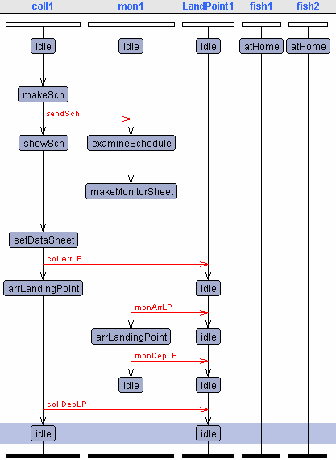
Coll1.1 “collector transitions
to make schedule”

Coll1.6 “collector sends schedule
and shows it to monitor”

Mon1.2 “monitor approves schedule
and makes monitor sheet”

Coll1.13 “collector prepares data sheet”

Coll1.2 “collector arrives at landing point”

Mon1.3 “monitor arrives at landing point”

Mon1.8 “monitor departs landing point”

Coll1.3 “collector departs landing point”

Two Landing Points Sequence Diagram with No Delay

XXV. Temporal Analysis Results

1. Most Efficient Path

For both one and two landing points there exists a path where a required amount of information is collected in a minimum amount of time. When a second landing point is introduced it would be valuable to see if the minimum time changes based on the differences between landing point parameters such as location and population.

Minimum Collecting Time Temporal Logic for Case of One Landing Point w/o Monitoring
E<> coll1.sendData and collGTime<5 will be satisfied
E<> coll1.sendData and collGTime<4 will be not satisfied (stuck)
Therefore, the minimum time to collect one set of data w/o monitoring is 4 units.

Minimum Collecting Time Temporal Logic for Case of One Landing Point w/o Monitoring
E<> coll1.sendData and monitorSheet>0 and collGTime<7 will be satisfied
E<> coll1.sendData and collGTime<6 will be not satisfied (stuck)
Therefore, the minimum time to collect one set of data with monitoring is 6 units.

Temporal Logic in Case of Two Landing Points
E<> coll1.sendData and dSheet[0][0]>0 will be not satisfied (stuck)
This statement means that is not possible for the collector to collect data and send it; however a simulation quickly proves that there are several paths where this term will be satisfied. This proves that the UPPAAL tool is not capable of verifying such large system.

2. Maximum Information Collected

Another goal of the system is to collect the maximum amount of data in a given period of time. Through this temporal modeling an estimate should be reach on how much data can be expected and what requirements may need adjustment to increase data collection. The case of one landing point will be analyzed.

Temporal Logic in Case of One Landing Point
E<> coll1.sendData and nData>2 will be not satisfied (stuck)
This statement means that it is not possible for the collector to collect and send more than two two sets of data; however, through a simulation the system is capable of collecting more than two data sets. The UPPAAL tool is limited in determining how much information may be collected because it cannot handle the number of possible paths allowed by the higly branched system.

XXVI. Limitations of UPPAAL Tool

During the analysis and modeling work several obstacles have been encountered due to the limitations of the UPPAAL tool.

- Limited language capability: It is difficult to use arrays unlike in JAVA or C++. Also there is no way to use loops in the language.
- Poor variable communication: During programming when we desire to restrict the access of certain variables it is difficult to do. Variables are either global or object local so there is no easy way to share variables between a limited set of objects.
- Size and complexity limitations: Locks up on difficult time consuming problems instead of stating a negative response. For two landing points we are not capable of verifying because of computation limitations. For a single landing point we cannot verify more than 2 data collection cycles because the branch state description is too large for UPPAAL to verify all paths. Our experience from the single landing point models explains why our two landing point verification does not work. With the two landing point model where the collector must return to reschedule, the tool cannot handle the second branch layer.
- No copy/past or export capability.

Visualization of UPPAAL Volume Limitation

XXVII. Verification Based Changes

System modeling and correction is an iterative process, which can benefit from the verification questioning allowed in UPPAAL. By identifying logical faults may not be apparent during simulations a more coherent system specification may be derived.

Scheduling Corrections

A problem that was identified during temporal analysis was that of mis-scheduling because of improper communication between the collector and monitor. If the parties do not synchronize their communications they may perform their tasks based on different schedules. To facilitate easy identification if such a situation occurs a deadlock state was introduced and a variable id for the schedule. The mis-schedule state is entered if the id codes between the monitor and collector schedule do not coincide. This is applicable to the real life model because human communication errors are common! The figures below show in a graphical form the correction.
Temporal Logic Check
E<> schUnMatch
Before improving
After improving

Collection Corrections

The collection problem requires a more detailed analysis depending on the model we choose whether the “best”, “B” case with no delay by the collector and fisherman or the “worst”, “W” case where there may be significant waiting.

By taking into consideration object parameters such as the travel distance for the collector whether “Far” or “Near” and the type of fisherman whether “Coastal” or “Deep sea”, we show a range of global collection times. There is also a difference depending on whether there are one or two fisherman and if both fisherman are of the same type. With a goal of less than 24 time units for collection, several system points to not meet the requirement.

 | One Fisherman |  |  |  | Two Fishermen
 | Coastal |  | Deep |  | 2xCoast |  | 2xDeep |  | C/D
Far | 10 (B) | 16 (W) | 10 (B) | 22 (W) | 10 (B) | 24 (W) | 10 (B) | 28 (W) | 10 (B) | 28 (W)
Near | 4 (B) | 10 (W) | 4 (B) | 20 (W) | 4 (B) | 10 (W) | 4 (B) | 20 (W) | 4 (B) | 20 (W)

We learn from this analysis and the tables and figures on the following pages that for landing points at far distances from the collectors and where several fisherman reside some changes must occur in order to collect information in a reasonable time. Previously, the concept of the part-time collector was introduced. This individual is a temporary worker and lives at the landing point. Because this person lives at the landing point travel times and wait times do not need to be considered. Although there is a time advantage here, there is a loss in terms of quality of collection because these workers are not usually as skilled and monitoring them is problematic. The type of collector must be considered in a full trade off where time and cost may be compared to find a best solution design.

XXVIII. Time Analysis

Best Case: Fishermen at landing point when Collector and Monitor arrive at the Landing Point.

Worst Case: Fishermen is not a landing point when the Collector and Monitor arrive.

Best Case: Fishermen at landing point when Collector and Monitor arrive at the Landing Point.

Worst Case: Fishermen is not at landing point when Collector and Monitor arrive.

In the above figures the local time clocks for “Schedule Time (Tsch)”, “Collecting Time (Tcol)”, and “Monitoring Time (Tmon)” are shown on the vertical axis contributing to increment the global or “Total (Tsys)” time of the system on the horizontal axis. Here the total system time is the sum of the scheduling time and the union of the collection and monitoring time. The union is taken for collection and monitoring because these tasks are performed at the same time and double counting would not be correct. Mathemtaically, Tsys = Tsch + (Tcol Tmon). It is clear that in the “worst” case due to the delay of waiting for the fisherman to arrive Tcol and Tmon are high and contribute significantly to Tsys.

Best Case vs Worst Case on Schedule Time

Best Case vs Worst Case on Collecting Time

Best Case vs Worst Case on Monitoring Time

In the above figures the difference between the “best” and “worst” case scenarios are displayed with regards to the local schedule clock, collecting clock, and monitoring clock. Whereas the difference for scheduling is null, the worst case time is approximately 2.6 times greater than the time in best case time for collecting and monitoring.
XXVIII. Phase Three Conclusions

Temporal modeling of the system in the final phase reinforced several requirement constraints that were first identified during the initial system trade-off analysis of phase one. The requirement in phase one was the number of local collection offices and the method of transportation. The analysis indicated that inorder to enough information many collectors were required and required to collect often but due to time and transportation cost constraints there needed to be many local offices to cut down on transportation costs. The same message is displayed in this phase of the analysis where “wait” time becomes significant and a system designed is needed to reduce this costly wasted time. A solution would be to pay “part-time” collectors, individuals living at the landing point and collecting information free-lance for the Ministry of Agriculture. Such a set-up would still require monitoring and training, but would results in few local offices, lower transportation costs, and no wasted time associated with delay.

The temporal based analysis highlights an important point of the UPPAAL modeling tool that would be useful for deeper understanding. That is, the tool cannot fully model scenarios because of memory limitations. There is a definite bound on how many state transitions may be tabulated and for a highly concurrent system the tool fails early in the analysis. There would be value in working with a tool where input parameters may be entered as with the UPPAAL tool and queries may be made to the system on identifying the “most efficient path”. While the current tool does identify for simple systems if certain conditions are attainable it does so in a passive manner. The statement is either returned as “satisfied” or “not satisfied” a tool that could trace the path that fulfilled the requirement and other sets of paths that could fulfill a “soft” requirement system modification based on the verifier would be far more useful. Modifications are only possible for the fishery statistics system because of the simplicity, but such a convenience is not always available for larger systems.

XXIX. Project Conclusions

Formalized in the first phase of the project, the system model has progress in phases two and three by different methods of analysis (LTSA and UPPAAL), requirements modification, and formal representation. Enough work has been performed to demonstrate functionality of the system; however, requirements have not been fully verified. Study of similar systems could aid with more realistic estimates of performance metrics and detailed requirements, but some of the requirement best estimate values may not be known until system implementation such as how much information may be collected and the timing of some communication events. During the second and third phase of the project (ENSE 622 and 623), more emphasis was placed on modeling and verifying using two emerging analysis methods LTSA and UPPAAL. These modeling software are still in development and are not adequate for completely verifying and validation or highly concurrent system. This is not to say that using these tools was not useful, significant insight was gained into the system and several new requirements were developed to ensure proper behavior.

The work in this report is exportable in the sense that information collection was studied in the abstract, which is useful to many systems both human and software based. Many of the requirements and lessons learned from analyzing this system would be valuable to these other information collection system.

Both authors of the report have learned many concepts and fundamental systems engineering techniques, which will be valuable for use elsewhere in real life systems.

XXX. References and Web Resources

ENSE 621
- Mark Austin: ENSE 621 Systems Modeling and Analysis and Lecture Notes
- Mark Austin: Lecture Notes for ENSE 621/ ENPM 641: Visual Modeling of Engineering Systems with UML
- Learning UML, O’Reilly 2003
- Applying Use Cases: A Practical Guide, by Geri Schneider and Jason P. Winter (1998)
- FAO Fisheries Department: Fishery Statistics Reliability and Policy Implications http://www.fao.org/fi/statist/nature_china/30jan02.asp
- Statistic Division in El Salvador: Annual report 2000, 2001 and 2002
- Statistical Information Government Service in El Salvador: Statistical Information list http://www.servicios.gob.sv/Completo2.htm

ENSE 622
- Mark Austin, ENSE 622: Systems Engineering Requirements, Design, and Trade-Off Analysis and Lecture Notes
- Magee and Kramer, Concurrency: State Models and Java
- Mark Austin, Design Structure Matrices Tutorial
- LTSA BPEL4WS plug-in, http://www.doc.ic.ac.uk/ltsa/bpel4ws/

ENSE 623
- P. BELLINI, R. MATTOLINI, and P. NESI, Temporal Logics for Real-Time System Specification
- Johan Bengtsson and Fredrick Larsson UPPSALA University, A Tool for Automatic Verification of Real-Time System UPPALL.
- Gerd Behrmann Kim Guldstrand LarsenAalborg University, DENMARK, Verification of Non-Functional Properties.
- Kim G. Larsen, Paul Petterson and Wang Yi - University of Bermingham, The model-checker UPPAAL
- Kim G. Larsen , Paul Pettersson , and Wang Yi - University of Bermingham, UPPAAL in a Nutshell
- M. Oliver M¨ oller – BRICS PhD School, Structure and Hierarchy in Real-Time Systems
- Luca Tesei, Specification and Verification using Timed Automata.
- Natalia Sidorova, Modelling Timed Systems
- Mamta Kothavale, Verifying a Burglar Alarm System Using UPPAAL
- Roger T. Alexander Mark R. Blackburn, Ph.D., Specification-Based Analysis and Testing
- Simon Burton, Automated Generation of High Integrity Test Suites from Graphical Specifications
- Roberto Sebastiani, Introduction to Formal Methods for SW and HW Development
- UPPALL Aalborg University, Denmark, http://www.uppaal.com/

